NEWSLETTER
Volume 20 Issue 02 February 2024

Guild Meeting:  February 8, 6:45pm  ~ Ascend Services, Manitowoc  ~Meetings are the 2nd Thursdays of the month | Upcoming Guild Events:  Sew for Fun Days  Feb 24 & 25 - see page 2  Camp Quilt  April 19-21 - see page 4
??? Mystery Quilt Clue #6 - Page 5 ???
Feb Hostess: Sue Dupont, Kay Olker, Joni Vandemale
February Program: Top Ten Gadgets and Tricks
by Sarah Gallagher of The Quilt Shop of Two Rivers.
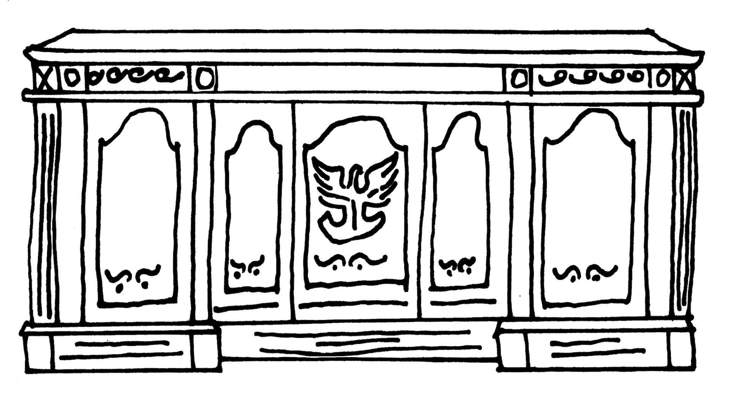
From the President’s Desk
Happy Valentines Day to you all. 💕 As you contemplate sweet people in your life, I’d like to thank all who came to the Charity sew day last month. Some projects were completed that day, but even more of you are finishing up quilts and smaller items to donate through our charity committee. Thank you! And speaking of sweet people, two really wonderful ladies have stepped up to chair our 2025 quilt show. More details will be revealed soon, and you will have the opportunity to vote on a theme and volunteer for the leadership role of your choice! What a privilege it is to be part of this dynamic group! I hope to see you at a meeting soon.
~Ellen Lewellen

Bring Toiletry Donations to February Meeting
Donated items will benefit InCourage {domestic violence shelter}.
Personal Hygiene Ideas |  | Cleaning Supply Ideas
- Soap  - Lotion  - Tooth Brush  - Tooth paste | - Shampoo & Conditioner  - Regular size or travel  - Ethnic  - Hairbrush | - Laundry Soap  - Dish Soap  - Scrubbers  - Washcloths

Days for Girls Sew Day
Days for Girls makes reusable menstrual products for girls and women around the world. The Green Bay chapter, TitleTown Days for Girls, has frequent workdays in Manitowoc.
One upcoming opportunity is Monday, Feb. 12, 1 pm at St Paul’s Lutheran, 2601 S. 10th St, Manitowoc. Sewing/cutting/pressing help needed. Bring a machine, or just yourself as there are many tasks available.

Sew for Fun Days
We thought we’d try for two days this time.
Mark your calendar for February 24 & 25 at Ascend Services from 8-4 each day. Cost is $10 for each day. Come on both days, or just Saturday or Sunday. Lunch is on your own. No need to pack up on Saturday if you decide to sew both days. All supplies can be left overnight.
Questions? Contact Julie Klumpp, 920-860-0485 or jaklumpp@tm.net

~ Patch of Lakeshore Quilters ~ Jan 11, 2024 Guild Meeting Minutes ~
- Call to Order
  - Ellen Lewellen
- Pledge
- Business Meeting
  - Secretary Report
    - Motion to accept: Jeanette Wiesner Second: Lori Stein Carried
  - Info shared on Kay Rusch’s funeral
  - Charity Sew Day - Jan 20 at Ascend
  - Mystery Quilt Clue 4 in December Newsletter
    - Examples shown by Ann Hall and Peggy Valitchka
  - Sew Days in Feb.
    - Feb 24 & 25, 8am-4pm at Ascend
    - $10 per day, BYO Lunch
    - Can leave supplies overnight if attending both days
    - Contact Julie Klumpp
  - Program for Feb
    - Top Ten Gadgets and Tricks by Sarah G of The Two Rivers Quilt Shop
  - Spring Camp Quilt
    - April 19-21
    - $55 for members
    - Details and registration form will be in Feb. Newsletter
Jan 11, 2024 Guild Meeting Minutes ~ Continued
  - National Quilt Day
    - March, date TBD
      - Open Sew day with short demos for those interested
      - $10
      - Have a technique that you can demo in about 10-15 minutes? Contact Ellen L.
  - Toiletry Collection
    - Bring toiletry items to the February Meeting
      - Donations will go to InCourage (domestic violence center)
  - Days for Girls
    - Monday, Feb 12, 1pm-4pm
    - St. Paul Ev. Lutheran, Manitowoc
    - Bring a machine to sew with, or there are other tasks available
    - Donations of dark colored flannel (prewashed is helpful), and ladies underwear always accepted
- Snacks
  - Thanks for the fresh fruit and cookies!
- Program
  - Thank you Julie K for the fun activities and time to socialize
- Show and Tell
- Motion to Adjourn:
    - Motion: Kay Olker Second: Cindy Dillman
Submitted by: Naomi Anderson

Some projects from the Charity Sew Day:
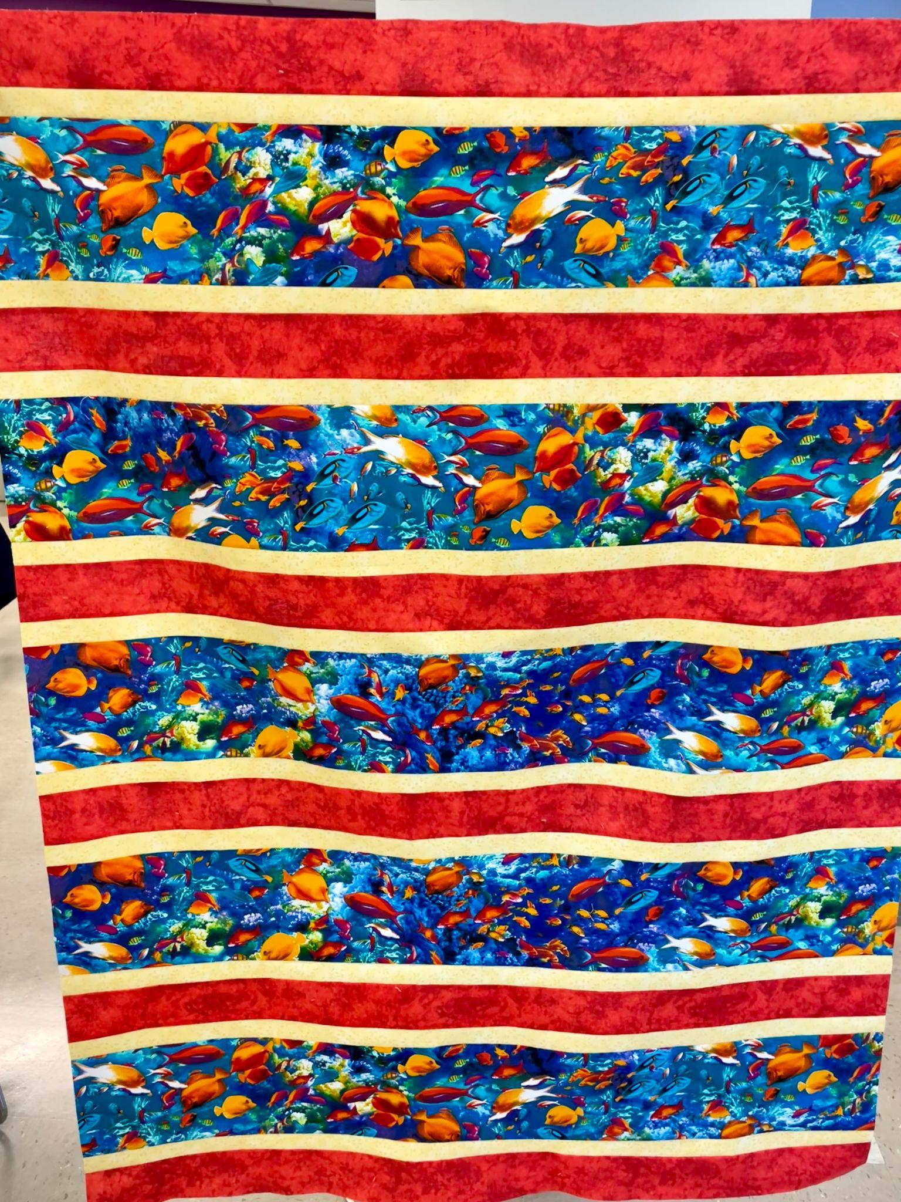
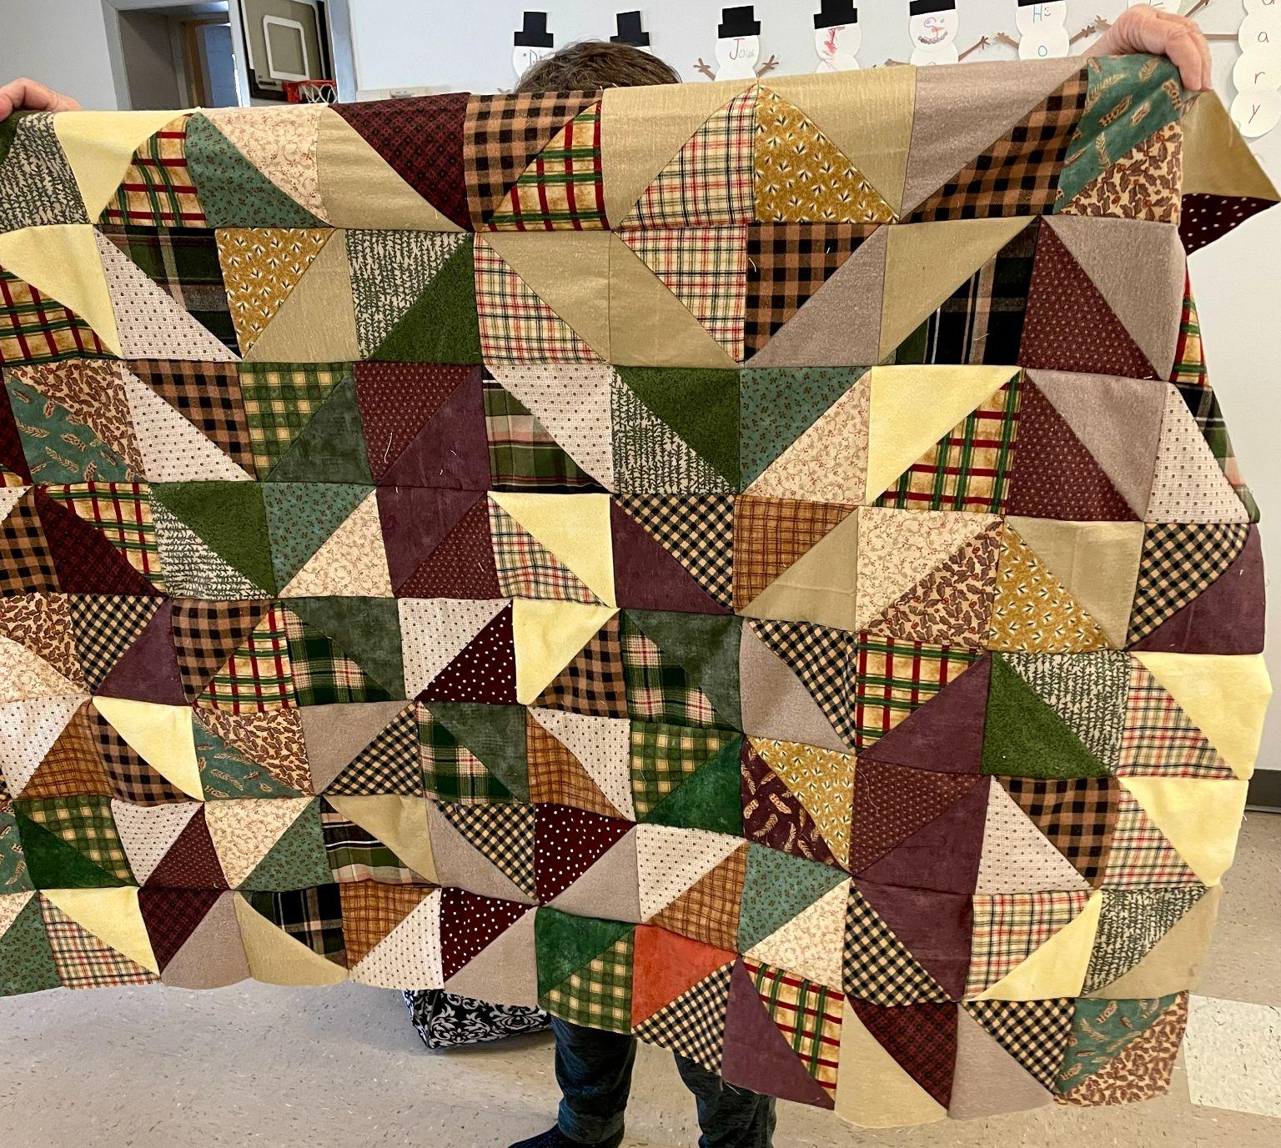
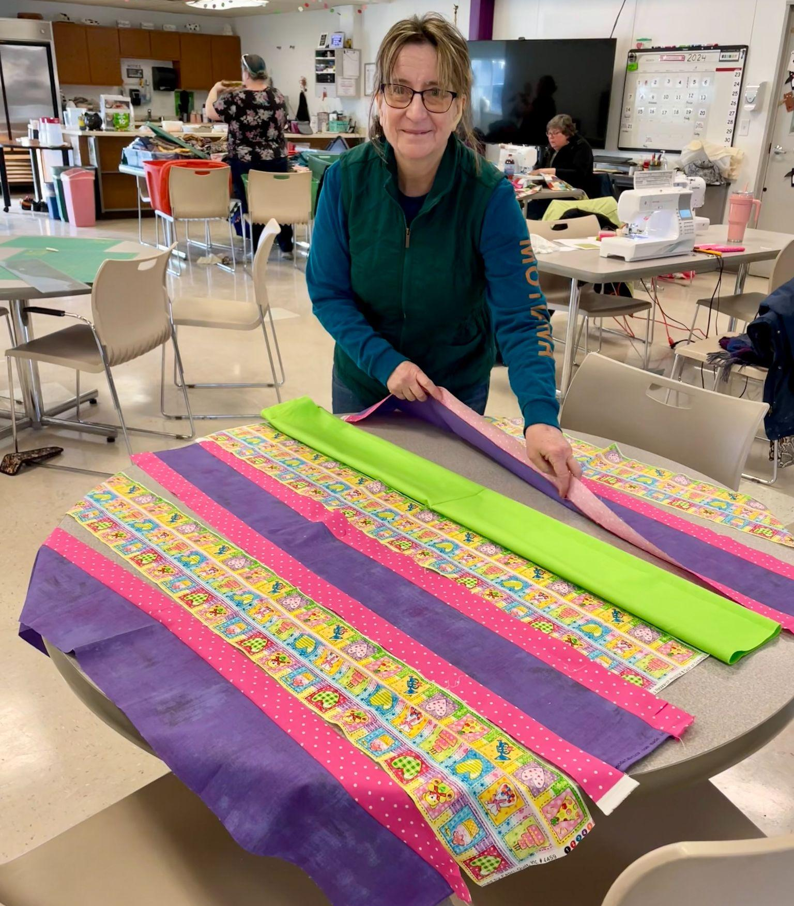

Spring Quilt Camp
Dates: April 19-21, 2024
There will be no overnight stay. The camp will be open from 8am to 11pm.
Cost: $55 for members, $75 for non-members
Meals: We provide meals on Friday evening, brunch and supper on Saturday and brunch on Sunday. We will meet for breakfast on Friday morning before camp. If you’d like to join us at the Two Rivers Family Restaurant, the cost is on your own. Lunch on Friday is also on your own.
Door prizes: Anyone at camp who wishes to participate in “BOGO” drawing brings a wrapped ($10.00) gift.
Project: We will present a project on Saturday. Participation is voluntary.
Shopping:
- The Quilt Shop of Two Rivers is offering a 20% discount to campers for the weekend. Hours: Sunday, 11-3; Monday to Friday, 9:30-5; Saturday, 9-3
- Norman General Store is offering a 20% discount for Thursday and Saturday. Hours: 10-4 each day
Questions: Julie Klumpp 920-860-0485 or jaklumpp@tm.net

QUILT CAMP REGISTRATION
APRIL 19-21, 2024

NAME: ____________________________________________________
ADDRESS: __________________________________________________
PHONE: ___________________________________________________

MEALS: CHECK WHICH YOU WILL BE PRESENT FOR
______ ALL MEALS
______ FRIDAY SUPPER
______ SATURDAY BRUNCH ______ SATURDAY SUPPER
______ SUNDAY BRUNCH

ARE YOU A COFFEE DRINKER? ______YES ______NO
IF YES, HOW MANY CUPS A DAY _____, REGULAR _____, DECAF _____

CAMP PAYMENT: MAKE CHECKS PAYABLE TO PLQ-QUILT CAMP
$55 MEMBERS $75 NON-MEMBERS

MAIL TO: JULIE KLUMPP, 2123 PRIMROSE LANE, MANITOWOC, WI 54220
Mystery Quilt Clue #6
Unfinished block 12.5” x 12.5” - Finished block 12′′ x 12′′

Clue #6 - Constructing Unit D and Assembling Block B
~Using constructed half square triangles,
Construct Unit D:

Quantity needed of Unit D | Table Topper | Lap Quilt | Twin | Full | Queen | King
 | 8 | 20 | 24 | 30 | 42 | 56

~With Unit D, and assembled Unit B from Clue 4, construct Block B:

# of Block B to make | Table Topper | Lap | Twin | Full | Queen | King
 | 4 | 10 | 12 | 15 | 21 | 28

~Assemble quilt top alternating
Block A and Block B

Block Layout
- Table Topper/Lullaby — 3x3
- Lap — 4x5
- Twin — 4x6
- Full — 5x6
- Queen — 6x7
- King — 7x8

