NEWSLETTER
Volume 19 Issue 11 December 2023

Guild Meeting:  Dec 14, 6:45pm  Christmas Social  ~ Ascend Services, Manitowoc  ~Meetings are the 2nd Thursdays of the month | Upcoming events:  Christmas Social  see below
??? Mystery Quilt Clue #4 - Page 3 ???
Jan Hostesses: Peggy Valitchka, Ann Hall, Lori Hansen-Stein
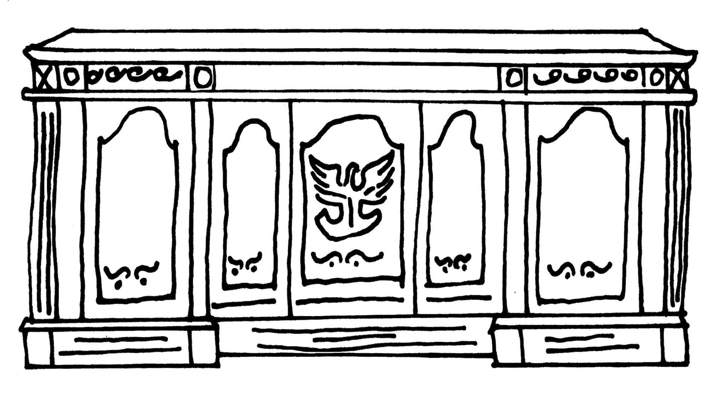
From the President’s Desk
I have a quote on the wall in my sewing space which reads, “A flower does not think of competing with the flower next to it, it just blooms”. This reminds me to stop comparing myself or my project to others but to celebrate the fact I'm able to make this beautiful quilt for my family or to give to another. If you have been busy making something handmade for Christmas for your 35 grandchildren entirely using your stash or an amazing thrift store find….well, God bless you, but for the rest of us mortals, don’t beat yourself up. Take pride in that one thing you did manage to finish, or those homemade cookies you baked, or the fact you actually put up a few decorations this year. I am thankful to be part of a group of such wonderful quilters who help each other and and donate their time, skills, and fabric! to help others too.
I look forward to seeing all of you at our holiday party December 14th.
Merry Christmas!
~Ellen Lewellen

Guild Christmas Party
The December meeting will be hosted by the lovely Christmas Social committee. The party starts at the regular meeting time (6:45pm). Enjoy a light supper with great dessert and smiles. Door Prizes and games to follow a short meeting and show and tell.
Nan, Kay, Gretchen, and Lynn
~ Patch of Lakeshore Quilters ~ Nov 9, 2023 Guild Meeting Minutes ~

- Call to Order
  - Ellen Lewellen
- Pledge of Allegiance
- Program
  - Quick and Easy Quilts presented by Kate LeRoy of Barn Door Quilts, Sturgeon Bay
    - A wonderful presentation focused on gifting quilts. Knowing the difference between “quilt-worthy” friends and friends that may not recognize the value of the time/materials can help in pattern choice.
    - Jelly Roll Quilts, 3 and 5 yard quilts were shown as fun, fast projects.
- Social
- Secretary Report: Motion: Bonnie Loeh Second: Lucy Z Carried
- Treasurer Report:Motion: Rosalie Miller Second: Ann Zeiman Accepted
- Old Business
  - Information about Sew Day for Nov. 11 shared
  - Send your pictures for posting on our media sites.
      - Naomi A. naomianderson428@gmail.com - text: 920-629-9277
      - Or Jennifer P. Olcootscreations@yahoo.com
  - Name tags update. If you still need a name tag (ie new member), please contact Ellen Lewellen with your name and city.
  - Mary Ellen Beebe will be teaching a class on Quilt As You Go.
    - May 18, $10 per person, plus $8.75 pattern
  - Membership Booklets
    - Available for $2, see Pam Posvec.
  - Christmas Social
  - Committees are listed in the new booklet
  - Mystery Quilt, step number 3 is available in the newsletter
- New Business
  - Quilts for Veterans - Interest was gauged regarding the making quilts for veterans, to be developed into an event to present veterans with quilts.
    - Completed quilts can be any size. Lap quilts are favored.
      - Complete solo or form a group to create the quilt.
    - Contact Pam Posvec
- Show and Tell
  - A lot of lovely items were shown, including many for charity.
    - Reminder: Meals on Wheels placemats sizes: 12x14 up to 14x16
- Meeting Adjourned Motion: Pam Posvec Second: Pearl Stock Carried
Submitted by: Naomi Anderson
Mystery Quilt Clue #4
For your planning / information:
Finished block 12′′ x 12′′
- Table Topper/Lullaby — 36′′ x 36′′
- Lap — 48′′ W x 60′′ L
- Twin — 48′′ W x 72′′ L
- Full — 60′′ W x 72′′ L
- Queen — 72′′ W x 84′′ L
- King — 84′′ W x 96′′ L

Clue #4 - Unit B
This month we continue working on the units that will eventually make up the blocks.

Pull the following number of background squares from your cutting step, and half square triangles from your completed HST step.
Components Needed | Table Topper | Lap Quilt | Twin | Full | Queen | King
Background 3 ½ x 6 ½ inch rectangles | 16 | 40 | 48 | 60 | 84 | 112
Half Square Triangle Units | 16 | 40 | 48 | 60 | 84 | 112
Caution: Do not use more that this step calls for in the charts. The rest of the squares, rectangles and HSTs will be used in future steps.
Construct Unit B:

Press the seams toward one side.

UNIT B | Table Topper | Lap | Twin | Full | Queen | King
Number of units to make | 8 | 20 | 24 | 30 | 42 | 56

