
NEWSLETTER
Volume 21 Issue 07 August 2025

Guild Meeting:  Aug 7 ~ Picnic, details pg 2  Sept 11th, 6pm  ~At Ascend Services  2818 Meadow Lane, MTWC | Upcoming:  Guild Picnic  Aug. 7 at Woodland Dunes  ~Details on page 2  Camp Quilt  Sept 19-21, details page 4  Registration form, page 5
Mystery Quilt - Page 9

From the President’s Desk
I came across an article recently which explained the Zeigarnick Effect (named after the female social psychologist who described it). It states that unfinished tasks loom larger in our minds than finished ones. In other words, when we finish a task, we mentally cross it off, but unfinished ones hang heavy in our minds. Of course I immediately thought of quilting applications such as UFOs, guilt over unused fabric purchases for planned but never made quilts and the like. A little kick in the pants is good to motivate us sometimes, but if you have projects or tasks which are weighing on you, here are some suggestions from Ms. Zeigarnick and me.
1. Develop systematic ways to track progress. This could be keeping a list, checking off the steps of a pattern, journaling, or stacking up those finished quilts or jars of jam (whatever!) and admiring them.
2. Create intentional closure points for ongoing projects such as those listed in #1 or simply setting a timer for so many minutes of work on your project.
3. Practice purposeful mind closing. In other words, at the end of each day instead of worrying about what there is yet to do, review in your mind all that you did accomplish that day and mentally pat yourself on the back. Many quilters keep scrapbooks or photo journals of completed quilts.
Do you have a trick to measure progress and keep track of what you’ve done? Email me and share it with the group!
~Ellen Lewellen, Guild President
AUGUST PICNIC FAQS
- When is it and why that date? It will be AUGUST 7. The county fair is the 3rd week of August, and guild members are needed to help at our booth there.
- When do we start? If you can come at 5, you will have time to find inspiration in the blooming butterfly garden or walk some of the trails. Ellen and Lucy were both teachers there for school groups for many years and will be available for Questions. Otherwise, a salad and dessert supper will be served at 6.
- How do I get to Woodland Dunes and is there parking there? If you’re going east towards Two Rivers on 310, look on your left just as the speed limit decreases and there are welcome to TR signs. Coming from Memorial Drive, turn away from the lake on Columbus St. After several blocks you will dead end into the Dunes. (For your GPS, the actual address is 3000 Hawthorne Ave, TR). There is parking in front on gravel and to the side on grass.
- Where do I go when I get there? From the parking lot in front, go through the glass doors into the building. The big room where we’ll be eating (or gathering if it’s raining) will be on the right. To reach the butterfly garden and the trails, continue straight through the entry hallway to the door in the back overlooking the gardens, tower and gazebo. The bathrooms are between the hallway and the big room.
- What do I need to bring? Bringing a friend would be nice but all you really need to bring is yourself and things you made this summer for Show & Tell.
- What’s the cost? Free!
- More questions? For any questions or need help coordinating a ride, feel free to call or text Ellen at 920-242-6758.

~ June Guild Meeting Minutes ~
- Call to Order
  - Pledge & Welcome to Painting Pathways reps Fran and Nathan.
- Program
  - Fran and Nathan shared about Painting Pathways, a place to “paint your own pathway,” that offers help to adults with concerns about their mental health. This is done by providing a daily meal, planned activities, small groups, counseling and more.
    - Volunteers welcome
- Old Business
  - Nominating Committee
    - Thank you to out-going board members: Ann Z, Chris B, Joni V. and Pam P.
~ June Guild Meeting Minutes Continued ~
    - There were no nominations from the floor. Ballot Closed
      - Elected to President: Ellen Lewellen
      - Elected to Secretary: Naomi Anderson
      - Elected to Board of Directors: Sue Dupont*, Mary Hutchinson, Kay Olker, Sue Marquart
        - Due to frantic note taking, I only wrote Sue D. I am making an educated guess that is Sue Dupont, however a correction will be put forth if needed.
  - Treasurer & Secretary Report
    - Motion to accept: Rosalie Miller; 2nd Ann Zeeman; motion carried
  - County Fair
    - Each year the county fair opens up a contest for quilt blocks based off that year’s fair theme. Submitted blocks are voted on and ribbons are given. These blocks are then assembled into a quilt (by members of our guild) that is raffled off at the following County Fair
    - Ellen Buck has been the point person for this committee
    - This year’s theme is Rock & Roll to the County Fair; colors Pink, Royal Blue and Black.
    - Link to Woman’s Day Event website: manitowoccountywi.gov/departments/expo/manitowoc-county-fair/ladies-day-event/***
      - ***As of printing, the link on their webpage for the Quilt Block Contest is still NOT accurate. Emailed them a second time.
    - You can help with this committee by:
      - Volunteering at the Quilt Raffle Table
      - Doing a sewing themed demonstration
        - Wed at 1pm OR Thurs at 1pm
    - Contact Ellen Buck with any questions buckconst5@gmail.com
  - Mystery Quilt Reminder
    - You can jump in any time. Current Mystery quilt began in Sept. 2024. All monthly blocks can be found in past copies of the Newsletters.
  - English Paper Piecing Workshop
    - 17 people turned up for this technique building workshop.
    - Thank you Ellen L for sharing your expertise with us.
  - Charity Quilt Labels are available at each guild meeting. See Naomi A
🚗
  - Name tags are made…but are stuck in Gretchen’s dead car up north.
        - Should be at the next meeting.
  - Bus Trip to Madison, sponsored by Brillion Quilt Group.
- Social and Snack Time
~ June Guild Meeting Minutes Continued ~
- New Business
  - Charity Sew Day: June 21 & 22
  - Library Book Sale: June 26-28
  - August Picnic
    - Take note: special date August 7th at Woodlands Dunes.
      - 5pm Butterfly Garden
      - 6pm Supper
    - Bring yourself and any Show and Tell you may have.
- Show and Tell
- Meeting Adjourned

Fall Camp Quilt September 19-21, 2025
Location: Camp Tapawingo, 915 W. Tapawingo Road, Mishicot
~Three days of sewing/quilting/ preparing for projects that you bring/sharing ideas/conversations/eating with fellow quilters. Bring your projects, sewing machine and whatever you need to work on your projects. Irons (water)/ironing boards/cutting tables/mats provided.
Overnight: We will be offering overnight stay for campers.
Please bring bedding and personal items for your stay.
Cost: $65 for members, $85 for non-members
Breakfast: Friday, September 19, 2025 meet at 8:00 am (optional)
Two Rivers Family Restaurant, 3015 Tannery Road, Two Rivers
Anyone wanting to join us before we go out to camp, you are responsible to pay for your own meal. If you are not meeting for breakfast, camp will open approximately 9:20.
Camp Project: We will have 2 camp projects. Participation is optional.
- One project requires 1 FQ or 2-10” squares.
- The other project requires a ½ yard of fabric.
Door prizes: Anyone at camp who wishes to participate in “BOGO” drawing brings a wrapped ($10.00) gift. Be sure to place your name inside the gift so the person receiving knows who to thank. Put your name on paper and place in drawing container. Drawings occur throughout the weekend.
Meals: Beverages: milk/coffee/ OJ/water. Or BYOBeverage. Ice machine at camp.
Friday lunch on your own. Supper – soup, salad and bread sticks.
Saturday – two meals provided, brunch and supper.
Sunday- brunch provided.
There is a sharing table for snacks; whatever you choose to bring. Please take home any of your leftovers.
*If you usually eat breakfast, on Saturday and Sunday you can eat off the sharing table or bring what you want to eat.
Questions: Julie Klumpp 920-860-0485 or email, jaklumpp@tm.net
QUILT CAMP REGISTRATION
Sept 19-21, 2025 ~ Camp Tapawingo, 915 W. Tapawingo Rd, Mishicot

NAME: __________________________________________________
ADDRESS: ______________________________________________
PHONE: _________________________________________________

MEALS: CHECK WHICH YOU WILL BE PRESENT FOR
______ ALL MEALS
______ FRIDAY SUPPER
______ SATURDAY BRUNCH ______ SATURDAY SUPPER
______ SUNDAY BRUNCH

ARE YOU A COFFEE DRINKER? ______YES ______NO
IF YES, HOW MANY CUPS A DAY _____, REG _____, DECAF _____

CAMP PAYMENT: MAKE CHECKS PAYABLE TO PLQ-QUILT CAMP
$65 MEMBERS $85 NON-MEMBERS

MAIL TO: JULIE KLUMPP, 2123 PRIMROSE LANE, MANITOWOC, WI 54220

QUESTIONS: JULIE KLUMPP, 920-860-0485 OR JAKLUMPP@TM.NET

? ? ? 2024-2025 Mystery Quilt ? ? ?

~ Pattern on page 6 & 7 ~ quantity: make 1 block of each ~
Join the Mystery Quilt anytime. Past newsletters, starting with Sept. 2024, contain all the blocks that have previously been revealed.

July Block
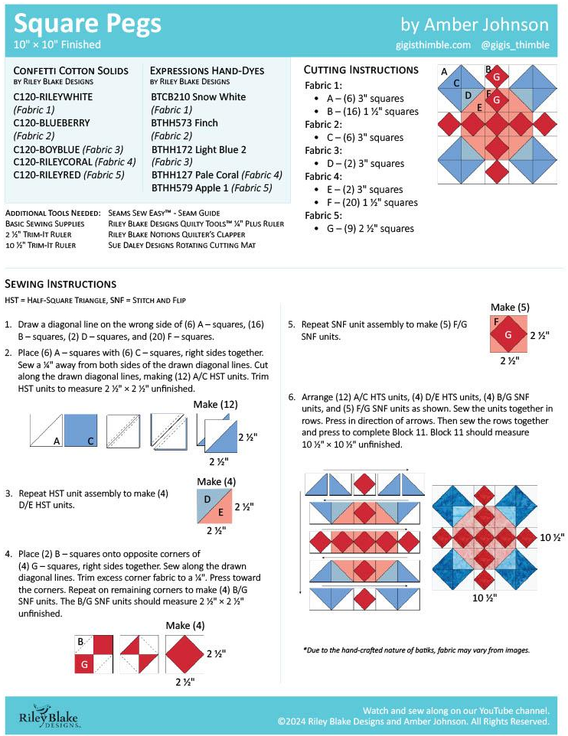
August Block