
NEWSLETTER
Volume 22 Issue 08 September 2026

Guild Meeting:  ~Sept. 10th, 6pm  At Ascend Services  2818 Meadow Lane, MTWC | Upcoming:  Quilt Camp  Sept. 18-20  See pages 7 & 8
Quilting Legacies Machine Repair drop-off and pick up months:
October, December
Contact Nan Groll if you plan on bringing a machine to the guild for pick up.

🌻 🌻 🌻 ~ Notes from the August Picnic ~ 🌻 🌻 🌻
Thank you to the WONDERFUL picnic committee! Our annual picnic is always a lovely time together. Picnicking at the Woodland Dunes Nature Center, we had delicious food (some of which was catered by Grow It Forward’s Harmony Cafe!), and enjoyed a fun sunflower themed craft.
Brief business notes:
- September Hostesses: Vicki P, Terri W, Julie K, Kat W
- Shared a quick overview of hostesses and committees for ‘26-’27 guild year
  - Details will be available in the yearly guild directory
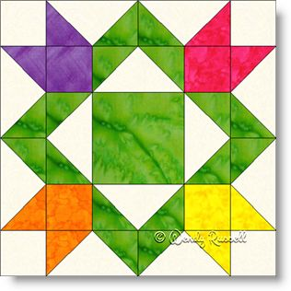
  - Committees that need volunteers (Contact Ellen for more info)
    - Nominating
    - Workshop/Skill-building
    - Field Trip
- Reminder that Quilt Show 2027 info is up on the website, including registration forms, challenge quilt info, and more
- Show and Tell (amazing as usual)

Four Flower Pattern: www.patchworksquare.com/mf/four-flowers-quilt-block.pdf?t=1788749607

~Guild President Ellen L~
While waiting for inspiration to strike to write this month’s piece, I came across a video from my favorite quilting YouTuber, Karen Brown of Just Get It Done Quilts. I’m going to paraphrase her list of 8 bad quilting habits she had and how she corrected them. Maybe some will be familiar to you because they certainly were to me.
“Yeah that 1/4” seam looks pretty good.” Slight inaccuracies multiply throughout a quilt, so now she makes a sample block for each new project and checks for that thickness of thread and fabric by measuring the seam, and adjusting her masking tape ledge guide until the seam is accurately 1/4”.
“When quilting, I’ll just leave the thread tails and bury them when I’m all done.” Hmm…too tired to do it when finishing the quilting and then some are missed. A better practice is to bury them as you go using a self-threading needle which is kept handy.
“I’m so eager to get cutting my pretty fabric I’ll worry about the selvages later.” Stupid idea! Not only can the edge of the unprinted selvage show up in your seams if you failed to remove it all, when you wash the piece the edges with selvedge bits can shrink differently. Cut them off before you cut your pieces.
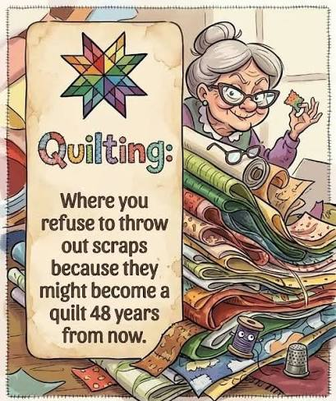
“Ooo I should save those cut off selvages, leftover triangles, odd buttons, old sheets etc. to make something with someday”. Really? Life is too short and there are too many quilts you really want to make to clutter up your sewing space with things you know you’re not likely to really use.
“Oh this quilt isn’t really my best so I won’t bother with a label.” Stop it! Seriously, you are a good quilter and are worthy of having your work recognized. Try making a label as you finish the top so you can sew it (or the guild’s charity label) into the binding or at least have it ready when the quilting is done.
“This step should be quick, so I’ll zip through it to get on to the next part.” Hang on….the whole point of quilting is to enjoy the process. When you are racing, you’re more likely to need the seam ripper and then how much time did you save? Take a picture of the finished quilt,and maybe even some of the steps along the way. You are a worthy quilter. If not for social media, keep a picture section on your phone or computer as a personal archive, especially for those quilts you gave away.
Plan ahead to be sure you have enough fabric, all the tools you need, a plan for quilting, and time before a deadline. Be kind to yourself. It’s only a mistake if you didn’t learn something from it.
~ About: Camp Quilt ~ Sept 18-20 ~
Location: Camp Tapawingo
915 W. Tapawingo Road, Mishicot
~Three days of sewing/quilting/ preparing for projects that you bring/sharing ideas/conversations/eating with fellow quilters. Bring your projects, sewing machine and whatever you need to work on your projects. Irons (water)/ ironing boards/cutting tables/mats provided.
Overnight: Overnight stay is available. Camp has bunk beds and showers in the lower level. Please bring bedding and personal items.
Cost: $65 for members, $85 for non-members
Breakfast: (optional) Friday, September 18, meet at 8:00 am
Two Rivers Family Restaurant, 3015 Tannery Road, Two Rivers
Anyone wanting to join us before we go out to camp, you are responsible to pay for your own meal. If you are not meeting for breakfast, camp will open approximately 9:20.
Meals: Beverages: milk/coffee/ OJ/water. Or BYOBeverage. Ice machine at camp.
Friday lunch on your own. Supper – provided by guild
Saturday – two meals provided by guild, brunch and supper.
Sunday- brunch provided guild
There is a sharing table for snacks; whatever you choose to bring. Please take home any of your leftovers.
*If you usually eat breakfast, on Saturday and Sunday you can eat off the sharing table or bring what you want to eat.
Door prizes: Anyone at camp who wishes to participate in “BOGO” drawing brings a wrapped ($10.00) gift. Be sure to place your name inside the gift so the person receiving knows who to thank. Put your name on paper and place in drawing container. Drawings occur throughout the weekend.
Questions: Julie Klumpp 920-860-0485 or email, jaklumpp@tm.net

QUILT CAMP REGISTRATION
September 18-20, 2026
NAME: _______________________________________________
ADDRESS: ___________________________________________
PHONE: _____________________________________________

MEALS: CHECK WHICH YOU WILL BE PRESENT FOR
______ ALL MEALS
______ FRIDAY SUPPER
______ SAT. BRUNCH ______ SAT. SUPPER
______ SUNDAY BRUNCH

ARE YOU A COFFEE DRINKER? ____YES ____NO
IF YES, HOW MANY CUPS A DAY _____,
REGULAR _____, DECAF _____

CAMP PAYMENT: MAKE CHECKS PAYABLE TO
PLQ-QUILT CAMP
$65 MEMBERS $85 NON-MEMBERS

MAIL TO: JULIE KLUMPP
2123 PRIMROSE LANE,
MANITOWOC, WI 54220

QUESTIONS: JULIE KLUMPP:
920-860-0485 OR JAKLUMPP@TM.NET

2027 Quilt Show Corner
- Setup dates: April 1 & 2, 2027
- Show dates: April 3 & 4, 2027
- Location: Manitowoc County Expo
- Theme: A Stitch in Time
- Quilt Show Chairwomen: Julie K, Kathy G, Jeanette W
- Featured Quilter: Ellen Lewellen

Committee Meetings: Committee Chairs meet the second Monday of the month at 6pm at the Two Rivers Quilt Shop.
Got Quilt Show info to share with the guild?
Contact Naomi to get it in the newsletter: naomianderson428@gmail.com

Quilt Challenge 2027
Theme : A Stitch in Time…Saves Nine!

Guidelines for this year’s challenge
- The entry must be a quilted project.
- It must have “NINE” of something in the quilt.
  - For example: 9 buttons, 9 different fabrics, 9-patch block(s), 9 hourglass blocks, 9 zippers (maybe on a fidget quilt), 9 flowers, 9 fun stitches on your sewing machine, 9 watches, etc.
  - Attached to the back of the quilt, the quilter must include an index card stating what “9” of something can be found on the quilt front.
- The perimeter of the quilt shall be no more than 144 inches around the outside borders.
  - For example: 27” X 45” or 36” X 36” for side lengths (perimeter = 144”)
  - Could have other side lengths, for example 9” X 16”, but must be 144” or less around the outside.
- All of the quilts entered in the Quilt Challenge category will be judged on these criteria:
  - Visual Impact, Design, Workmanship, Guildline compliance
- First, Second, Third place winners each earn a ribbon.

Chairpersons: Peggy Valichka and Terri Waack
~~~~~~~~~~~~~~~~~~~~~~~~~~~~~~~~~~~~~~~~~~~~~~~~~~~~~~~~~~~~~
Ellen Lewellen, Kathy Guralski, and Kay Olker met on August 24, 2026 with Guild Treasurer Mary Ellen Beebe for a review of the guild’s financial books as per the bylaw requirements.
~~~~~~~~~~~~~~~~~~~~~~~~~~~~~~~~~~~~~~~~~~~~~~~~~~~~~~~~~~~~~
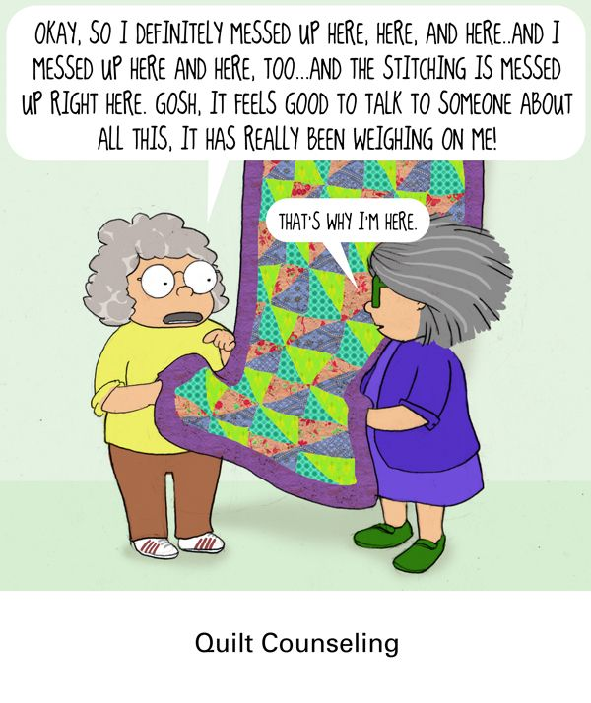

? ? ? ? ? It’s Mystery Time ? ? ? ? ?

Dear Quilting Friends,
It’s time for the 26-27 Mystery Quilt. This month you are getting the fabric requirements and cutting instructions. There will be a new task every month from now until June 2027. The March task will be a short simple one since we will all be busy getting ready for the quilt show. The finished quilt will measure approx 70” square. There are no curves, applique, or y-seams. It is scrap friendly or can be made with coordinated yardage. Please read all the cutting instructions before beginning. ( In other words, don’t be like me )
We hope you join us for this project. ~Cindy Dillman and Kay Olker

MYSTERY QUILT ‘26 - ’27 - FABRIC REQUIREMENTS

PATTERN NOTES:
Width of fabrics (WOF) for this pattern is assumed to be 40”.
A scant ¼" (a thread width smaller than ¼") seam is to be used throughout the construction of the quilt unless otherwise instructed.

Fabric Requirements
Fabric A 1 yard OR 2 charm packs OR 72 4x4” scraps
Fabric B 1 yard
Fabric C 1 ¾ yards
Background fabric (Bg1) 2 ¾ yards
Binding Fabric ⅝ yard
Backing Fabric 4 yards ⅓
Batting 78" x 78"

~It is suggested that a solid or a tone-on-tone print that reads as a solid be used for the background fabric.
~Due to the finished fabric piece sizes and piecing methods for the quilt top, it is recommended that fabric prints used have a non-directional design.
~To help plan your fabrics for the mystery quilt, be sure that all fabrics that are next to each other have enough contrast between them.
~Scrappy/Charm Pack Option - The fabric A may be made using scraps or from charm packs (or other precut fabrics). Generally, the fabric A pieces within the quilt are 4" x 4" or smaller.

Within the pattern the following colors will be used to represent each fabric
A B C Bg .

Note on fabric cutting:
- On the background fabric step 2 ( 4- 6.5” squares) you may use focus fabric or panel blocks instead of background.
- On the background fabric step 5a (8 -3.5x6.5 rectangles) you may use focus fabric or coordinating fabric if you chose to do so in step 2

MYSTERY QUILT ‘26 - ’27 - CUTTING INSTRUCTIONS

FABRIC A - if using yardage
1. Cut 2 strips 4" x WOF.
a. Sub-cut 1 strip into 10 squares 4" x 4".
b. Sub-cut 1 strip into 2 squares 4" x 4", 4 squares 3 ⅞" x 3 ⅞," and 3 squares 3 ½" x 3 ½".
2. Cut 2 strips 3 ⅞" x WOF.
a. Sub-cut each strip into 10 squares 3 ⅞" x 3 ⅞".
3. Cut 3 strips 3 ½" x WOF.
a. Sub-cut each strip into 11 squares 3 ½" x 3 ½".
~Total: 12 squares 4" x 4", 24 squares 3 ⅞" x 3 ⅞", and 36 squares 3 ½" x 3 ½".

FABRIC A - if using charm squares or scraps, cut to:
- 12 squares 4" x 4"
- 24 squares 3 ⅞" x 3 ⅞"
- 36 squares 3 ½" x 3 ½”

FABRIC B
1. Cut 4 strips 7¼ " x WOF.
a. Sub-cut the strips into 18 squares 7¼ " x 7¼ " (each strip yields 5).

FABRIC C
1. Cut 2 strips 4" x WOF.
a. Sub-cut the strips into 18 squares 4" x 4" (each strip yields 10 squares).
2. Cut 14 strips 3 ½" x WOF.
a. Sub-cut 4 strips into 12 rectangles 3 ½" x 12 ½" (each strip yields 3).
b. Sub-cut 2 strips into 12 rectangles 3 ½" x 6 ½" (each strip yields 6).
c. Reserve the remaining 8 strips.

BACKGROUND FABRIC (bg)
1. Cut 2 strips 7 ¼" x WOF.
a. Sub-cut the strips into 6 squares 7 ¼" x 7 ¼" (each strip yields 5).
2. Cut 1 strip 6 ½" x WOF.
a. Sub-cut the strip into 4 squares 6 ½" x 6 ½"
3. Cut 3 strips 4" x WOF.
a. Sub-cut the strips into 30 squares 4x4 " (each strip yields 10 squares).
4. Cut 8 strips 3 ⅞ " x WOF.
a. Sub-cut the strips into 72 squares 3 ⅞ " x 3 ⅞ " (each strip yields 10).
5. Cut 7 strips 3 ½ " x WOF.
a. Sub-cut 2 strips into 8 rectangles 3 ½" x 6 ½" (each strip yields 6).
b. Sub-cut 5 strips into 49 squares 3 ½" x 3 ½" (each strip yields 11).

