
NEWSLETTER
Volume 22 Issue 07 August 2026

Guild Meeting:  August Annual Picnic  ~ Aug. 13  ~ at Woodland Dunes  3000 Hawthorne Ave,  Two Rivers | Upcoming:  Quilt Camp  Sept. 18-20  See pages 7 & 8
Quilting Legacies Machine Repair drop-off and pick up months:
August, October, December
Contact Nan Groll if you plan on bringing a machine to the guild for pick up.
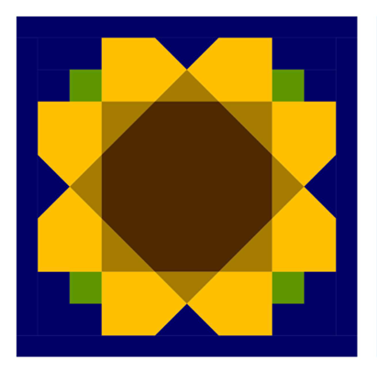
August Picnic

August 13
At Woodland Dunes
3000 Hawthorne Ave, Two Rivers

5pm - optional Nature Walk
6pm - official start
Meal, show and tell, fun project, and friends

~~🌻~~~~🌻~~~~🌻~~~~🌻~~~~🌻~~~~🌻~~~~🌻~~~~🌻~~~~🌻~~
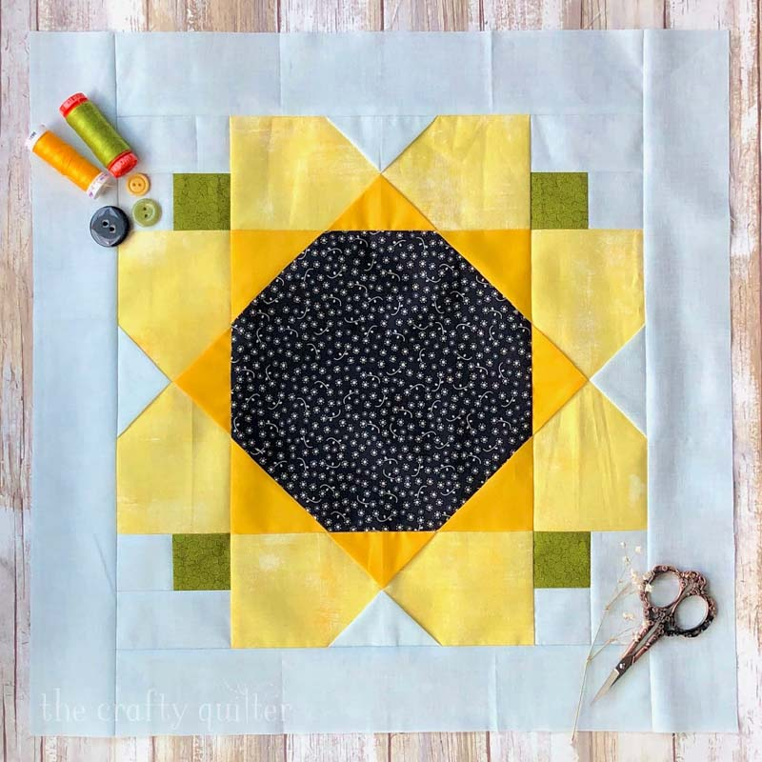

Check out this website for the free pattern to the Sunflower Block above:
thecraftyquilter.com/2023/06/free-garden-
Sunflower-quilt-block-pattern

Informal minutes of the POLQ Board meeting 6/23/26
Members Present: Ann Hall, Sue Marquardt, Sue DuPont, Mary Hutchison, Kay Olker, Cindy Dillman, Kim Hafeman, Lori Hansen-Stein, Ellen Lewellen
Absent: MaryEllen Beebe, Naomi Anderson. Guest: Nan Groll
Our first discussion was how we can better welcome and shepherd new members. Since Nan has been involved in this area, she was invited to share her ideas too. It was decided that after our treasurer receives a new member registration, she would immediately forward that person’s name and contact information to the president, secretary, and the welcome/membership chair so the new person would be included in emails. Nan is working on a simple trifold flyer with help from Kay which would describe the guild and it’s goals, list of charity donations, types of other activities such as camp retreats, sew days, picnic and holiday social, mystery quilt etc. It will prominently feature our website where an interested person could get more information and a registration form. These trifold flyers will be available at meetings for guests, at the quilt show, and possibly at local quilt shops or even other places around town where there are pamphlets on local attractions. In addition, we’d like to resurrect the idea of a folder for prospective new members which would have descriptions of our committees, a registration form, possibly a small gift, and the name of a guild member who will serve as a mentor for the following year. Hence this committee will be called “New Members”.
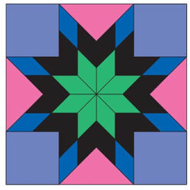
Next the discussion turned to codifying miscellaneous policies we’ve been doing but aren’t written down. (Unless there is a policy/procedure binder I’m not aware of? Let me know!). We will continue the door prize drawing (Thank you Julie K for continuing to obtain the $10 gift certificates!) to encourage the wearing of name badges unless a person is waiting for one to be made. The name badges will continue to be $8 for replacement but the first is free for new members. Dues for the membership year are to be sent in before June 30th for the following program year. New members who sign up at the quilt show are registered for the following year. Other new members who join during
Continued: Informal minutes of the POLQ Board meeting 6/23/26
the year will have the Membership cost prorated at $3 per month remaining. To clarify what the Sunshine committee should do, it was decided that the Guild would send a check for $30 for the death of a member’s spouse or child. If a recently active Guild member passes, $50 would be sent to the family. The committee would just send cards for all other bereavements or hospitalizations at the discretion of the committee.
Mary Ellen had prepared a next-to-final year end statement of our income, expenses vs. the budget for the year concluding. The Board talked about each line and which items might need to be increased or decreased for next year. We are in really good shape financially right now due to the success of the last quilt show and the care of everyone needing to make purchases. Ellen will work with Mary Ellen to finalize a proposed budget for the membership to vote on in September. It was also noted that we will need to do a review of our books in August as per our bylaws.
Other topics discussed included possible advertising in our membership booklet, suggestions for trips, programs, workshops, and less expensive venues for sew days. One Board member said she had been approached by Guild members asking for the speaker and agenda to be listed in advance in the newsletter.
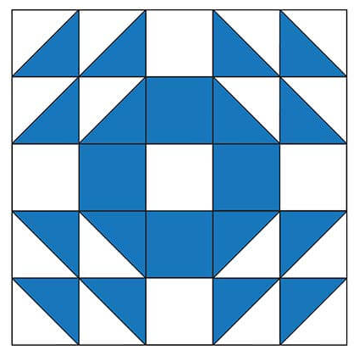
The next task is sending out an email letter reminder to those who have not yet sent in a registration. Lori, Sue D and Kay offered to help phone or otherwise contact those we don’t hear from in a few weeks. (Note from EL: This letter was sent out today along with the registration form and committee descriptions.)
Prepared by Ellen Lewellen 6/30/26

Some ridiculous quilt humor:
Q: Why did the quilter go to therapy?
A: Because she was feeling a little "frayed".
Q: Why did they send the quilt guild to a war zone?
A: Because they're excellent piece-makers!
My sewing machine and I are in a committed relationship, we just have a few tension issues.
~ June 11, 2026 Guild Meeting Minutes ~
June 11, 2026 Ascend Services
- Welcome
- We spent some time introducing ourselves as there have been many new members this past year.
  - Everyone…all 43 of us(!) introduced themselves and gave a quick when/how they joined the guild. Many discovered the guild through friends, at one of our quilt shows, and a good number found us through Google. (So, find your crafty leaning friends and invite them to get into a new addiction, I mean, a new hobby.)
- Pledge
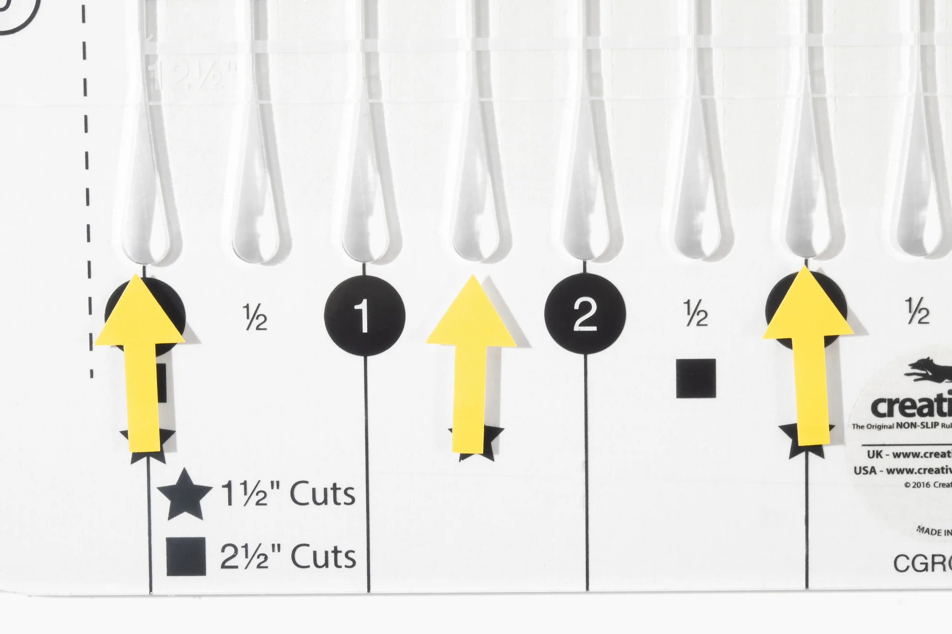
- Guest Speaker: ~The night’s speaker fell through. A few of the guild members shared favorite tools and techniques. Thank you members for always being willing to step up and help out.
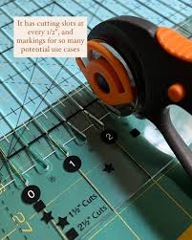
  - Tools included:
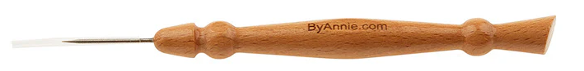
    - Stripology Ruler: Square ruler with open slots for the rotary blade to fit into for strip cutting, then rotate 90° and cut again to get squares.
    - Stiletto: sharp and narrow pointed tool used for control of a project as it gets closer to the need.
      - You can use a set tool, or improvise: Seam ripper point, long nosed tweezers, dental tool, cocktail stick, any sharp pointy thing.
    - Scrap Quilting
      - What makes a good scrap quilt?
        - Contrast, color family,
      - Leaders and Enders
        - Use them to count large chain piecing
      - How to organize?
        - By color, by size,
- Interested in doing a Friendship / Round Robin quilt? Contact Lori Hansen-Stein
- Business
  - May Minutes motion to accept Cindy Dillman second Pam Posvic
  - County Fair
    - Contact Ellen Buck to help donate to a “raffle basket” for the winners of County Fair Quilt Block
~ June 11, 2026 Guild Meeting Minutes, Continued~

  - Cleveland Lutze House Barn
    - 175th Anniversary of the Lutze Housebarn Celebration July 25th from 1:00-4:00 pm featuring reenactments, displays, historic skills, music and ethnic foods.
      - Looking for a few people to represent the Guild and sell Raffle Tickets for the County Fair Quilt. Contact Ellen Lewellen
  - Quilt Show
    - Looking for:
      - History: Donations to any group, please get a brochure or flyer from that organization to
        - Sample items
      - Quilt Walk
        - Smaller quilts, spring/bright colors
    - Challenge Quilt
      - Terry W & Peggy V incharge
      - Quilt must have 9 of something
        - 9 blocks, 9 stitches
        - Up to 144 perimeter
        - See newsletter for details. Will also be posted on the website
  - August Picnic
    - Sunflower theme
    - Aug 13, 6pm meal (5pm optional nature walk)
    - Show and tell
    - Food
    - Projects
  - No Meeting in July
  - Charity
    - Annette C
    - Holy Family
      - Generous lap size quilts for cancer patients
    - Back to School
      - Come to september meeting with these items
  - Election
      - First, thank you to Ann Hall and Sue Mardquart for serving as members at large

~ June 11, 2026 Guild Meeting Minutes, Continued ~
      - Offices up for election
        - Vice-President, Treasurer, and Two Members at Large
          - Ballots included Lori Hansen-Stein, Mary Ellen Beebe, Kim Hafeman, Cindy Dillman respectively
        - Nominated from the floor for Member at Large: Vicki Patt
      - Election Results:
        - Vice President: Lori Hansen-Stein
        - Treasurer: Mary Ellen Beebe
        - Members at Large: Kim Hafeman and Cindy Dillman
  - Registration Forms (please turn yours in asap)
    - New Form needed each year
    - Pay special attention to Committees
    - Name, email & telephone number
      - Most of our communication is done via email. Please make sure to fill out clearly.
      - Birthday: Just need a month and date.
  - Camp Quilt
    - Sept 18-20
  - Show and Tell
    - Reusable bags shown as examples for the Charity Booth at the Quilt Show
      - Any size, shopping bag / tote
  - NO JULY MEETING 🙂
  - Watch for picnic details in an email
- Motion to Adjourn
  - Sue Mardquart 2nd Naomi Anderson
Submitted by Naomi Anderson

~ About: Camp Quilt ~ Sept 18-20 ~
Location: Camp Tapawingo
915 W. Tapawingo Road, Mishicot
~Three days of sewing/quilting/ preparing for projects that you bring/sharing ideas/conversations/eating with fellow quilters. Bring your projects, sewing machine and whatever you need to work on your projects. Irons (water)/ ironing boards/cutting tables/mats provided.
Overnight: Overnight stay is available. Camp has bunk beds and showers in the lower level. Please bring bedding and personal items.
Cost: $65 for members, $85 for non-members
Breakfast: (optional) Friday, September 18, meet at 8:00 am
Two Rivers Family Restaurant, 3015 Tannery Road, Two Rivers
Anyone wanting to join us before we go out to camp, you are responsible to pay for your own meal. If you are not meeting for breakfast, camp will open approximately 9:20.
Meals: Beverages: milk/coffee/ OJ/water. Or BYOBeverage. Ice machine at camp.
Friday lunch on your own. Supper – provided by guild
Saturday – two meals provided by guild, brunch and supper.
Sunday- brunch provided guild
There is a sharing table for snacks; whatever you choose to bring. Please take home any of your leftovers.
*If you usually eat breakfast, on Saturday and Sunday you can eat off the sharing table or bring what you want to eat.
Door prizes: Anyone at camp who wishes to participate in “BOGO” drawing brings a wrapped ($10.00) gift. Be sure to place your name inside the gift so the person receiving knows who to thank. Put your name on paper and place in drawing container. Drawings occur throughout the weekend.
Questions: Julie Klumpp 920-860-0485 or email, jaklumpp@tm.net

QUILT CAMP REGISTRATION
September 18-20, 2026
NAME: _______________________________________________
ADDRESS: ___________________________________________
PHONE: _____________________________________________

MEALS: CHECK WHICH YOU WILL BE PRESENT FOR
______ ALL MEALS
______ FRIDAY SUPPER
______ SAT. BRUNCH ______ SAT. SUPPER
______ SUNDAY BRUNCH

ARE YOU A COFFEE DRINKER? ____YES ____NO
IF YES, HOW MANY CUPS A DAY _____,
REGULAR _____, DECAF _____

CAMP PAYMENT: MAKE CHECKS PAYABLE TO
PLQ-QUILT CAMP
$65 MEMBERS $85 NON-MEMBERS

MAIL TO: JULIE KLUMPP
2123 PRIMROSE LANE,
MANITOWOC, WI 54220

QUESTIONS: JULIE KLUMPP:
920-860-0485 OR JAKLUMPP@TM.NET

2027 Quilt Show Corner
- Setup dates: April 1 & 2, 2027
- Show dates: April 3 & 4, 2027
- Location: Manitowoc County Expo
- Theme: A Stitch in Time
- Quilt Show Chairwomen: Julie K, Kathy G, Jeanette W
- Featured Quilter: Ellen Lewellen
Committee Meetings: Committee Chairs meet the second Monday of the month at 6pm at the Two Rivers Quilt Shop.
Got Quilt Show info to share with the guild?
Contact Naomi to get it in the newsletter: naomianderson428@gmail.com

Quilt Challenge 2027
Theme : A Stitch in Time…Saves Nine!

Guidelines for this year’s challenge
- The entry must be a quilted project.
- It must have “NINE” of something in the quilt.
  - For example: 9 buttons, 9 different fabrics, 9-patch block(s), 9 hourglass blocks, 9 zippers (maybe on a fidget quilt), 9 flowers, 9 fun stitches on your sewing machine, 9 watches, etc.
  - Attached to the back of the quilt, the quilter must include an index card stating what “9” of something can be found on the quilt front.
- The perimeter of the quilt shall be no more than 144 inches around the outside borders.
  - For example: 27” X 45” or 36” X 36” for side lengths (perimeter = 144”)
  - Could have other side lengths, for example 9” X 16”, but must be 144” or less around the outside.
- All of the quilts entered in the Quilt Challenge category will be judged on these criteria:
  - Visual Impact, Design, Workmanship, Guildline compliance
- First, Second, Third place winners each earn a ribbon.

Chairpersons: Peggy Valichka and Terri Waack

