
NEWSLETTER
Volume 21 Issue 08 September 2025

Guild Meeting:  Sept 11th, 6pm  ~At Ascend Services  2818 Meadow Lane, MTWC | Upcoming:  Camp Quilt  Sept 19-21, details page 4  Registration form, page 5
Mystery Quilt - Page 6


Frog Eye Salad
Weird name, delicious salad from the Guild Picnic.

1-3/4 C. pineapple juice 1 (16 oz.) pkg acini di pepe pasta
1 C. white sugar 3 (11oz.) cans mandarin oranges, drained
2 eggs, beaten 2 (20 oz.) cans pineapple tidbits, drained
2 Tbsp. flour 1 (20 oz.) can crushed pineapple, drained
2-1/2 tsp. salt 1 (8 oz.) container whipped topping, thawed
1 Tbsp. lemon juice 1 C. miniature marshmallows
1 Tbsp. Vegetable oil 1 C. shredded coconut

- Combine pineapple juice, sugar, eggs, flour and ½ tsp. salt in saucepan.
  - Stir and cook over medium heat until thickened.
  - Stir in lemon juice and cool to room temp.
- Bring a large pot of water to a boil; add oil and 2 tsp. salt.
  - Add pasta and cook until al dente, 5 to 7 minutes.
  - Drain and rinse under cold water.
- Combine cooked pasta, cooled egg mixture, mandarin oranges, pineapple and whipped topping in a large bowl.
  - Chill 8 hours or overnight.
  - Before serving, add marshmallows and coconut, toss and serve.

Floral Mandalas made at our August Picnic at the Woodland Dunes.


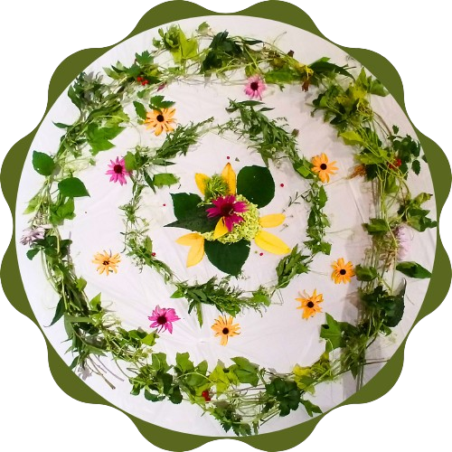







~ August Guild Meeting Minutes ~
- Welcome
  - Sue Crowley welcomed the group to Woodland Dunes’ 1,500+ acre preserve, home to over 600 species of plants, 250 species of birds, 42 species of mammals, 10 species of amphibians, and thousands of species of invertebrates.
    - Volunteer opportunities available! www.woodlanddunes.org
  - The picnic committee provided an amazing meal.
- Business Meeting
  - County Fair
    - Woman’s Day Event - Aug. 23
      - Special speakers and promos
    - Contact Ellen Buck with any questions buckconst5@gmail.com
  - Mystery Quilt Reminder
    - You can jump in any time. Current Mystery quilt began in Sept. 2024. All monthly blocks can be found in past copies of the Newsletters.
  - Camp Quilt
    - Sept 19-21 at Camp Tapawingo, Mishicot
      - $65 for members
      - See newsletter for details and registration form
- Show and Tell
- Meeting Adjourned
From the President’s Desk
Hi everybody and welcome back to another exciting year with A Patch of Lakeshore Quilters. We are very privileged to have 6 or 8 new members join us since the spring quilt show, so if you are new or newer, please feel free to ask me or any of the members if you have questions…we try to be a pretty friendly bunch!
One of the projects of the officers over the summer was trying to contact the handful of past guild members who did not return a registration form and dues for this year and also to make assignments for those who did. Our yearly membership booklet lists all the people who volunteered for committees and monthly hostesses as well as all the current members. It is in the process of being printed now. If I somehow missed contacting you with emails and texts and you want to join or rejoin, it’s no big deal for us to write your name in, so please contact me or another officer right away.
This newsletter is your place to find information for all upcoming events. Happening immediately is the Great Wisconsin Quilt Show in Madison Sept. 4-6th. Some members plan to join quilters from Brillion taking a bus there. Our September program will be presented by a representative from Project Linus, a charity gathering baby quilts. Camp Quilt is a weekend retreat to work on your own project at Camp Tapawingo (either sleep there or drive back and forth) planned for Sept. 19-21. We eat together, encourage each other, and have loads of fun. The newsletter also features monthly installments of our current mystery quilt blocks.
Looking forward to seeing all of you at 6 PM at Ascend on September 11. Bring any quilt projects you finished over the summer for Show & Tell…you know we all want to see them and applaud your beautiful work!
~Guild President: Ellen Lewellen


The HST (half star triangle) is a common quilt base for many traditional quilt blocks.
Popular blocks include:
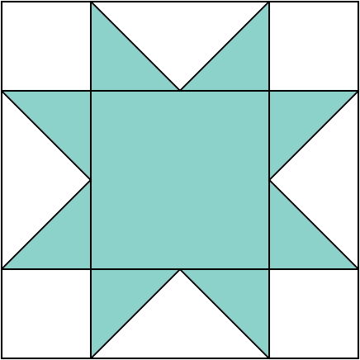
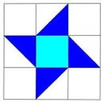
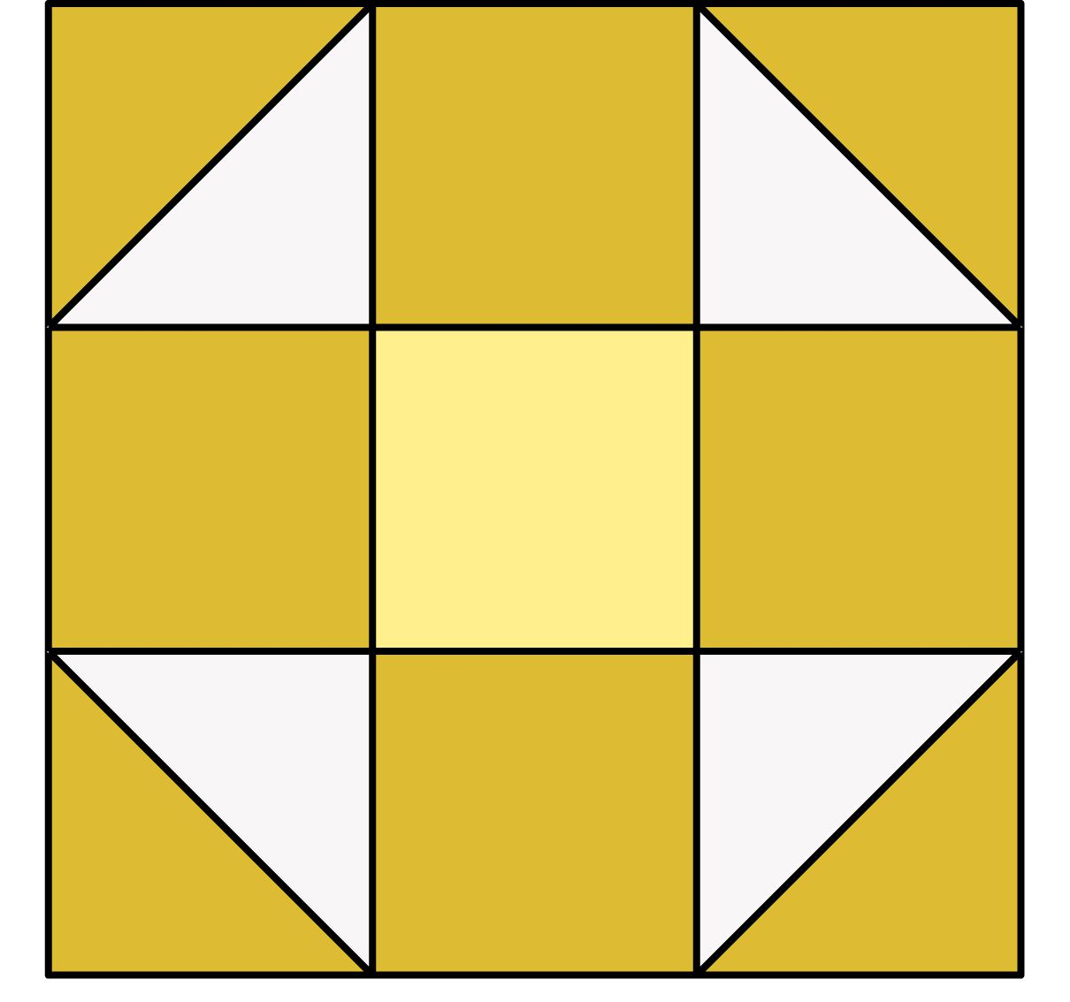


Pinwheel Friendship Star Shoo Fly Sawtooth Star

Fall Camp Quilt September 19-21, 2025
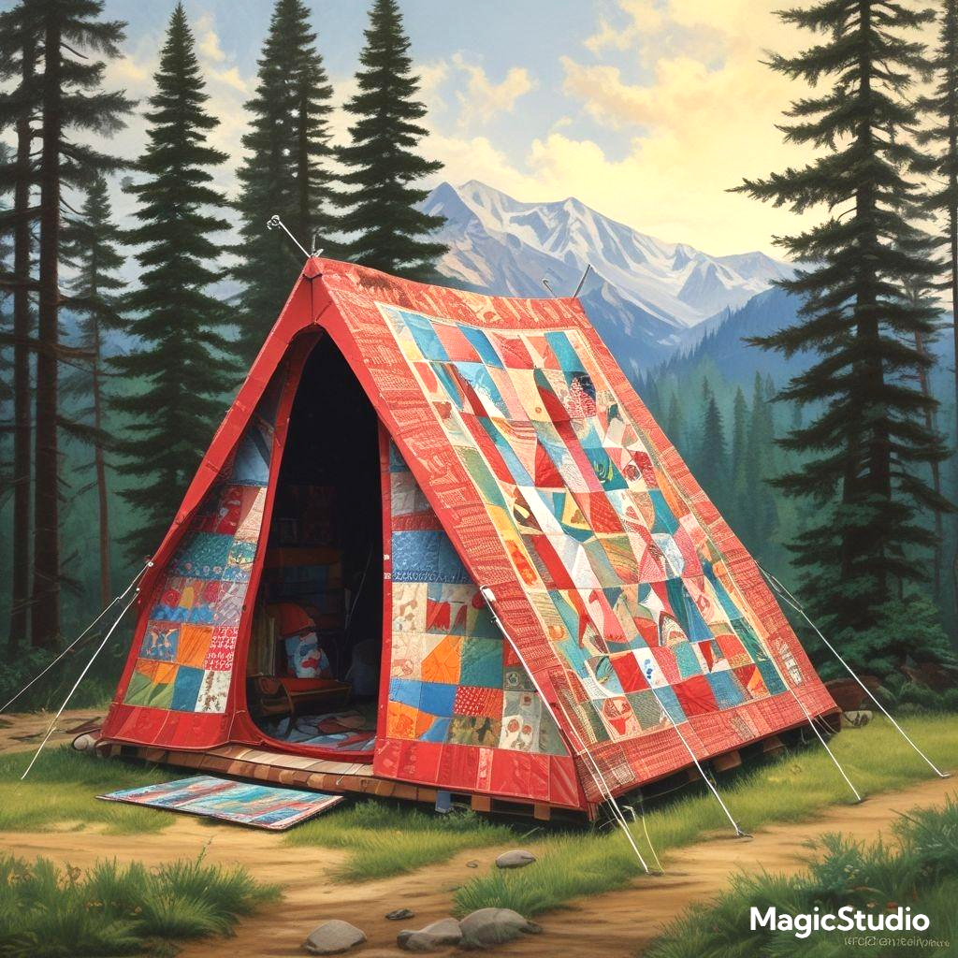
Location: Camp Tapawingo
915 W. Tapawingo Road, Mishicot
~Three days of sewing/quilting/ preparing for projects that you bring/sharing ideas/conversations/eating with fellow quilters. Bring your projects, sewing machine and whatever you need to work on your projects. Irons (water)/ironing boards/cutting tables/mats provided.
Overnight: Overnight stay is available. Camp has bunk beds and showers in the lower level. Please bring bedding and personal items.
Cost: $65 for members, $85 for non-members
Breakfast: Friday, September 19, 2025 meet at 8:00 am (optional)
Two Rivers Family Restaurant, 3015 Tannery Road, Two Rivers
Anyone wanting to join us before we go out to camp, you are responsible to pay for your own meal. If you are not meeting for breakfast, camp will open approximately 9:20.
Camp Project: We will have 2 camp projects. Participation is optional.
- One project requires 1 FQ or 2-10” squares.
- The other project requires a ½ yard of fabric.
Door prizes: Anyone at camp who wishes to participate in “BOGO” drawing brings a wrapped ($10.00) gift. Be sure to place your name inside the gift so the person receiving knows who to thank. Put your name on paper and place in drawing container. Drawings occur throughout the weekend.
Meals: Beverages: milk/coffee/ OJ/water. Or BYOBeverage. Ice machine at camp.
Friday lunch on your own. Supper – soup, salad and bread sticks.
Saturday – two meals provided, brunch and supper.
Sunday- brunch provided.
There is a sharing table for snacks; whatever you choose to bring. Please take home any of your leftovers.
*If you usually eat breakfast, on Saturday and Sunday you can eat off the sharing table or bring what you want to eat.
Questions: Julie Klumpp 920-860-0485 or email, jaklumpp@tm.net
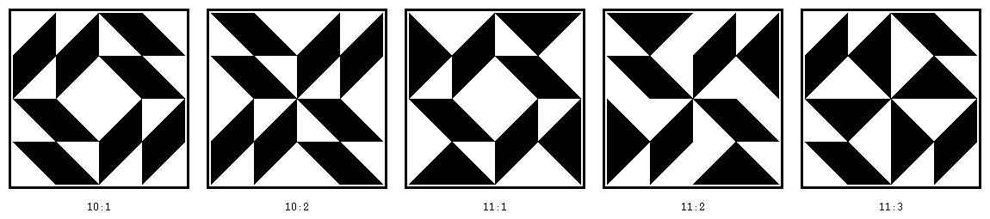

Look! 16 patch half square triangle layouts!
QUILT CAMP REGISTRATION
Sept 19-21, 2025 ~ Camp Tapawingo, 915 W. Tapawingo Rd, Mishicot

NAME: __________________________________________________
ADDRESS: ______________________________________________
PHONE: _________________________________________________

MEALS: CHECK WHICH YOU WILL BE PRESENT FOR
______ ALL MEALS
______ FRIDAY SUPPER
______ SATURDAY BRUNCH ______ SATURDAY SUPPER
______ SUNDAY BRUNCH

ARE YOU A COFFEE DRINKER? ______YES ______NO
IF YES, HOW MANY CUPS A DAY _____, REG _____, DECAF _____

CAMP PAYMENT: MAKE CHECKS PAYABLE TO PLQ-QUILT CAMP
$65 MEMBERS $85 NON-MEMBERS

MAIL TO: JULIE KLUMPP, 2123 PRIMROSE LANE, MANITOWOC, WI 54220

QUESTIONS: JULIE KLUMPP, 920-860-0485 OR JAKLUMPP@TM.NET

? ? ? 2024-2025 Mystery Quilt ? ? ?

~ Pattern on page 6 ~ quantity: make 1 block ~
Join the Mystery Quilt anytime. Past newsletters, starting with Sept. 2024, contain all the blocks that have previously been revealed.
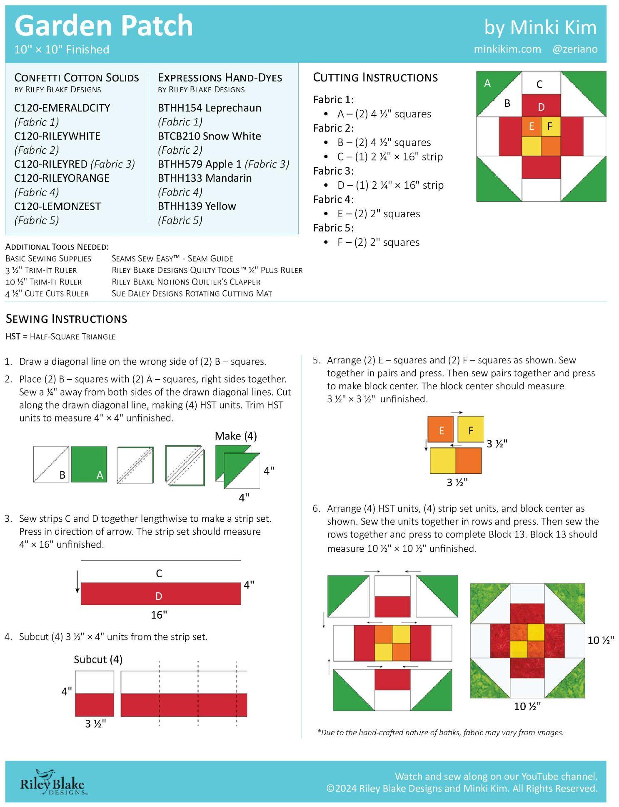

Shared with the Guild

Fox Cities Quit Shop:
First ever Sewing Machine Show sponsored by the Featherweight Friends
September 25
We are celebrating our vintage, well loved, special, historical, and very valued sewing machines by having a sewing machine show from 10:30am-4:40pm. Do you have a machine to show and share the story? It need not be a featherweight, but instead have a great story, heritage or maybe a special use.
Register here to show your machine.
Visit us while wearing your pillbox hat (or other vintage hat) and receive 15% off one 2-yard cut of fabric. Bring in any single domestic machine for basic service and receive $15 off when you pick it up.
Fox Cities Quilt Shop, 1400 W. College Avenue, Appleton, WI 54914

Sheboygan Quilters Guild
The "Splashes of Color" Quilt Show will take place at Sheboygan Lutheran High School, 3323 University Drive, Sheboygan, on Saturday, September 27, 2025 from 9:00 a.m. to 4:00 p.m. $7
For more information: www.sheboyganquiltersguild.org/show

Quilt College ~ Wausau
Quilt College is the annual (and only) fundraiser supporting the Pine Tree Quilters Guild (located in Wausau WI). PTQ also partners with our local technical college, Northcentral Technical College, and 4 of our great local shop owners / instructors, to provide a day filled with education and quilting fun!
Classes included: Blackwork, Visible Mending (Boro), Crazy Patchwork, Dresden Plate, Wonky Neighbor (paper piecing), Collaged Mini Art Quilt.
More details about the classes and instructors are given on the NTC website. It is easy to sign up for Quilt College – follow the link below to get to the website, or go to NTC’s main web page (ntc.edu) and type Quilt in the search field.
https://www.ntc.edu/calendar/2025/10/11/quilt-college-2025
You can sign up in person, via phone, or online. The price for a full day of quilting fun is $90.
Join your friends and make new friends at Quilt College!
Date: Saturday, October 11, 2025
Time: 8 am - 4:30 pm
Location: NTC, Wausau WI

Impressionist Art Quilt Workshop
https://allevents.in/columbus/wt-quilt-show-and-sale-tickets/80001362745952
Oct. 30-Nov. 1 Wyverns Trove Museum, 254 W. Mill St., Columbus, WI
A few more details on the Impressionist Art Quilt Workshop: This workshop uses fairly basic piecing techniques, but is intended for experienced quilters. No basics will be taught. You will be expected to be familiar with strip sewing, 9- or 16 - patch assembly, and half square triangles. Nor is the class for quilters who only want a detailed pattern that they need to follow exactly, or who have never intentionally changed a quilt pattern. Everyone will receive a pattern, but the pattern is more like a guideline. It will be up to you to fill in details, with the guidance of the instructor, using design-as-you-go techniques to make a unique art quilt. The available kits each include their own pattern (a gridded drawing, mostly landscapes) and a unique selection of fabric strips and pieces.
Class - $15
Kit - $50 (roughly 5 yds of fabric for approximately 60x60 quilt)
In addition, specialty novelty and other prints will be available for use by students to incorporate into their designs.

You will need to bring your own sewing machine and cutting wheel. Most other supplies will be available on site. Meal plans can be discussed but many restaurants are in easy walking distance of the museum and the town hotel.

The instructor's time will be split between the museum and workshop, especially on Saturday. Sunday is not officially part of the workshop but the instructor will be available and the time can be used by participants if desired for cleanup, planning, and finishing if your quilt tops are not yet complete.
Space is limited! Register for the workshop by 16 October, especially if you dont want to buy a kit, so that we can provide guidance for selecting fabrics and time for precutting fabrics. You dont want to be spending half the workshop cutting before you can begin! Space available will be filled first come, first serve.
You can sign up online but we are not big on tech so you can also call/email to reserve a spot or ask a question. You can send a check in advance or pay on arrival.
Call or text 920 350 5618, email twyverns@gmail.com.
Mail to
Wyverns Trove Inc.
254 W Mill St.
Columbus WI 53925.
If you dont get a response (instructions, confirmation, request for information) within a day or two, please try again.
Thank you, Barbara Oelke

