
NEWSLETTER
Volume 22 Issue 02 February 2026

Guild Meeting:  Feb 12th, 6pm  ~At Ascend Services  2818 Meadow Lane, MTWC | Upcoming:  April 11  ~Impressionist Art Quilt Workshop
February Hostesses: Sue DuPont, Kay Olker, Sylvia Scherer,
Joni Vandermale, Terri Waack
Quilting Legacies Machine Repair drop-off and pick up months. (see page 2)
February, April, June, August, October, December
Quilt Show Corner: pages 6-10

From the President’s Desk - Ellen Lewellen

For Christmas I received one of those little desktop calendars that has a quote for each day; this one was “Words from Women Who Shaped the World”. You’ve probably seen one attributed to Margaret Thatcher, “If you want something said, ask a man; if you want something done, ask a woman.” HaHa.
There were several other quotes, however, that had me thinking of all of us—the creative process, accepting challenges, and procrastinating.
“Don’t wait for permission to do something creative.” ~Ava Duvernay
“Fearlessness is not the absence of fear. It’s the mastery of fear.”
~Arianna Huffington
“What you do every day matters more than what you do once in a while.”
~Gretchen Rubin
and finally,
“Every twist and turn in life is an opportunity to learn something new about yourself, your interests, your talents, and how to set and then achieve goals.”
~Jameela Jamil
Let’s keep those thoughts in mind when we begin to ask about the quilt show committees at the March meeting. Happy quilting this month!
~Ellen Lewellen, Guild President
Sewing Machine Service Opportunity
Hello Manitowoc Quilt Guild! Amanda from Quilting Legacies here. We know that many of you travel a good distance to access reliable sewing machine repair services, and we’d love to help make that a little easier.
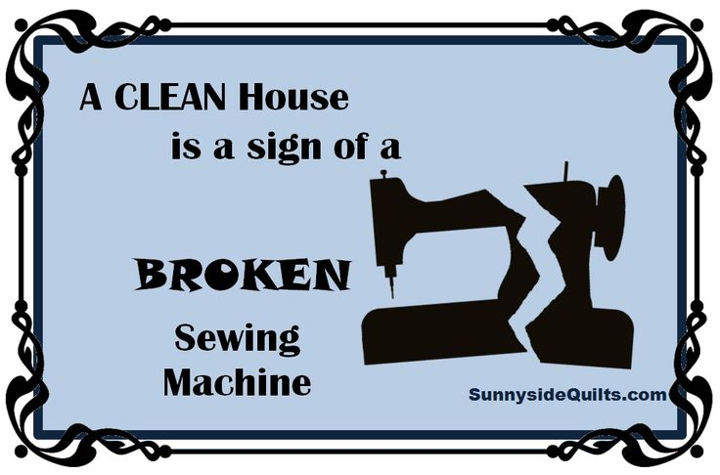
We’re excited to pilot a machine service pickup program with your guild. A representative from Quilting Legacies will attend the meetings every other month to collect machines needing service and transport them to our Fond du Lac location. Once service is complete, machines can either be picked up at the store or returned at our next visit. To start, we will pick up machines in February, April, June, August, October, and December. If there is strong interest, we will definitely increase our visits! There are no additional fees for this transportation; regular machine service fees apply.
We’re looking forward to testing this program with your guild and I’m excited to be presenting in February! ~Warmly, Amanda

Art Quilt Workshop - April 11, 2026
From Barbara, our Impressionist Art Quilt Workshop teacher:
“Here is my most recent blog on an impressionist art quilt wall hanging (smaller than the ones we will be making) that the April students might find useful. Feel free to share.”
wyvernstrove.wordpress.com/2026/01/25/heart-and-flowers-wall-hanging/
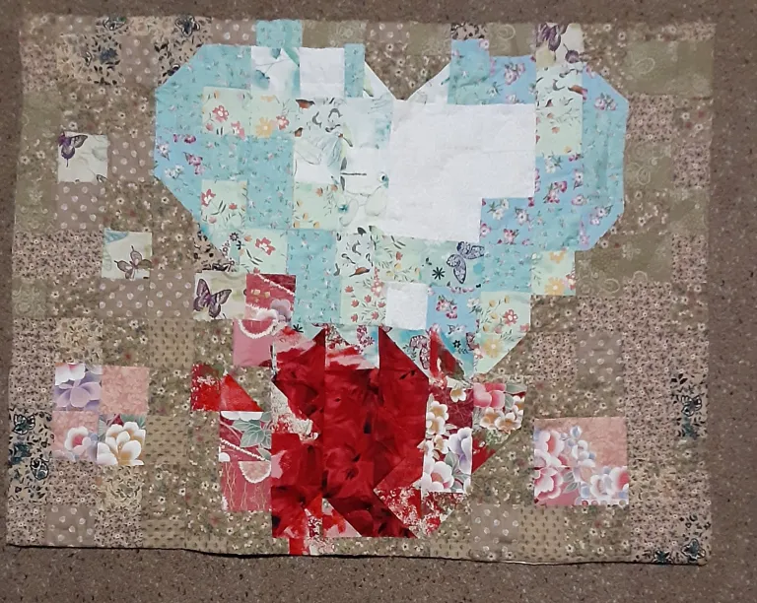
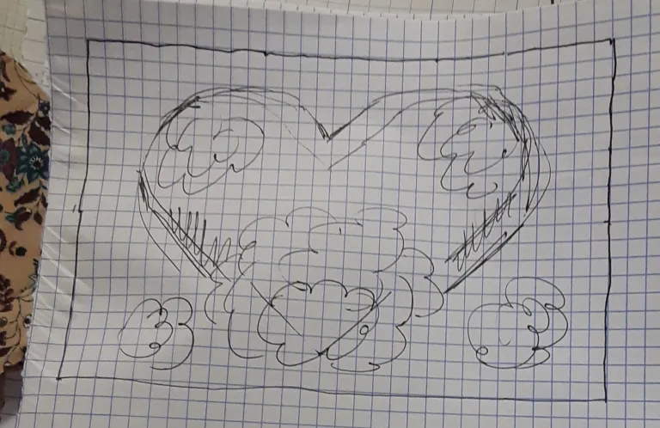

~ January 8, 2026 Guild Meeting Minutes ~
- Welcome & Pledge
- Old Business
  - Thank you again to the Christmas Committee!
  - Membership Booklets are available for $1
  - Charity Committee (Annette C, Sue Dupont)
    - Quilts were given to the Salvation Army. They were very much appreciated and the timing was perfect. The quilts were delivered on a distribution day and went fast!
  - Counted Cross-stitch Workshop
    - Jan. 31, Thank you to Mary Ellen
  - Mystery Quilt
    - Final step revealed in the January Newsletter
- New Business
  - February’s Program: The Mental Health Benefits of Sewing and Quilting
  - Quilt Show 2027
    - Dates are April 3 & 4, 2027
    - Theme: A Stitch in Time
    - Show Chairwomen needed…update Jan 22 - a HUGE thank you to Julie K, Kathy G, and Jeanette W, our 2027 Quilt Show Chairwomen!
    - Have ideas for the raffle quilt? Contact Ellen Lewellen
  - The Guild is in need of a historian.

- Social time and Snacks! Yum yum
- Presentation by Nan Groll: Threads and Needles
  - An absolutely fabulous presentation. Thank you Nan for all the detailed information.
  - (information shared in the newsletter…as best as I [Naomi] am able)
- Show & Tell
  - Lovely stories shared about some very special quilts
  - Tip: Used christmas cards make great template pieces
- Motion to Adjourn 1st Tina Waack, 2nd Mary Kay Burish, motion carried

Thread, Needles - Presented by Nan Groll
(an attempt by Naomi to briefly highlight the vast knowledge shared at the guild.)
Superior Threads: good quality, reasonable pricing. www.superiorthreads.com
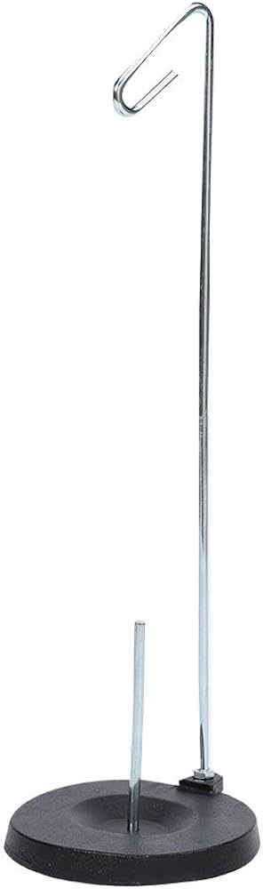
Specialty Threads tips and info
Metallic - Tip: place spool on thread stand and move stand further away from your machine. This allows the thread to “relax.”
Glow in the Dark - Thread is a little heavier, so go slow in heavy stitching. Good for topstitching and decorative stitching.
Variegated Thread - check the color change length. Some change every inch, some have longer color changes.
Fusible Thread - use as temporary applique stitching
Vanishing Thread - good for embroidery
Other Thread Info
- Store your thread away from sunlight as this fades and weakens it.
- Got or found a spool of old thread (i.e. at a thrift store)?
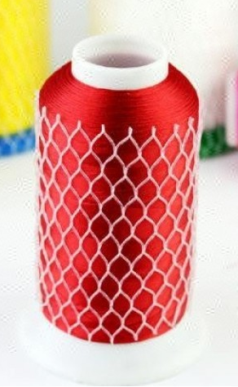
  - Test out its strength. With a length of thread wound onto your index fingers, give the thread between them a gentle tug. It should not break. If it does, toss it.
  - Hold the thread up to the light. Is the thread fuzzy? Big no no. This will leave lots of lint in your machine.
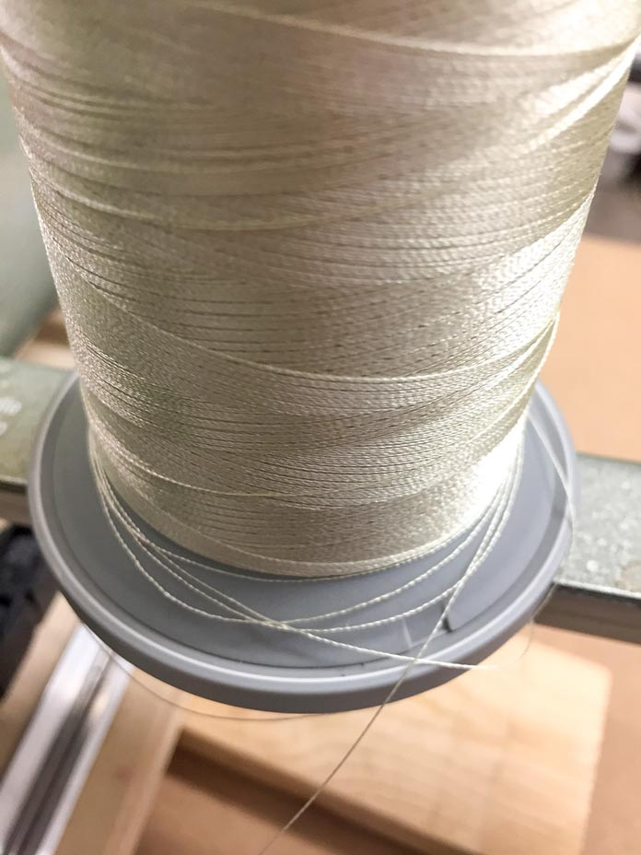
- Use a Thread Net to keep your thread from “pooling” at the bottom of your spool.
POOLING THREAD .

- When changing thread, DON’T pull thread out the top. Cut thread nearer the spool, then pull thread gently out through the needle.
- Always thread your machine with the needle all the way up.
Bobbins
- Use the correct and best quality bobbin for your machine.
  - Check the instruction booklet for your machine, or go to their website.
- Pre-wound bobbins (from a quilt shop)
  - They are a better quality thread than they used to be.
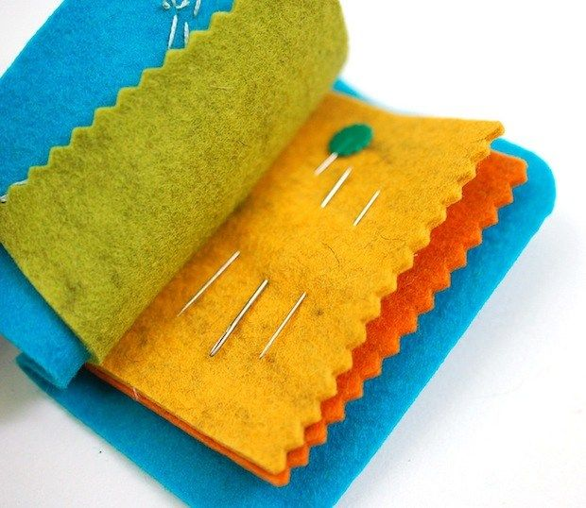
  - The bobbins themselves are a cheaper quality, so do not re-wind the bobbin with new thread.
Needles (more info on following pages)
- Use the proper needle for the job.
  - Ballpoint, Quilting, Sharp, Denim, Topstitching, Embroidery, etc
- Needles have a work life of 8 hours. A dull/dulling needle is a recipe for disaster.
- Dispose of needles safely. Use an old pill container and label it “Sharps.”
- Needle storage: felt needle “book”; use marker on felt to label needles
- Machines can have their favorite needles.
Let your sewing machine repair person know of any particulars of your machine.
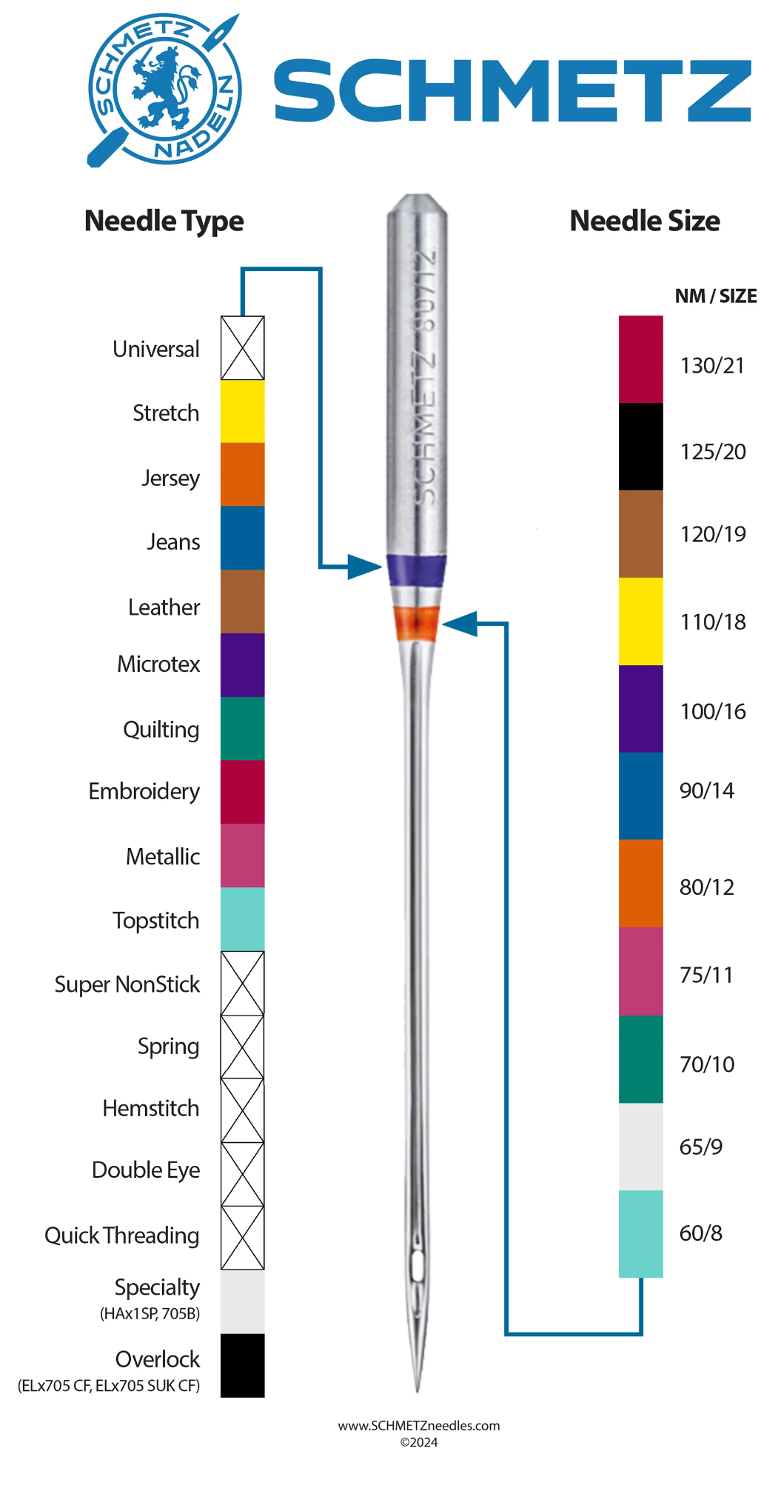
Making your own “Needle Minder Booklet”
is pretty straight forward. At its most basic,
you layer 2-4 rectangular pieces of felt
horizontally then sews vertically down the
center to create a booklet.

A quick google search reveals all sorts of
ways to make your book unique.
- Use patterned felt for the cover
- Embellish with simple felt shapes
- Add a button or loop closure
- Add humor to the front by stitching:
  - Feeling Stabby
  - Stay Sharp
  - Looking Sharp
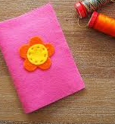
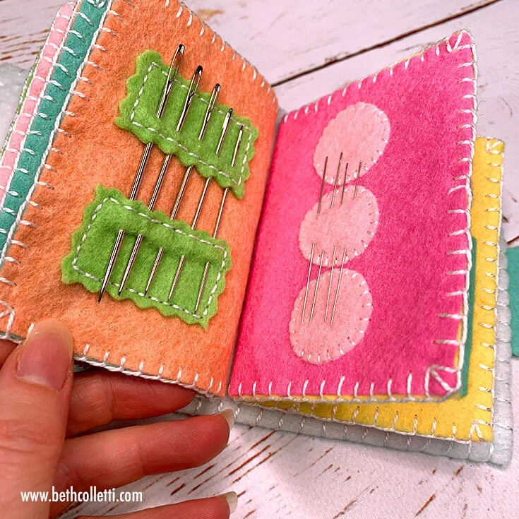

(left)sewasoftie.com/2021/09/easy-to-sew-needle-book-for-kids
(right) www.bethcolletti.com/blog/needle-book-tutorial

What needle do I use for my project?
Fabric weight | Fabrics (not exhaustive) | Needle size
Delicate or very light weight fabrics | lace, organza, thin silk | 8 or 9
Lightweight fabrics | taffeta, lining, voile, silk chiffon, shirting | 9, 10 or 11
Medium weight fabrics | Cotton, knits, muslin, stretch fabrics, flannel, spandex, | 12 or 14
Heavy weight fabrics | Suiting, Tweed, fleece, denim, leather, vinyl, upholstery fabric | 14 or 16
Very heavy weight fabrics | Heavy canvas, thick leather, ticking, thick denim seams | 16 or 18

Program for the March Guild Meeting
Samantha Tamayo, the current Lieutenant of our local Manitowoc Salvation Army office will be the guest speaker at our Thursday, March 12th Meeting. We are asking that Quilt Guild Members bring donations to the meeting for us to give to her after her presentation.

Any of the following new items are greatly appreciated :
- Non-Perishable Food Items
- Body Care Items
  - Men, Women, and Children including Diapers and Wipes

Also accepts:
- Gently Used Small Household Items, Toys, or Clothing (All Sizes)
- Any Homemade Items
  - Such As Pillowcases, Blankets, Quilts, Hats, Scarves, Mittens

*Monetary Donations Are Also Appreciated

Quilt Show Corner
Would you look at that! It’s Quilt O’Clock!
Believe it or not, planning as begun for our
2027 Quilt Show: A Stitch in Time

Each month’s newsletter will contain this “Quilt Show Corner” section that will have lots of valuable information about our upcoming show and the various tasks involved in making it a success.
Some of this information will also be posted on the website (in the next few weeks). This will be a good reference point for information about: committees, potential project days, how to register your quilt, how to put a hanging sleeve on the back of your quilt, etc. All the important information about the show in one convenient location.
General Quilt Show Overview

2027 Quilt Show
- Show dates: April 3 & 4, 2027
- Location: Manitowoc County Expo
- Theme: A Stitch in Time
- Quilt Show Chairwomen: Julie K, Kathy G, Jeanette W

General Schedule:
- Thursday & Friday before the Show:
  - Setting up for the show.
    - Assembling the posts with their bases.
    - Setting up the posts and cross poles that will display the quilts
      - Hanging black curtains
    - Marking out locations for the vendors
    - Receiving Quilts
    - Hanging Quilts and attaching appropriate labels
    - Assist Vendors as needed
- Saturday & Sunday of the Show:
  - Work various assigned jobs at the show
    - ie Charity Booth, Kitchen, admissions
  - At end of show:
    - Help vendors as needed.
      - Nothing comes down until all the vendors have left the building. This is for everyone’s safety.
    - Set up tables for sorting quilts and folding black curtains
    - Take down quilts, black curtains, poles and supports.
    - Gift Boutique taken down
    - Once EVERYTHING is down, then quilts can be released. No exceptions.
    - Tear down typically takes about 3 hours.

Committees
Below is information about the various Quilt Show Committees. If the info is in italics, it was written from MY understanding of the committee and may contain errors or have very limited content. ♥️ (Naomi)

Quilt Show Committees:
- Appraiser/Judging
  - We have a nationally certified judge hired to judge any quilts our members want to be judged. Ribbons will be awarded as determined by the judge.
  - We also have a nationally certified appraiser hired to be at the show for our guild members & the public. Guild members do need to make an appointment. The cost is $55.00. You will receive a legal printed appraisal. Walk ins from the public will be worked into the schedule as they arrive.
- Badges/Ribbons/Voting
  - Gets the award ribbons for the winning quilts.
- Food - Thursday and Friday
  - Plans the food for guild members during set-up.
- Food - Saturday and Sunday
  - This committee plans the food that will be sold on Saturday and Sunday of the show. Any food that can be prepared ahead of time is done so. Meats need to be cooked in an approved kitchen. We have been fortunate in the past to be able to use Grace Congregational Church in Two Rivers. Shopping for non-perishable items is done ahead of time. Members of the guild are asked to donate non-refrigerated desserts to be sold on show days. Committee members help set up the kitchen before the show.
- Gift Boutique
  - The Gift Boutique is for those members wanting to sell their wonderful creations during the quilt show.
  - The boutique committee provides info to members about selling their items (price tag size, inventory list, etc).
  - The committee is responsible for the set up, method of receiving funds, creating a schedule for volunteers, and tearing down the boutique.
- Guild Challenge
  - This committee is responsible for coming up with a challenge quilt idea for the upcoming show. The committee determines the parameters for the challenge, provides any required challenge items to be incorporated into the quilt (for example a past show challenge provided yarn), makes ribbons for judging and finds a judge.
- History
  - Shows our guild’s history, with some emphasis on our charitable donations, and also honors our past guild members who have passed away.

Committees continued
- Kids Corner
  - We create a fun and interactive area for the kids. They are able to play with “quilt block design” using felt pieces, and are given an “i-spy” checklist (available at the entry table) to keep them engaged in looking at the quilts with their parents/grandparents. For completing their checklist, they get a cookie/treat from the Kids Corner table.
- Props
  - Using the quilt show theme, we come up with props and decor to be placed around the exhibit hall. We typically work on constructing / prepping some items at one of the guild meetings, and may need a helper or two for a short time during setup.
- Publicity
  - Promotes the Quilt Show via various methods.
    - Newspaper, Radio, Channel 5, flyers, facebook.
- Raffle Quilt Tickets
  - Obtains the proper permits to hold a raffle, and gets the tickets for said raffle. Members each receive an envelope of tickets, and photo of the quilt, to sell to their friends/family/coworkers/etc.
- Registration of Quilts
  - Providing forms for the registration of show quilts.
  - Creates a system for checking in and out the quilts at the show.
- Set-up and Hauling
  - Hauling of quilt show items from storage
  - Every member is expected to assist as they are physically able to.
  - Helpers (guild members and able bodied family members)
    - put together the wooden stands. This can be done sitting or standing; bring labeled tools (hammer, pliers/screw drivers) to assist with assembly.
    - Set up tables, carry quilts to specific tables, someone to sit and direct runners/walkers to carry quilts to/from tables to bays for hanging.
    - People to carry poles and stands to specified areas for set up.
    - People to set up wooden stands and poles.
    - People to direct helpers which can be someone who needs to sit or limited standing/walking.
    - People physically able to climb ladders to hang quilts on poles runners.
- Signage
  - This committee will be responsible for signs around the show such as Admission prices, Charity booth information, Do not touch/no food among the quilts, Featured quilter, etc.

Committees continued

- Take Down
  - At end of show after vendors have left. Some vendors allow us to assist carrying/moving their supplies. We will ask which vendors would like assistance and let quilt show helpers know which venders.
  - Every member is expected to assist as they are physically able to.
  - If you have any family members to also help such as husband to take apart the wooden stands and tools such as hammer, pliers/screw drivers whether manual or cordless. Be sure to put your name on tools you bring so yours is returned to the correct person.
  - Helpers (guild members and able bodied family members)
    - take down up tables, carry quilts to specific tables, someone to sit and direct runners/walkers to carry quilts to/from tables.
    - People to carry poles and stands to specified areas after take down.
    - People to dismantle after quilts and curtains have been removed from wooden stands and poles.
    - People physically able to climb ladders to remove quilts and curtains from poles and hand to runners.
- Vendors
  - This committee contacts past vendors and potential new vendors to have booths at the show.
  - Forms and payments are collected
  - Also checks in with vendors during set up, show and take down.
- Work Schedule
  - Generates a “work schedule” for the quilt show weekend. Schedules members to help in various areas around the exhibit hall. (every member is expected to sign up for a few time slots).
- Quilt Descriptions
  - Types up and formats the quilt descriptions from the quilt registration forms.
- Quilt Layout
  - Creates a layout for the registered quilts based on size. This layout is in regards to where quilts are going to hang, and not
- Quilt Walk
  - Works to get promotional material to various local businesses. Usually asks if the business would like to display a quilt along with the flyer and hand outs.
    - Creates a way to track whose quilt is in what shop
    - Establishes a pick up date with the business

