
NEWSLETTER
Volume 22 Issue 03 March 2026

Guild Meeting:  March 12th, 6pm  ~At Ascend Services  2818 Meadow Lane, MTWC | Upcoming:  March 14 & 15 =pg 3  ~National Quilting Sew Days  April 11  ~Impressionist Art Quilt Workshop  April 24-26 =pg 5  ~Camp Quilt
Quilting Legacies Machine Repair drop-off and pick up months:
February, April, June, August, October, December

From the President’s Desk - Ellen Lewellen
A recent New York Times article wrote about the “Present Me”; doing tasks today which will benefit the “Future Me”. Think about saving for retirement or exercising. What quilting steps do you do for your future self? Finish all those tedious HSTs first so you can go on to the next step? Tidy up your space after finishing a project? Sorting your scraps into some system, or (gasp!) turning your scraps into precuts? Maybe you’re saving all the fabric you can find in a
certain color for a future as yet undefined project.
The article also talked about “Present Me” taking count of what “Past Me” did which allowed you to reap benefits today. In quilting terms, what is more satisfying than looking at the completed quilt on the wall, table, or bed? How about seeing your completed quilt hanging in the next quilt show?
As we begin to gear up for our quilt show a year from now, I hope your “to do” list includes making/finishing all kinds of quilts. Without them, there wouldn’t be much of a show. Please know that we need a variety. Not every quilt is going to get a ribbon, but we cherish everything our members have made. So, make some time TODAY and get quilting!
President - Ellen Lewellen

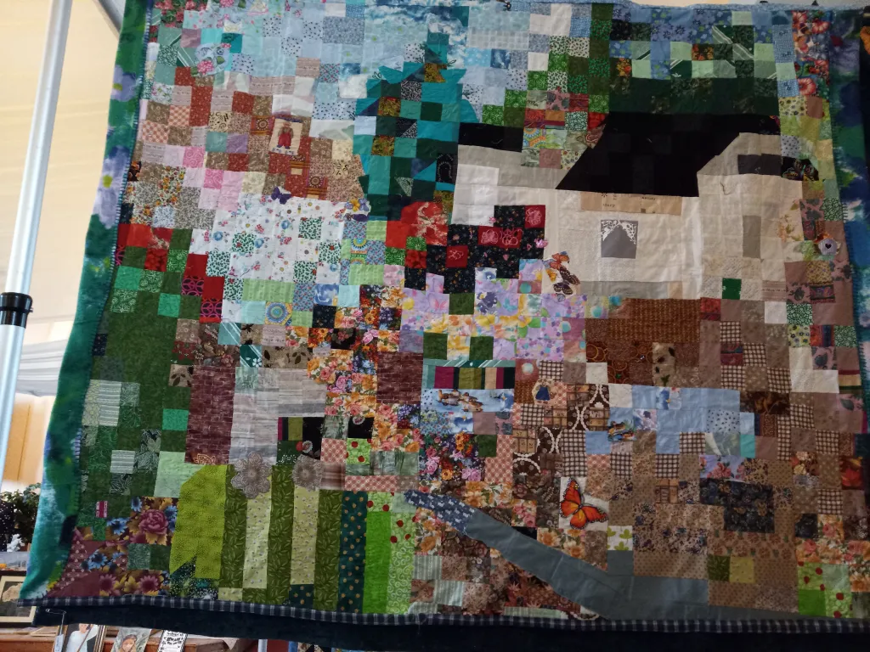

Art Quilt Workshop
April 11, 2026
Reminder: continue collecting novelty fabric scraps for personal use and for sharing. Think nature / landscape / floral etc.

~ Feb 12, 2026 Guild Meeting Minutes ~
- Welcome & Pledge
- Presenter: Amanda from Quilting Legacies
  - Store: 1325 S. Main Street, Fond du Lac, WI 54935
  - quiltinglegacies.com
  - The Therapeutic Benefits of Crafting
    - Creativity is intelligence having fun. -Albert Einstein
    - Sense of Accomplishment
    - Builds Community
  - Quilting Legacies services : Husqvarna, Necchi, Pfaff, Singer +
  - Retreats, Events, Classes
  - Providing a “Shuttle Service” for your machines!
    - Machine pick up and return to guild meeting
    - No extra charge, just the cost of the cleaning
- Old Business
  - Chairwomen for the quilt show
    - Julie K, Kathy G, Jeanette W
  - Jan. 2026 Minutes motion to accept: Bonnie Loeh, 2nd: Chris Bauknect
  - Treasurers report motion: Jeanette Weisner 2nd: Bonnie Loeh
- New Business
  - Forms to sign up for the quilt show available
    - Committees that especially need to start soon:
      - Raffle Quilt
      - Publicity
- Social Time & Show and Tell
- Motion to Adjourn: Sue Marquardt second: Terri Waack
National Quilting Day {weekend} - March 14 & 15
Our sew day to celebrate National Quilting Day on Saturday, March 14th, has grown into a weekend of sewing! Sew Days available March 14 & 15. You can come for one day or both.
Cost is $10 per person per day. Lunch is on your own.

Ann Zeman will do a demo of the Point of View Folded Star Table Topper (details below) that she brought for Show and Tell at our February meeting.
“Point of View” Folded Star Table Topper Demonstration - 17 inch finished diameter

Supplies needed:
- The Center showcase panel: To be completed first. (Your showcase panel, the center of table topper, can be embroidered, cross-stitch, or appliqué and make it the focus!)
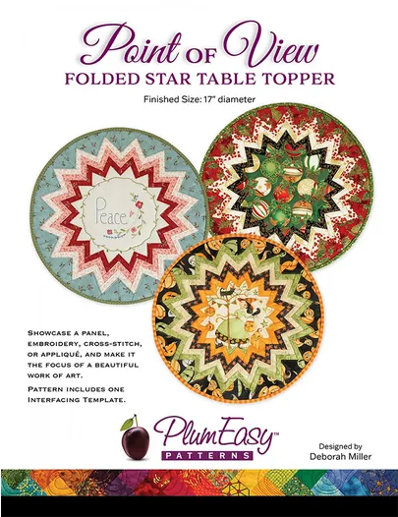
- Center Options are:
    - for a finished 9 1/2 inch - 11 inches in diameter, requires 5 fabrics (⅓ yard each) for Prairie points.
    - for a finished 11 inch - 12 inches in diameter, requires 4 fabrics for Prairie points 1/3 yard each of 4 or 5 fabrics for prairie points
- 19” x 19” for backing 2/3 yard of batting (45”wide)
- Binding - FQ or 1/2 yard fabric - or matching binding 1/6 yard
- Point of View Interfacing Template, can be purchased online, or 1 is included in the pattern which is also sold online
- Water soluble glue
- Thread - will also be used in topstitching
- Scissors & rotary cutter

Program for the March Guild Meeting

Samantha Tamayo, the current Lieutenant of our local Manitowoc Salvation Army office will be the guest speaker at our Thursday, March 12th Meeting. We are asking that Quilt Guild Members bring donations to the meeting for us to give to her after her presentation.

Any of the following new items are greatly appreciated :
- Non-Perishable Food Items
- Body Care Items for Men, Women, and Children including Diapers and Wipes

Also accepts:
- Gently Used Small Household Items, Toys, or Clothing (All Sizes)
- Any Homemade Items
  - Such As Pillowcases, Blankets, Quilts, Hats, Scarves, Mittens

*Monetary Donations Are Also Appreciated
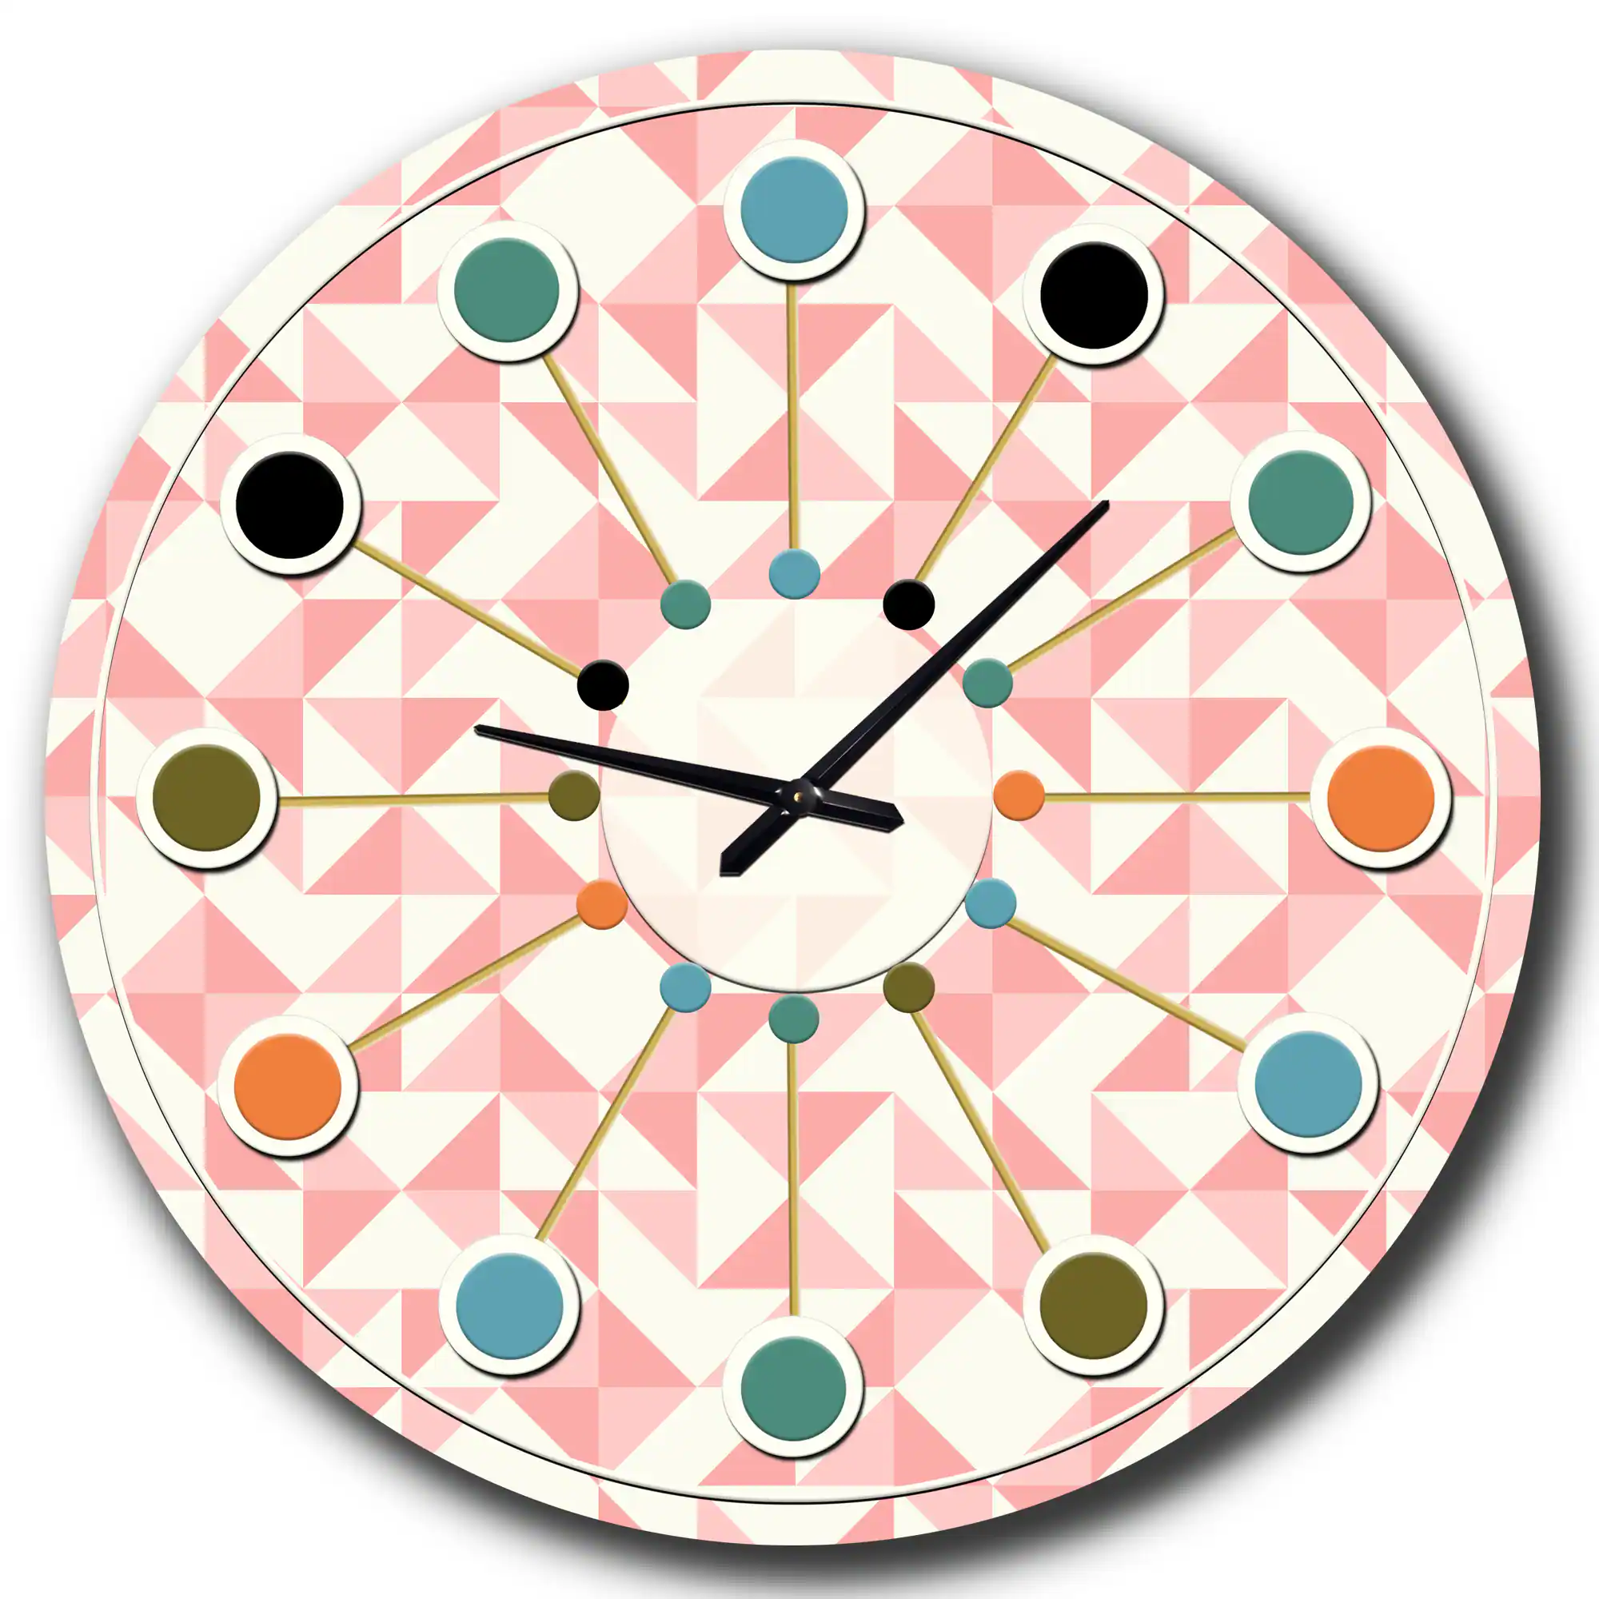

Quilt Show Corner
Would you look at that! It’s Quilt O’Clock!
Believe it or not, planning has begun for our
2027 Quilt Show: A Stitch in Time

Nothing new to report as of printing. Thank you to all who signed up for the various committees.

2027 Quilt Show
- Show dates: April 3 & 4, 2027
- Location: Manitowoc County Expo
- Theme: A Stitch in Time
- Quilt Show Chairwomen: Julie K, Kathy G, Jeanette W

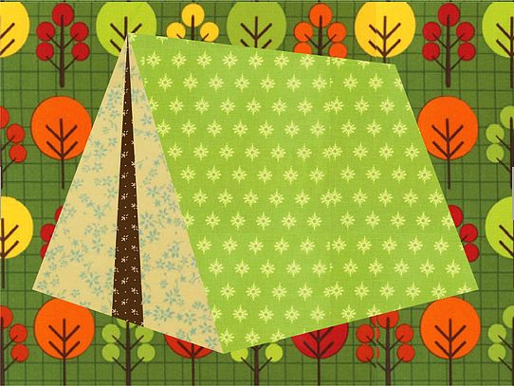
QUILT CAMP REGISTRATION
April 24-26, 2026
NAME: ____________________________________________________
ADDRESS: __________________________________________________
PHONE: ____________________________________________________

MEALS: CHECK WHICH YOU WILL BE PRESENT FOR
______ ALL MEALS ______ FRIDAY SUPPER
______ SATURDAY BRUNCH ______ SATURDAY SUPPER
______ SUNDAY BRUNCH

ARE YOU A COFFEE DRINKER? ______YES ______NO
IF YES, HOW MANY CUPS A DAY _____, REGULAR _____, DECAF _____

CAMP PAYMENT: MAKE CHECKS PAYABLE TO PLQ-QUILT CAMP
$65 MEMBERS $85 NON-MEMBERS
MAIL TO: JULIE KLUMPP, 2123 PRIMROSE LANE, MANITOWOC, WI 54220
QUESTIONS: JULIE KLUMPP, 920-860-0485 OR JAKLUMPP@TM.NET

