

NEWSLETTER

Volume 21 Issue 09 October 2025

Guild Meeting:  Oct. 9th, 6pm  ~At Ascend Services  2818 Meadow Lane, MTWC | See page 2 for suggested  Items to bring Oct. 9th  for Grow It Forward’s  “After School  Backpack Program”
Mystery Quilt - Page 5
Shared with the Guild - Page 6-7

From the President’s Desk - Ellen Lewellen

As October breezes in, it seems that pumpkins, bats, black cats and skeletons are popping up everywhere, and the quilting world is no exception. Are you a person who likes to put up Halloween decorations including a few quilted things, or do you prefer to skip that all together and go for a fall harvest theme? I admit I’ve made a black cat and pumpkin door hanging for our front door, but inside I have a basket of wooden apples and plastic grapes with an artificial autumn leaf arrangement on the mantel and a fall leaves quilted throw on the couch. I’m sure some of you organized quilters are already busily stitching holiday gifts as well. And if you are someone who is just trying to stay ahead of the dirty dishes and laundry — forget about decorations and lovely quilting time — there’s no judgement here! The fun and beauty of the guild is that we support one another and inspire each others’ quilting efforts in whatever form or amount that is.
Speaking of supporting each other and having fun, if you missed Camp Quilt in September, I hope you can plan to come for one in the future. At the October meeting, we will have a speaker from Grow It Forward, a nonprofit agency here in Manitowoc which finds creative ways to help local families who experience food insecurity. We should also have the new booklets ready with member, committee and hostess information. Of course we always enjoy sharing Show & Tell with each other. The Board is meeting Sept. 30, so we hope to have a budget to present to the membership as well.
My hope for you is that the beautiful autumn we usually have here on the lakeshore will inspire you to quilt in whatever way brings you joy….maybe with a pumpkin spiced treat or drink? Cheers!
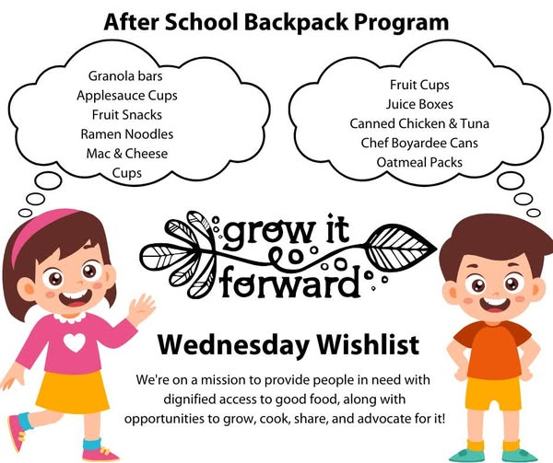

Grow It Forward is our program speaker for Oct. Vice President Lori mentioned bringing donations to the Oct. meeting to give to Grow It Forward for one of their programs.
Support kids
in our
Community
Their “After School Backpack Program” is available for food insecure children in participating Manitowoc County schools. This program provides dignified access to good food through the weekend so no child goes hungry.
Suggestions include:
●Granola Bars ●Applesauce Cups ●Fruit Snacks ●Ramen Noodles
●Fruit Cups ●Mac&Cheese Cups ●Juice Boxes ●Oatmeal Packets
●Canned Chicken & Tuna ●Chef Boyardee Cans

~ September Guild Meeting Minutes ~
- Welcome
  - Meeting called to order at 6:00pm, and started with the Pledge of Allegiance.
  - We have a tip jar for ideas for the guild.
- Business Meeting
  - Wrap up on County Fair Quilt
    - Ellen Buck said “Thank you” to everyone that sold tickets during the fair and to those that made blocks for the guilt.
    - 500 tickets were sold and the profit for the guild was $379
    - The winner of the quilt was Barb Ebert
    - The theme of blocks submitted for next years quilt was “Rock ‘N Roll at the County Fair”
      - Contest was open to all ages. There were 11 participants .
        - Some of the ages of the entrants were 9, 11, 13, and 15.
    - Viewers Choice for blocks entered:
      - 3rd Barb Paulson, 2nd Ann Zeman, 1st Ellen Buck
  - Woman’s Day Event
    - Karol Harcus won the grand prize of a new recliner
~ September Guild Meeting Minutes Continued ~
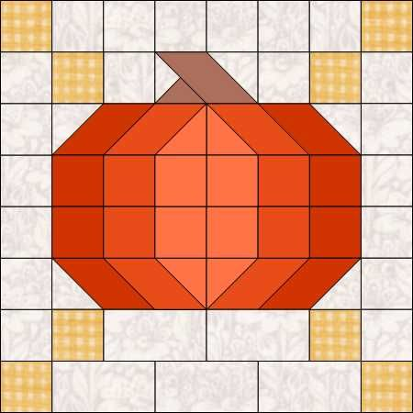
  - August Picnic
    - It was held at Woodland Dunes and was a lot of fun and making the mandalas
  - Hope all had fun at the Quilt Show in Madison. Those who took the bus said it was a lot of fun.
  - Camp Quilt
    - Sept. 19-21
    - $65 members, $85 non-members
    - Optional Breakfast at Two Rivers Family Restaurant on Friday morning.
    - Soup and salad dinner Friday night
    - Brunch provided Sat morning and supper Sat night
    - Brunch on Sunday morning
    - There is a voluntary gift exchange.
      - $10 wrapped gift.
    - There will be a make and take project for those who want to participate.
  - Mystery Quilt
    - Check old newsletters for patterns
  - No questions on the Secretary Report.
    - Motion to accept secretary report by Bonnie Loeh
    - Second by Tina Waack. Motion passed
  - Treasurer’s Report was accepted
  - Membership books are not ready yet. They should be ready by next month.
  - Those who signed up for committees got together and discussed budgets. Mary Ellen Beebe handed out information on last year’s budget for each committee.
  - The Board will meet, before the next meeting, to discuss the budget.
  - The only money coming in for the quilt guild is the Quilt Show and money from the Fair Quilt.
  - Positions not filled are Historian, August Picnic and Field Trip.
  - If anyone needs a name tag, see Gretchen Scheidt
- Speaker
  - Our Speaker was Ashleigh Brooks from The Sewing Machine Shop in Sheboygan Falls.
    - She spoke about Project Linus.
    - The shop is a drop off place for quilts. They sew the labels on and distribute to places in Sheboygan County.
    - There have been over 10 million quilts over all of the USA given out.
    - Quilts are for kids. Popular size is 36”x36”, but will accept any size.
    - Cotton and fleece fabrics are welcome, but not wool due to allergies.
~ September Guild Meeting Minutes Continued ~
- Next Month’s Speaker
  - Grow It Forward
  - They help people with food needs in Manitowoc County.

  - Lori brought in some of the food that is supplied to children’s backpacks. If you want, bring some donations to the October Meeting.
    - Snack bars - Granola
    - Fruit / applesauce cups
    - Ramen Noodles, mac and cheese in a cup
    - Instant oatmeal
    - Cans of soup
- Show and Tell
- Prize winner for drawing - Bonnie Loeh
- Cindy Dillman made motion to end the meeting.
  - Gretchen Scheidt second
Respectfully submitted - Kay Olker

QUILT TIL YOU
WILT

? ? ? 2024-2025 Mystery Quilt ? ? ?

~ Pattern on page 6 ~ quantity: make 1 block ~
Join the Mystery Quilt anytime. Past newsletters, starting with Sept. 2024, contain all the blocks that have previously been revealed.
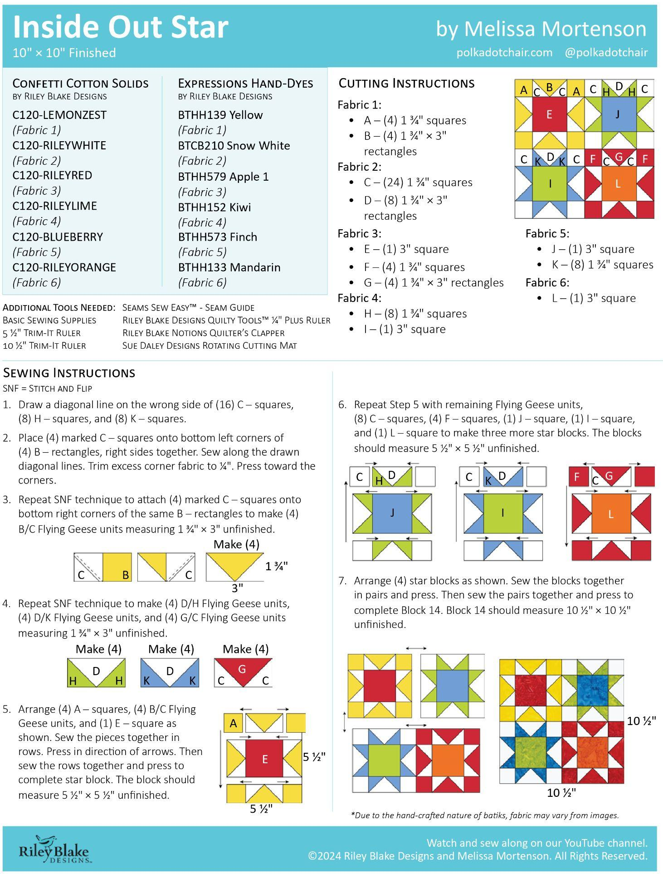

Shared with the Guild

Quilt College ~ Wausau
Quilt College is the annual (and only) fundraiser supporting the Pine Tree Quilters Guild (located in Wausau WI).
Classes included: Blackwork, Visible Mending (Boro), Crazy Patchwork, Dresden Plate, Wonky Neighbor (paper piecing), Collaged Mini Art Quilt.
More details about the classes and instructors are given on the NTC website. It is easy to sign up for Quilt College – follow the link below to get to the website:
https://www.ntc.edu/calendar/2025/10/11/quilt-college-2025
Sign up in person, via phone, or online. Full day of quilting fun: $90.
Join your friends and make new friends at Quilt College!
Date: Sat, Oct 11, 2025 Time: 8 am - 4:30 pm Location: NTC, Wausau WI

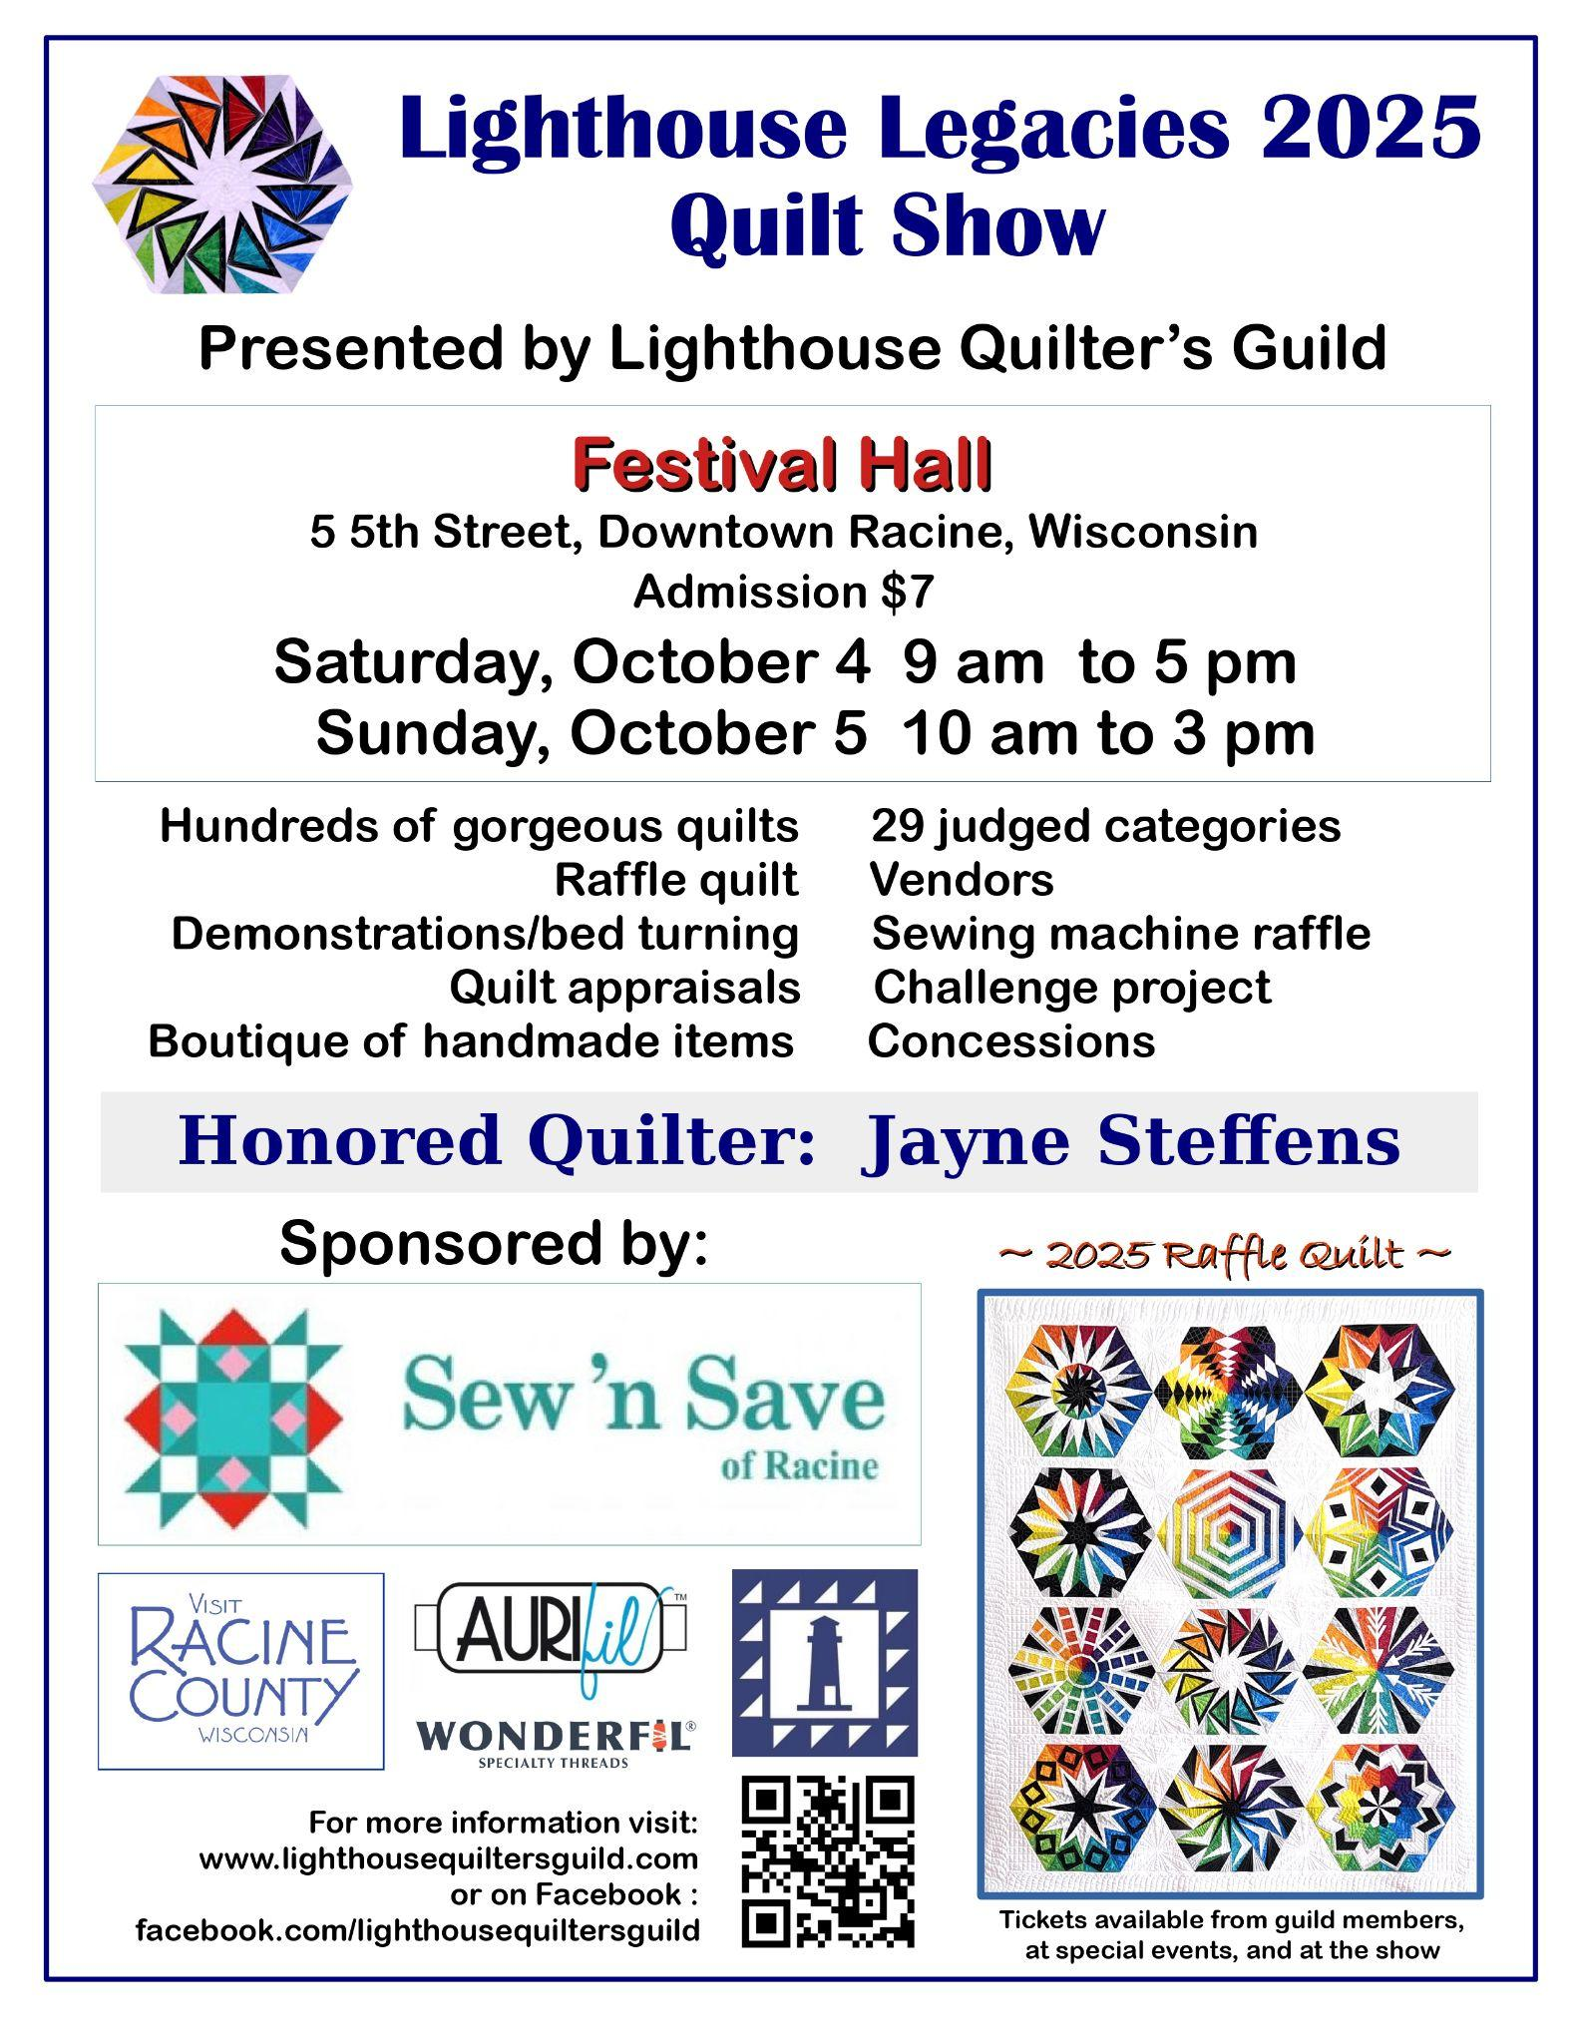
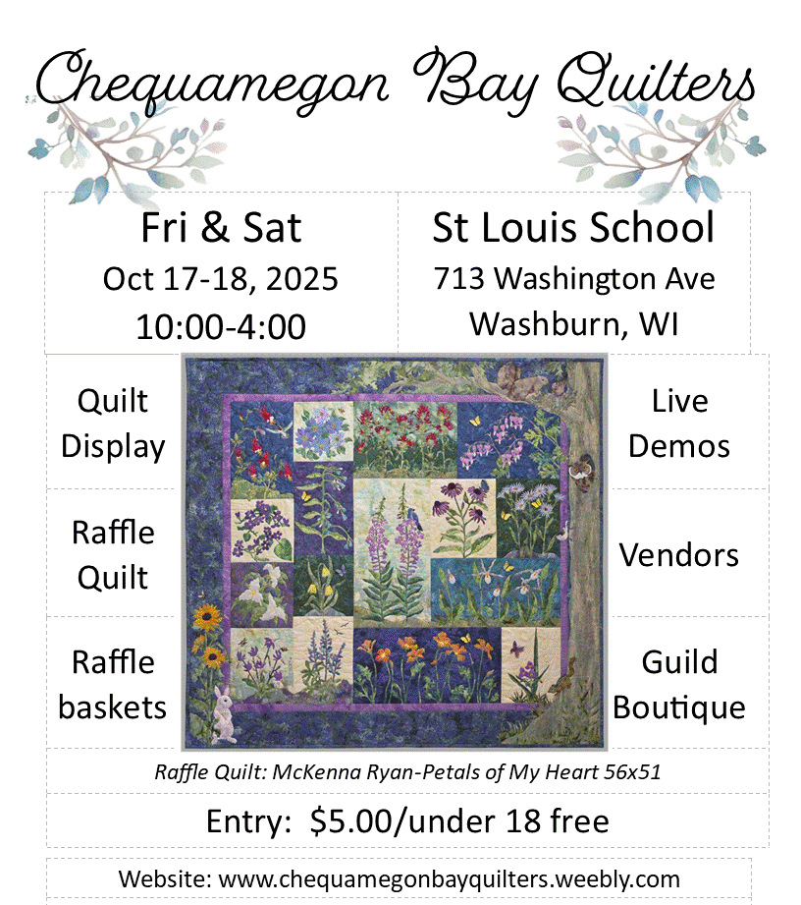

Impressionist Art Quilt Workshop
https://allevents.in/columbus/wt-quilt-show-and-sale-tickets/80001362745952
Oct. 30-Nov. 1 Wyverns Trove Museum, 254 W. Mill St., Columbus, WI
A few more details on the Impressionist Art Quilt Workshop: This workshop uses fairly basic piecing techniques, but is intended for experienced quilters. No basics will be taught. You will be expected to be familiar with strip sewing, 9- or 16 - patch assembly, and half square triangles. Nor is the class for quilters who only want a detailed pattern that they need to follow exactly, or who have never intentionally changed a quilt pattern. Everyone will receive a pattern, but the pattern is more like a guideline. It will be up to you to fill in details, with the guidance of the instructor, using design-as-you-go techniques to make a unique art quilt. The available kits each include their own pattern (a gridded drawing, mostly landscapes) and a unique selection of fabric strips and pieces.
Class - $15
Kit - $50 (roughly 5 yds of fabric for approximately 60x60 quilt)
In addition, specialty novelty and other prints will be available for use by students to incorporate into their designs.

You will need to bring your own sewing machine and cutting wheel. Most other supplies will be available on site. Meal plans can be discussed but many restaurants are in easy walking distance of the museum and the town hotel.

The instructor's time will be split between the museum and workshop, especially on Saturday. Sunday is not officially part of the workshop but the instructor will be available and the time can be used by participants if desired for cleanup, planning, and finishing if your quilt tops are not yet complete.
Space is limited! Register for the workshop by 16 October, especially if you dont want to buy a kit, so that we can provide guidance for selecting fabrics and time for precutting fabrics. You don't want to be spending half the workshop cutting before you can begin! Space available will be filled first come, first serve.
You can sign up online but we are not big on tech so you can also call/email to reserve a spot or ask a question. You can send a check in advance or pay on arrival.
Call or text 920 350 5618, email twyverns@gmail.com.
Mail to
Wyverns Trove Inc.
254 W Mill St.
Columbus WI 53925.
If you don't get a response (instructions, confirmation, request for information) within a day or two, please try again.
Thank you, Barbara Oelke

