
NEWSLETTER
Volume 22 Issue 09 October 2026

Guild Meeting:  ~Oct 8th, 6pm  At Ascend Services  2818 Meadow Lane, MTWC | Upcoming:  ~Charity Sew Day  Nov. 5th, 9am-5pm
Quilting Legacies Machine Repair drop-off and pick up months:
October, December
Contact Nan Groll if you are bringing a machine for pick up.
Quilt Show Corner - Pages 3-5
Mystery Quilt - Pages 5-7

From the President
I don’t know about you but I really am not a fan of horror films. Yet it seems the network and streaming channels are full of them, even starting in September. However, I find QUILTS featuring black cats, bats and spider webs to be fun and adorable. Maybe you are a person who celebrates October and Fall harvest with pumpkins, scarecrows and baskets of apples. Have you made a quilt, pillow, wall hanging or table runner October themed? If so, why not bring it to Show & Tell at our October meeting? Pick your favorite one, even if you made it a long time ago. I can’t wait to see it! Boo!

Quilt Show Charity Sew Day
Sat. Nov. 5th, 9am-5pm at
Grace Congregational Church of Christ ~ 2801 Garfield St. Two Rivers
More information and a sign up will be at the October Guild Meeting.
Contact Sue DuPont 920-242-7402
September 10, 2026 Minutes
- Welcome
- Program: scheduled presenter had to cancel.
  - Information was shared about non-profit organization: Sleep in Heavenly Peace (SHP)
    - From their website: Too many children go without a bed—sleeping on floors, couches, or sharing overcrowded spaces. It affects their sleep, health, schoolwork, and sense of security. Every community has kids sleeping on the floor. But YOU can change that.
    - SHP helps with this need by building beds and providing the mattress, bedding and pillows.
    - See the DePere or Appleton facebook page to see how you can help.
- Business
  - Motion to accept August ‘26 minutes
    - Kay Olker, second Tina Waack, motion accepted
  - County Fair Quilt
    - Over $550 was raised through the raffle tickets. This money goes to the guild.
    - 13 blocks were entered into this year’s contest.
  - AMVETS99 was selected as the charity to receive the proceeds from the quilt show
    - Their Mission: To enhance and safeguard the entitlements for all American Veterans who have served honorably and to improve the quality of life for them, their families, and the communities where they live through leadership, advocacy and services.
- Motion to Adjourn: Sue Marquardt, second Tina Waack, accepted
Submitted by Naomi Anderson

2027 Quilt Show Corner
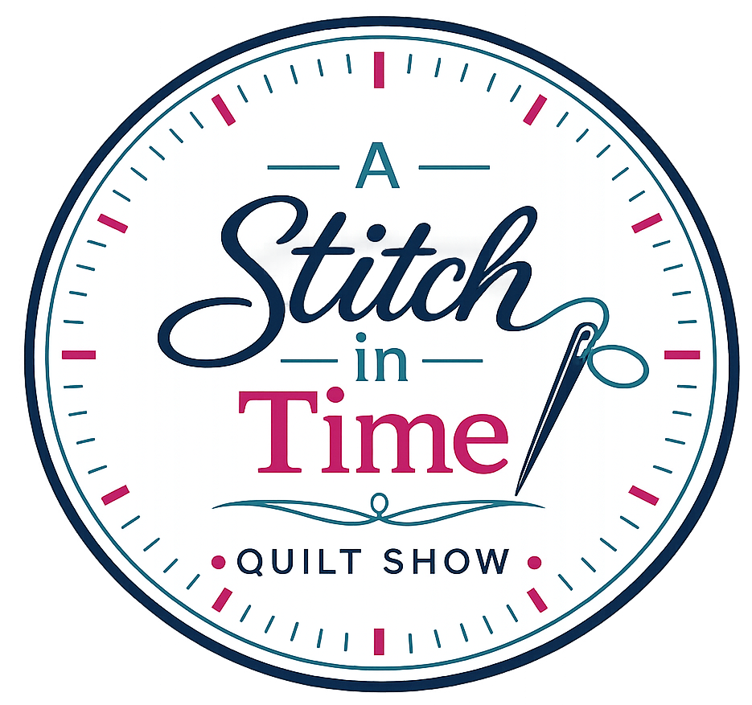
- Setup dates: April 1 & 2, 2027
  - Show dates: April 3 & 4, 2027
- Location: Manitowoc County Expo
  - Theme: A Stitch in Time
- Quilt Show Chairwomen:
Julie K, Kathy G, Jeanette W
  - Featured Quilter: Ellen Lewellen

Committee Meetings: Committee Chairs meet the second Monday of the month at 6pm at the Two Rivers Quilt Shop.
Got Quilt Show info to share with the guild?
Contact Naomi to get it in the newsletter: naomianderson428@gmail.com

2027 Quilt Show ~ GIFT BOUTIQUE
What’s the Gift Boutique? The Gift Boutique is an opportunity to sell your handiwork at the Quilt Show (items don’t have to be sewing related). The Boutique Committee (and helpers) beautifully display guild member’s wares and handle the sales.
More info from the Gift Boutique Committee:
- For those members, especially our newest members, wanting to sell their wonderful creations in the Gift Boutique, any homemade items made by you are welcome. Here's a chance to showcase your talents and earn a bit of money to support your “fabric habit”!
- Any member is limited to display at any one time, a maximum of 12 items in any one of your categories (ie ≧12 potholders, ≧12 dishtowels). As sales are made, your supply may be replenished. Any extra items may be stored underneath the tables and should be placed in boxes or plastic bins with your name on it.

GIFT BOUTIQUE ~ Continued
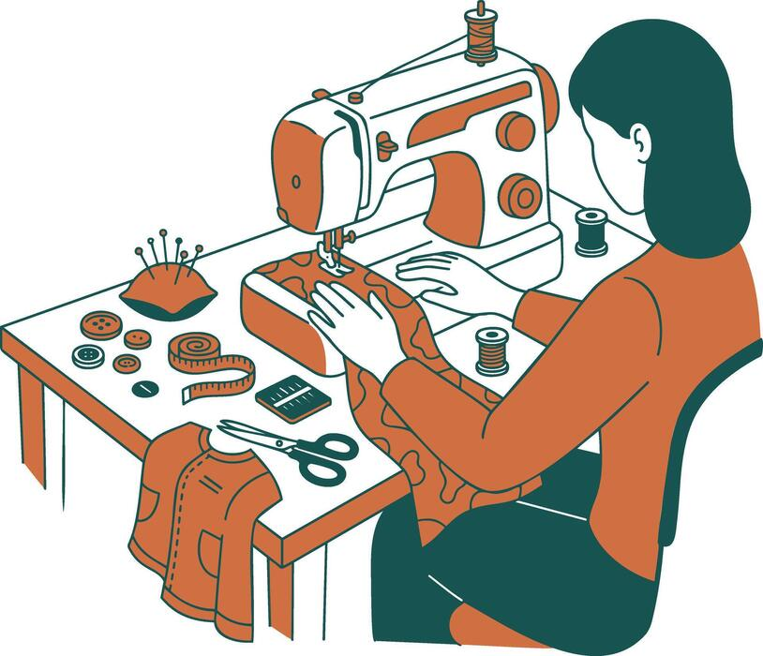
- If you can display your items in a container, i.e., basket, bowl, decorative box - please do so, and put your name on the bottom of the container.
- The Guild retains 10% of all sales.
- An inventory list and sample price tag will be published in a future newsletter. We will also have them at upcoming meetings. We want you to use this uniform inventory list, as it will be much easier to keep an accurate record of all the sales.
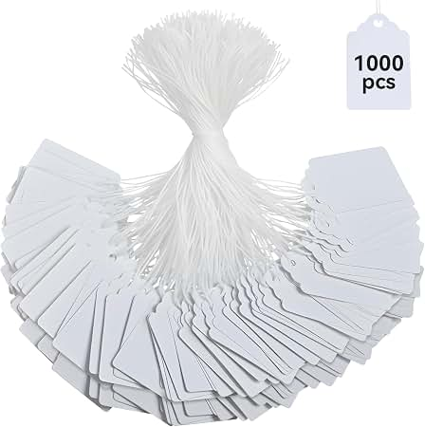
- As to price tags, Walmart has a box of 100 strung marking tags by Avery, 1 3/4” x 1 3/32”, No. 6732.
- Please number your items consecutively.
- Each and every item must have a price tag attached to it with a safety pin. Please set your pricing at full dollar or half dollar amounts for ease in making change.
- Anyone wishing to donate gently used gift bags can bring them to our meetings. We will donate the tissue paper.
- We meet three people on each shift. Two at the checkout and one to help the customers by walking around and keeping an eye out for anyone wanting an item and “forgetting” to pay for it.
- You, or the person dropping off your items, will be asked to sign a disclaimer. The drop-off days and times will be announced later.

If you have any questions, please contact us.
Mary Kay Burish Bonnie Loeh
mkburish@icloud.com bnloeh@gmail.com
920-682-7006 920-682-3259

2027 Quilt Show ~ PROPS

Hello from Props!

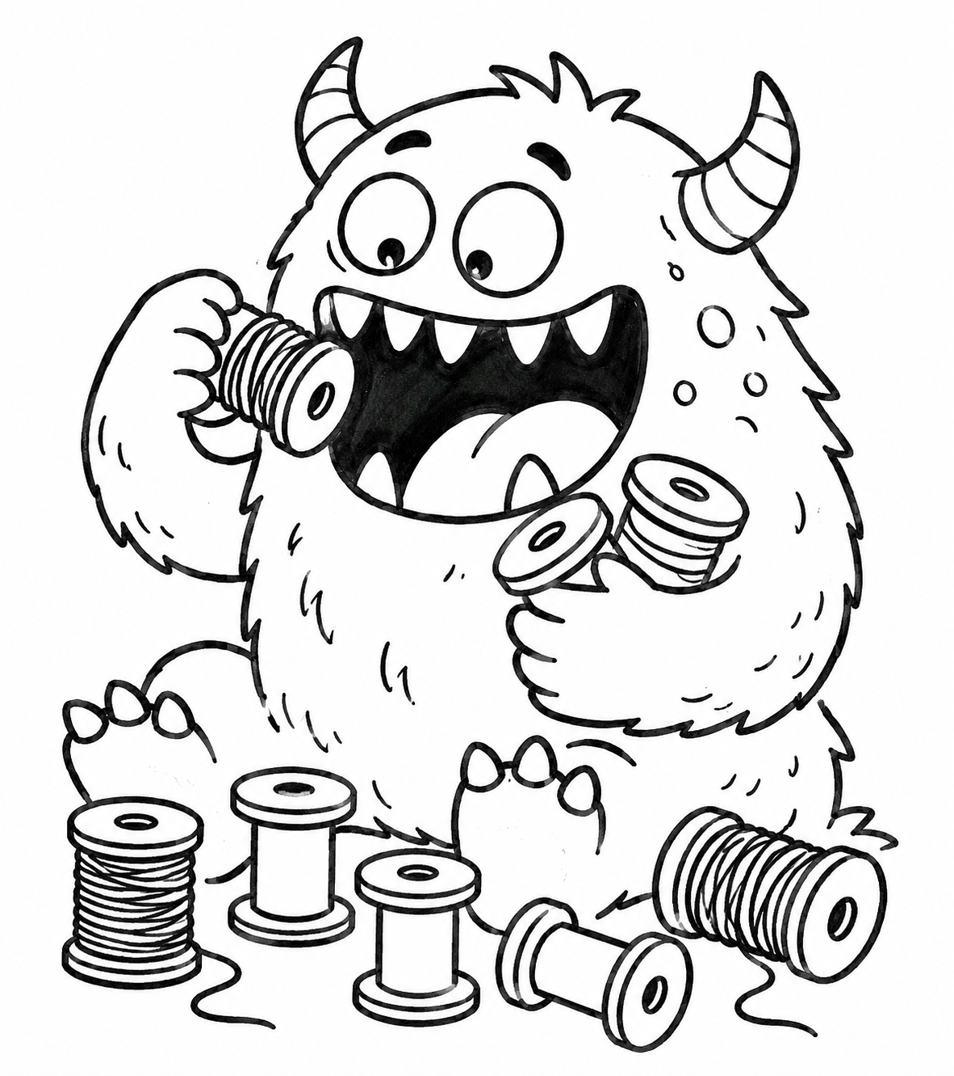
The Spool Monster is still hungry, so keep bringing those spools.
- Any Style Spool (wood, plastic, cylinder, cone)
- Empty or With Thread
        - Got some old spools with questionable quality thread? Thread that is fuzzy, brittle, sun exposed, or been sitting in that cookie tin for who knows how long?
The Spool Monster is happy to take them off your hands.
There will be a bin at guild meetings to collect the spools.
Thanks You - Naomi

? ? ? ? ? 2026-27 MYSTERY QUILT ? ? ? ? ?

Dear Quilting Friends,
It’s time for the 26-27 Mystery Quilt. There will be a new task every month from now until June 2027. The March task will be a short simple one since we will all be busy getting ready for the quilt show.
The finished quilt will measure approx 70” square. There are no curves, applique, or y-seams. It is scrap friendly or can be made with coordinated yardage. Please read all the cutting instructions before beginning. ( In other words, don’t be like me )
We hope you join us for this project. ~Cindy Dillman and Kay Olker

MYSTERY QUILT ‘26 - ’27 - CONSTRUCTION STEP ONE
Flying Geese Units
Combine 6 bg fabric squares 7 ¼" x 7 ¼"
and 24 fabric A squares 3 ⅞" x 3 ⅞"
to make 24 A/bg ﬂying geese units 3 ½" x 6 ½"
using the No Waste Flying Geese method.

FLYING GEESE BLOCK

A | B | C | bg

FABRIC COLOR KEY

Helpful Tips:
- Use a scant ¼ inch seam
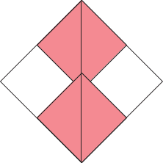
- Make one set before you start chain piecing

1. Place 2 of the fabric A squares 3 ⅞ x 3 ⅞" on opposite corners of a bg square 7 ¼" x 7 ¼" right sides together.
The fabric A squares will overlap in the middle of the bg square.
Use a removable marking device to make a line diagonally across the fabric A squares (solid line).

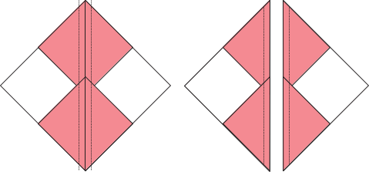

2. Sew a scant ¼" seam on both sides of the marked line (dotted lines) and then cut on the marked line (solid line).

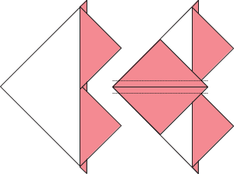
3. Press the seams towards the fabric A squares. (You will have two of these intermediate units.)
For each intermediate unit, place a fabric A square 3 ⅞ x 3 ⅞" on the corner of the bg square right sides together.
Draw a diagonal line on the fabric A square (solid line) and sew a scant ¼" on both sides of the marked line (dotted lines).

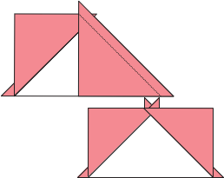

4. Cut on the marked line (solid line) and press the seams towards the fabric A squares.
Each set of 1 fabric bg square and 4 fabric A squares will yield 4 A/Bg ﬂying geese.

5. Repeat steps 1-4 to make a total of 24 A/bg ﬂying geese units.
Cut oﬀ tabs (also known as dog ears) and trim blocks to 3 ½" x 6 ½" if necessary, making sure there is ¼" between the point of the goose triangle and the edge of the unit.

Make 24 A/bg ﬂying geese units

A | B | C | bg

Fabric Color Key

