NEWSLETTER
Volume 20 Issue 04 April 2024

Guild Meeting:  April 12, 6:45pm  ~ Ascend Services, Manitowoc  ~Meetings are the 2nd Thursdays of the month | Upcoming Guild Events:  Camp Quilt  April 19-21 - see page 4
Quilt Show Corner - Page 5
April Hostesses: Bonnie Loeh, Mary Kay Burish, LouAnn Moore
April Program: Deanna Genske, Executive Director of Ascend. Topic: a recap of services that they provide and discuss some changes that they have made.

2025 Quilt Show Theme
A theme was voted on at the March Guild meeting.
The winner:
~ Patch of Lakeshore Quilters ~ March 16, 2024 Guild Meeting Minutes ~
- Call to Order
  - Ellen Lewellen
- Program
  - Quilt Show Committees presented by Julie Klumpp and Kathy Guralski
  - Details about the various committees will be made available in the April Newsletter as well as a web page dedicated to the quilt show.
- Business Meeting
  - Old Business
    - Secretary & Treasurer Report
      - 1st Bonnie Loeh 2nd Linda Londo Reports: Accepted
    - Mystery Quilt
      - Final clue posted in March 2024 newsletter
      - contact Ann Hall and Peggy Valitchka with any questions
Guild Meeting Minutes Continued
      - You can still get in on the fun! The 2023-24 Mystery Quilt clues are on the website starting in the Sept. 2023 Newsletter.
    - Spring Camp Quilt
      - April 19-21
      - $55 for members, $75 for non-members
      - Details and registration form will be in newsletter
    - Thank you notes
      - Notes of thanks were received from Aurora Hospice and the Salvation Army for donations.
    - Fair Quilt
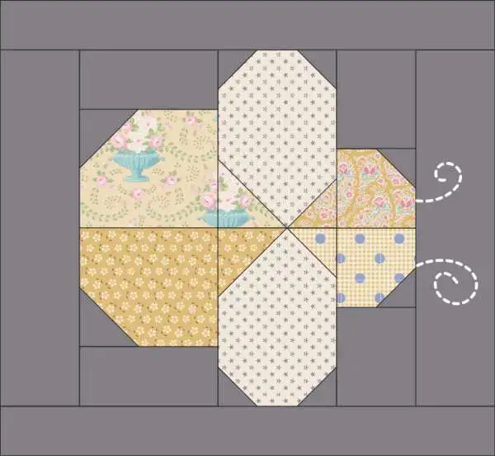
      - Raffle tickets for the 2023 Fair Quilt are being sold at various events. Have a suggestion for an event? contact Ellen Buck.
      - The county fair theme is: “Make a Beeline for the County Fair”
The colors are: Yellow, Black and Royal Blue
      - For information on the 2024 County Fair Quilt theme and Quilt Block requirements, check the Manitowoc County Fair Website
      - Guild contacts: Ann Zeman and Ellen Buck
    - National Quilt Day
      - March 16, 8am-4pm
      - Open Sew day with short demos for those interested
  - New Business
    - New Officers
      - Two positions are up for voting.
        - Treasurer
          - Role includes: Record keeping for the guild’s finances
        - Vice-President
          - Role includes: Coordinating Programs for guild meetings
      - Consider serving the guild in one of these roles.
      - Bonnie Loeh and Mary Kay Burish are part of the nominating committee and help to find members willing to fill the above roles. Talk with one of them if you are willing to serve as Treasurer or Vice-President.
    - Start Time
      - We’d like to open a discussion regarding our guild’s start time.
        - Does 6:45 still serve its purpose?
        - What do members think about a 6:00 or 6:30 start time?
      - Contact any member of the board to share your thoughts.
Guild Meeting Minutes Continued
    - Quilt As You Go Workshop - Please sign up!
      - Quilt As You Go Workshop, taught by Mary Ellen Beebe
      - May 18, 9am-3pm @ Ascend Services
      - Cost is $20, covers the rental and pattern.
      - Material list will be given
      - Sign up at the April Guild meeting, or contact Rosalie Miller
- Show and Tell
  - Many charming quilts were shown!
  - Thank you for the charity quilts!
- Motion to Adjourn:
    - Motion: Jeanette Wiesner Second: Rosalie Miller
Submitted by: Naomi Anderson

Days for Girls Sew Day
Days for Girls makes reusable menstrual products for girls and women around the world. Below are some of the work days of the Green Bay chapter, TitleTown Days for Girls. See their Facebook page for details.
April 8, 1-4pm - St. Paul’s Lutheran, 2601 S. 10th Street, MTWC
April 20, 9:30am-12:30pm - Grace Congregational Church, 2801 Garfield St. Two Rivers

Quilt As You Go Workshop
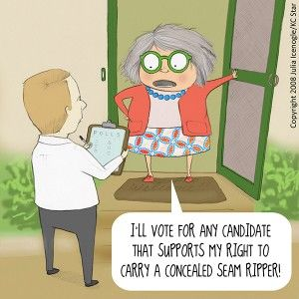
May 18, 9am-3pm at Ascend
Cost is $20 for pattern and to cover facility rental. Supply list to be provided.
Mary Ellen Beebe, guild member, will be teaching a Quilt As You Go Workshop. Add a new technique to your repertoire and enjoy a speedy new way to finish quilts. Sign up at the April Guild Meeting, or contact Rosalie Miller.

Spring Quilt Camp
Quilt Camp is an opportunity to sew with guild friends and enjoy time away!
Bring your own sewing machine, basic supplies and projects. The Guild provides irons, ironing boards, cutting mats…plus lots of friendly tips and delicious food.
Dates: April 19-21, 2024
Location: Camp Tapawingo, 915 Tapawingo Rd, Mishicot, WI
There will be no overnight stay. Open House style from 8am to 11pm.
Cost: $55 for members, $75 for non-members
Meals: Guild provides:
Friday: supper; Saturday: brunch and supper; Sunday: brunch
optional: Friday 8am breakfast at Two Rivers Family Restaurant, pay your own
Door prizes: Anyone at camp who wishes to participate in “BOGO” drawing brings a wrapped ($10.00) gift.
Project: We will present a project on Saturday. Participation is voluntary.
Shopping:
- The Quilt Shop of Two Rivers is offering a 20% discount to campers for the weekend. Hours: Sunday, 11-3; Monday to Friday, 9:30-5; Saturday, 9-3
- Norman General Store is offering a 20% discount for Thursday and Saturday. Hours: 10-4 each day
Questions: Julie Klumpp 920-860-0485 or jaklumpp@tm.net

QUILT CAMP REGISTRATION
APRIL 19-21, 2024

NAME: _____________________________ PHONE: _______________________
ADDRESS: ________________________________________________________

MEALS: CHECK WHICH YOU WILL BE PRESENT FOR
______ ALL MEALS
______ FRIDAY SUPPER
______ SATURDAY BRUNCH ______ SATURDAY SUPPER
______ SUNDAY BRUNCH

ARE YOU A COFFEE DRINKER? ______YES ______NO
IF YES, HOW MANY CUPS A DAY _____, REGULAR _____, DECAF _____

CAMP PAYMENT: MAKE CHECKS PAYABLE TO PLQ-QUILT CAMP
$55 MEMBERS $75 NON-MEMBERS

MAIL TO: JULIE KLUMPP, 2123 PRIMROSE LANE, MANITOWOC, WI 54220
⚘ ⚘ ⚘ 2025 Quilt Show Corner ⚘ ⚘ ⚘
Believe it or not, we are on our way to our guild’s biennial Quilt Show! Each month our newsletter will now have a section called “Quilt Show Corner” where various information about the upcoming show is shared. Keep an eye out for important information!
Mark your calendars! The show is April 5 & 6, which means set-up is April 3 & 4.
The show is held at the Manitowoc County Expo.

2025 Quilt Show Chairs:
Julie Klumpp & Kathy Guralski

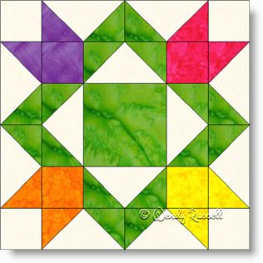
Here is a summary of the various Quilt Show Committees as outlined at the March 2024 guild meeting program.

Quilt Show Committee Information

The following is information about the various committees for the 2025 Quilt Show. It is based on info collected from past shows, with slight updates. If the info is in italics, it was written from MY (Naomi, secretary) understanding of the committee and may contain errors or very limited content. ♥️

I know it’s a lot of information, but it’s good to have a basic understanding of the overall workings of the quilt show. Also, this can help you decide where to volunteer. Some committees have a lot to do leading up to the quilt show, and some are not really busy until the actual show. All committees need “chair” people as well as helpers.

ALL committees have folders full of information from past quilt shows that outline the various responsibilities of the committee as well as resources/contact info as needed. These folders are distributed to the various committee chairs many months before the show so that there is time to plan.

Each committee has a chairperson. They lead their committee (which varies in size depending on need) and ensure it runs smoothly in coordination with the whole quilt show. These various “sub”-committee chairs meet as a group with the main Quilt Show Chairs monthly leading up to the show and are given lots of support.

Committees:
- Appraiser/Judging
  - Committee is responsible for securing a judge and appraiser for the show.
  - A nationally certified judge is hired to judge any quilts our members want to be judged. Ribbons will be awarded as determined by the judge.
  - A nationally certified appraiser is hired to be at the show for our guild members & the public.
- Badges/Ribbons/Voting
  - Gets the award ribbons for the winning quilts.
    - They also add decorations/toppers to the ribbons based around the theme.
- Charity Boutique
  - The Charity Boutique sells donated handmade items from guild members. Funds are donated to a local charity.
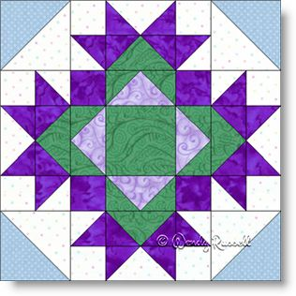
  - Committee is responsible for collecting donations from the guild, setting up and running the boutique.
- Charity Raffle
  - Donated items from the guild (and community?) are collected during the months leading up to the show. Items are grouped into “raffle baskets” and are divided into two groups, one for each day of the show.
  - During the show, the baskets are displayed, tickets sold, and winners chosen at the end of each day.
- Food - Thursday and Friday
  - Plans the food for guild members and vendors during set-up.
- Food - Saturday and Sunday
  - This committee plans the food that will be sold on Saturday and Sunday of the show. Any food that can be prepared ahead of time is done so. Meats need to be cooked in an approved kitchen. We have been fortunate in the past to be able to use Grace Congregational Church in Two Rivers. Shopping for non-perishable items is done ahead of time. Members of the guild are asked to donate non-refrigerated desserts which will also be sold on show days. Committee members are expected to help set up the kitchen prior to the show.
  - In 2023, the committee tried out a streamlined food service, featuring Jimmy John’s. All info will be in the folder, including pros and cons, for future committee consideration.

- Gift Boutique
  - At the show, there is an area designated for members to sell their handmade items.
  - The committee chairs give the guidelines to members for selling items, provide inventory lists, set up and schedule workers for the Gift Boutique during the show.
- Guild Challenge
  - This committee is responsible for coming up with a challenge quilt idea for the upcoming show. The committee determines the parameters for the challenge, provides required challenge items (for example a past show challenge required yarn), makes ribbons for judging and finds a judge.
- History
  - Sets up a display to show the history of the guild.
  - Great for promoting the guild and highlighting our charity giving.
- Kids Corner
  - Create a fun and interactive area for the kids. They are able to play with “quilt block design” using felt pieces, and are given an “i-spy” checklist (available at the entry table) to keep them engaged in looking at the quilts with their parents/grandparents. For completing their checklist, they get a cookie/treat from the Kids Corner table.
- Props
  - Using the quilt show theme, we come up with props and decor to be placed around the exhibit hall.
- Publicity
  - Promotes the Quilt Show via various methods.
- Raffle Quilt Tickets
  - Obtains the proper permits to hold a raffle, and gets the tickets for said raffle. Members each receive an envelope of tickets, and photo of the quilt, to sell to their friends/family/coworkers/etc.
  - Contact those working with the County Fair Raffle Quilt…can work under the same license.
- Registration of Quilts
  - Collects and enters data from the quilt registration forms.
- Set-up and Hauling
  - Coordinates the hauling of needed items from the storage shed and the setting up of the show.
    - Set up includes: tables, assembling stands, poles, curtains, lights, etc.
    - Set up usually takes place for the 2 full days before the show.
    - Everyone is expected to help as they are physically able and are encouraged to bring able bodied family members to help.

- Take Down
  - Coordinating the taking down of the quilt show.
    - Vendors take down their areas first. No part of the quilt show is taken down until they are all out.
  - Take down is usually completed in 4 hours.
  - Every member is expected to assist as they are physically able to.
- Vendors
  - This committee contacts past vendors and potential new vendors to have booths at the show.
- Veterans Quilts
  - After a very successful “Quilts for Veterans” feature and presentation of quilts, there is interest in continuing this practice.
  - Committee would be responsible for promoting the making of quilts for veterans, contacting various local groups to find veterans who have not yet received a quilt, and organizing the presentation of the quilts at the show.
- Work Schedule
  - Generates a “work schedule” for the quilt show weekend.
  - Contact various committees to see how many people they need for the show.
  - This will come out closer to the show.
- Quilt Descriptions
  - Types up and formats the quilt descriptions as given on the quilt registration forms. These are then hung and displayed with the quilts at the show.
- Quilt Layout
  - Works out a layout map for the registered quilts based on quilt sizes.
- Quilt Walk
  - Works to get promotional material to various local businesses. Usually asks members to work their contacts to get quilts and promo items into local shops.

