
NEWSLETTER
Volume 22 Issue 05 May 2026

Guild Meeting:  May 14th, 6pm  ~At Ascend Services  2818 Meadow Lane, MTWC | Upcoming:  June 13 ~ Hand Applique Workshop  ~Reminder: No Meeting in July
Quilting Legacies Machine Repair drop-off and pick up months:
June, August, October, December
Contact Nan Groll if you plan on bringing a machine to the guild for pick up.

From the President’s Desk - Ellen Lewellen
I was trying to say “gob-smacked”— my reaction to being voted to be the featured quilter for the next show— but my autocorrect changed it to “gobble-smacked”😅. Anyway, I am most humbled and grateful to all of you. I had already been jawing on at the meeting about how thrilled I was at the new members and guests coming to the guild, the enthusiastic participation in workshops and Camp Quilt, the willingness of members to teach and lead, the very real friendships…in short, how wonderful it is to be a part of such an active and generous guild.
Here is a recap of “tips” left in the tip jar to share:
humorously from Tammy Ricks: if you’re having trouble threading your machine needle, take it out of the machine and hold it closer to your face. Curse when you lose it in your excitement of achievement and try again.
From Marlene Denor: when you want to make “Frankenbatting” by adding one piece to another, try using fusible tricot interfacing which comes on a 2” roll. Also, you only need to hold the top thread when beginning sewing to avoid the dreaded bird’s nest.
From Chris Bauchnecht: let’s each suggest our favorite YouTube quilting site to share in the newsletter.
And here’s one from me: Binding clips made by Clover have a 1/4” line marked on the flat side (can’t vouch for accuracy of other brands but you can check). Who knew?
Enjoy the spring weather, but plan on coming to the meeting May 14th.🌷
~Ellen Lewellen, Guild President
Hand Applique Workshop - June 13, 2026
June 13, 9am to 3pm at Ascend Services.
Cost: $15 Sign up will be available at the May meeting.
Contact person: Rosalie Miller - 920-980-0572
You will need to bring:
☐ 18in square fabric (color of your choice) for background for a black cat
☐ Black thread ☐ Scissors ☐ Hand sewing needle
For the needle, I recommend the kind called Straws or Milliners, about 1 1/2 inches long with a tapered threading eye
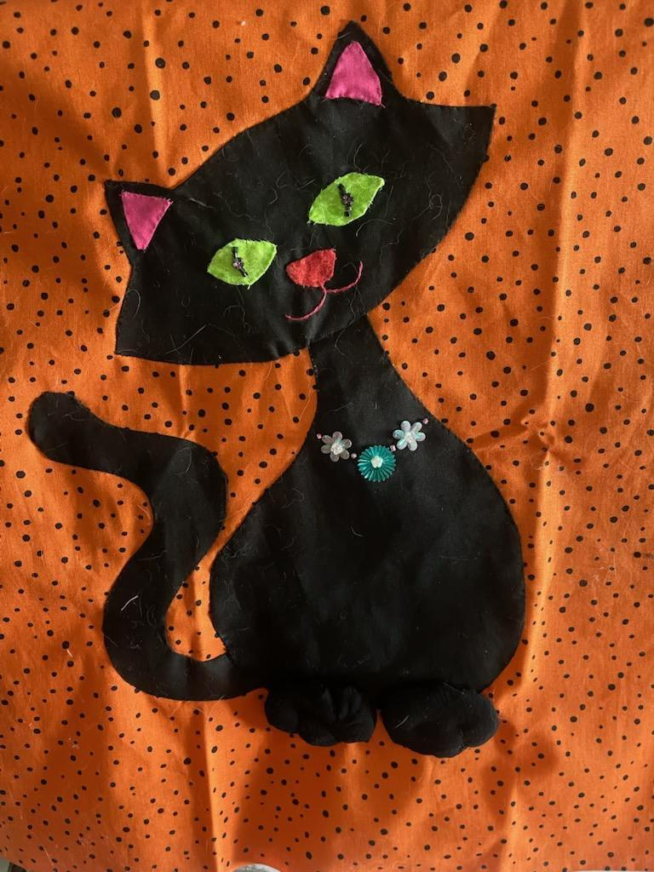
From Vivian Wendorf regarding the appliqué class:
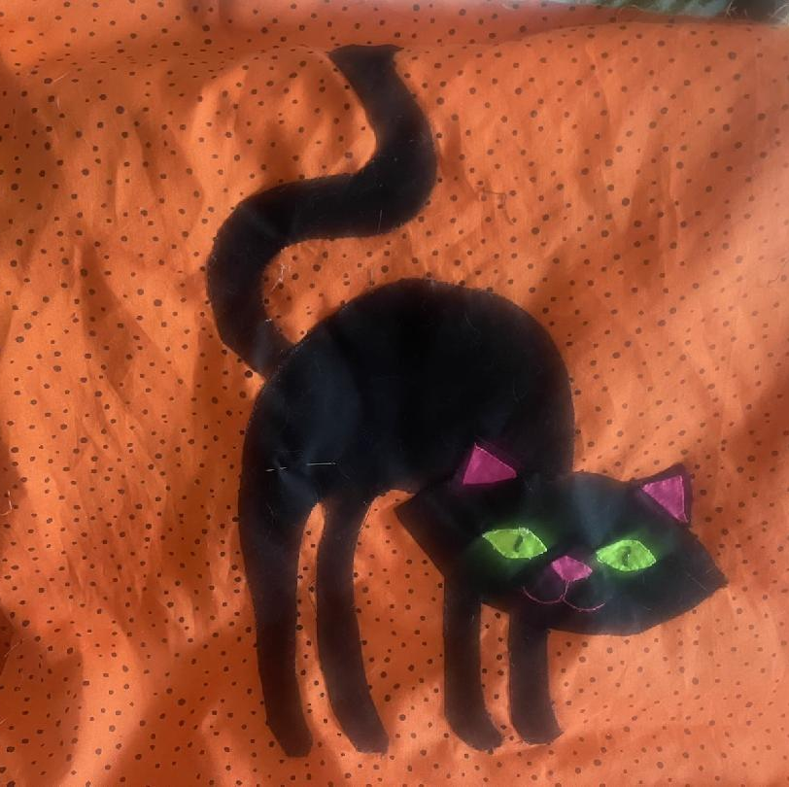
These are the two easiest and interesting patterns that I have created for your attendees to choose from. They can choose either one as the pattern pieces and time are almost the same. I will provide kits with the black pieces, eyes ,ears, and nose.

~ April 9, 2026 Guild Meeting Minutes ~
- Welcome, Greet Guests & Pledge
- Guest Speaker: Mary Wolter
  - Mary Wolter is a quilt judge and appraiser.
  - She talked about what it takes to be a certified judge. It takes 5 years of classes, training, and hands on experience to become certified. There are 50 certified judges in the United States.
  - Mary told us what she looks at when judging a quilt and how judges decide on 1st, 2nd, and 3rd place in different categories.
  - When judging a quilt, she looks for inspiration and feedback to the quilter. She has 3 minutes to judge a quilt. She will give 2 good qualities in a quilt and 1 comment on how to improve an area.
~ April 9, 2026 Guild Meeting Minutes Continued ~
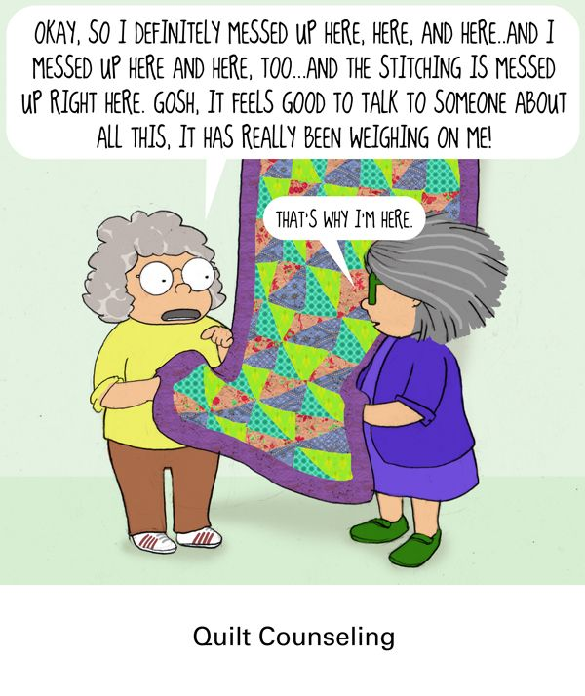
  - She judges on:
    - General Appearance
      - Does it lay flat?
      - Is the quilt clean?
    - Overall Visual Impact
      - Contrast
      - Pattern
      - Impact on viewer
      - Elements of design
    - Workmanship
      - Applique well done?
      - Seams flat?
      - Points sharp?
      - Will check the back of the quilt
      - Even quilting, consistency, even tension, do the motifs fit?
      - Hand quilting - even stitches
    - Finish
      - Binding - she doesn’t care if it is hand or machine finished, as long as it is done well.
      - Will embellishments fall off?
  - How she picks 1st Place and Best in Show is she looks at the degree of difficulty plus the complexity of the design.
  - Mary stressed that you should make and exhibit your quilts as much as you can.
  - We then had Show and Tell, and Mary critiqued the pieces. She pointed out all good qualities in the pieces.
  - Mary Wolter will be our judge for the 2027 Quilt Show.
- TIP JAR
  - If you put an idea, “TIP,” into the jar, and it is used, you will get a little gift.
- Thank you to the Hostesses!
- Motion made by Bonnie Loeh and second by Marlene Dener to accept the March Minutes as written.
- Treasurer’s Report was accepted as read. Motion: Ellen Buck Second: Tina Waack
- Mary Ellen Beebe (treasurer) reported that we can purchase some small CD’s for interest income.
  - Mary Ellen will look into this and make sure that it doesn’t affect our non-profit status.
~ April 9, 2026 Guild Meeting Minutes Continued ~
- County Fair Block
  - If you want information on making a block, paperwork is available.
  - Quilt theme is “Heart of the County”
  - Blocks made last year are made into a quilt and will be raffled off at this year’s County Fair. Tickets are $1 each, or 6 for $5. All proceeds will go to our guild.
  - Thank you to the County Fair Quilt Committee.
- Thank you to the people who put together the Quilting Day event.
- Saturday is the workshop on Impressionism. It will start at 9am and end at 4pm. A list of supplies was in the last newsletter.
- Camp Quilt - April 24-26
  - All info was in the last newsletter
- Evergreen Quilt Show - April 17 & 18 in Green Bay
- Quilting Legacies, from Fond Du Lac, will drive to our guild meetings every other month to pick up any machines that need repair or cleanings. Please let Nan Groll know if you have a machine. We don’t want Quilting Legacies to drive over and not have any machines to pick up.
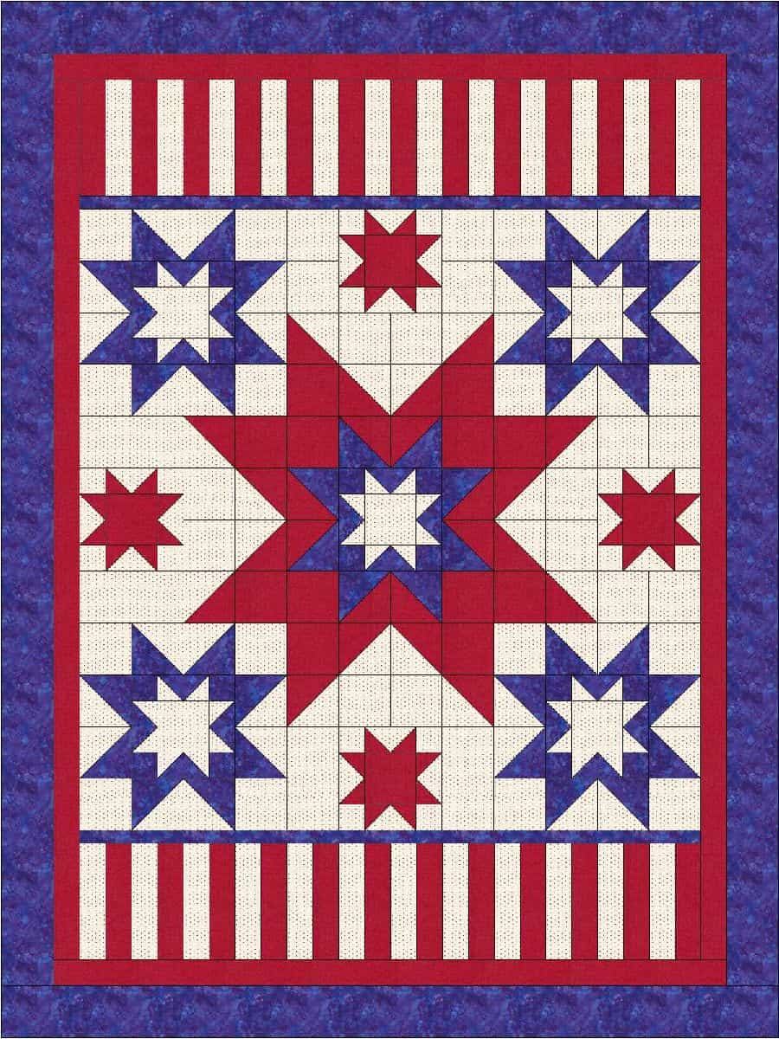
- Veteran’s Quilts
  - A sign up sheet for making a quilt for a veteran was passed around. It you don't have a designated to person to give the quilt to, we will get names from our local Army Reserve Unit #377.
- Next month’s program will be on Sewing Machine Repair
  - Have an idea for a program? Contact Lori H
- Reminder that the Quilt Show Committee meeting will be held on the 2nd Monday of each month, at 6:00pm, at the Two Rivers Quilt Shop.
- Featured Quilter for our show is Ellen Lewellen
- We need another person to help on the Nominating Committee.
- We need help on the Quilt Show Facility Committee. The job will be divided up among the committee members.
- The drawing for the door prize was won by Sue Marquardt.
- Motion to adjourn was made by Sue Marquardt and 2nd by Vickie Patt. Meeting adjourned at 8pm.
Submitted: Kay Olker

♥️ 2026 Manitowoc County Fair - Quilt Block Contest info ♥️
Consider submitting a block to the County Fair!
(moving forward, this information will be on the website.)
2026 theme: Heart of the County.
With theme colors Red, Black and Royal Blue.
Check out the Fair’s webpage for the Ladies Event, which includes info on the Quilt Block Contest. manitowoccountywi.gov/departments/expo/manitowoc-county-fair/ladies-day-event/
Or, go directly to the Quilt Block Contest Rules and Regulations Form:
manitowoccountywi.gov/wp-content/uploads/2026/02/Quilt-Block-Contest-Rules-and-Regulations-2026.pdf
See Ellen Buck with any questions - 920-645-1740

Quilt Show Corner
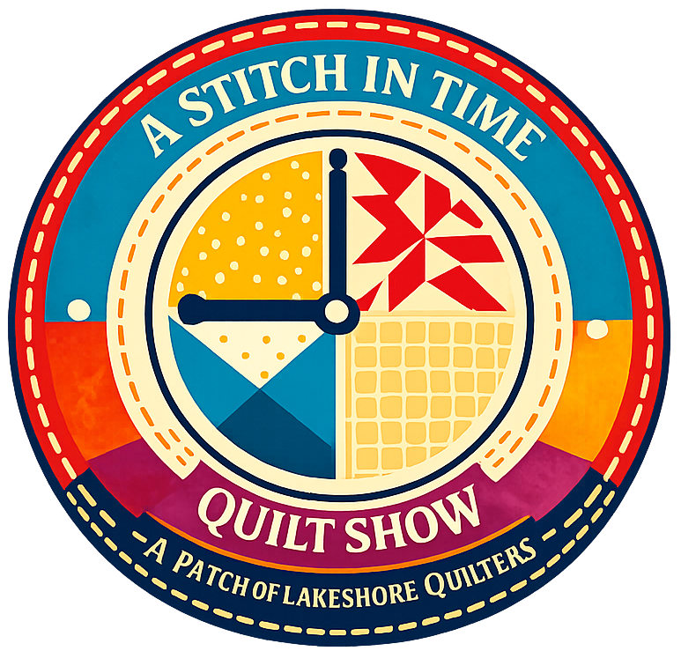
2027 Quilt Show
- Show dates: April 3 & 4, 2027
- Location: Manitowoc County Expo
- Theme: A Stitch in Time
- Quilt Show Chairwomen:
Julie K, Kathy G, Jeanette W
- Featured Quilter: Ellen Lewellen

Committee Meetings: Committee Chairs meet the second Monday of the month at 6pm at the Two Rivers Quilt Shop.

Got Quilt Show info to share with the guild?
Contact Naomi to get it in the newsletter: naomianderson428@gmail.com

From the Props Committee:
Please bring your empty spools to guild meetings. I (Naomi) will save them and use them as part of our props for the show.

Quilt Camp Fun - THANK YOU CAMP COMMITTEE!!
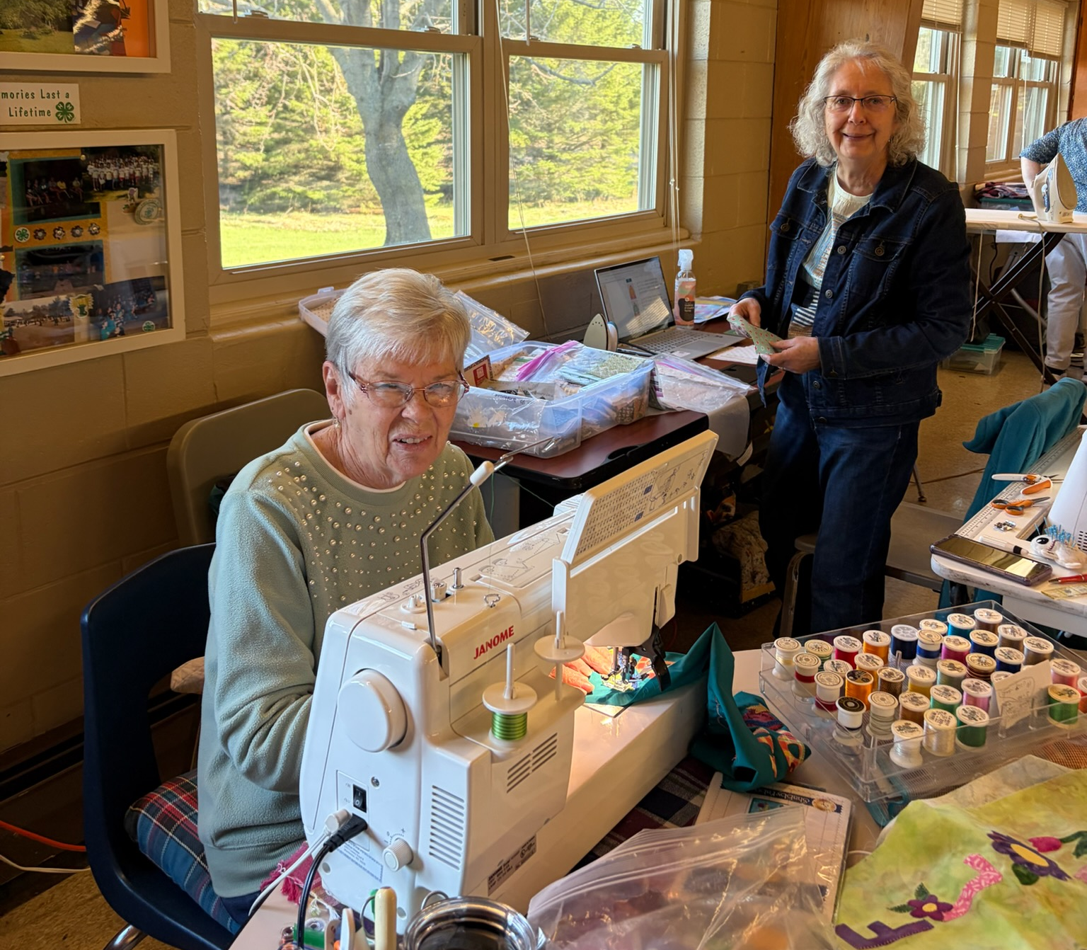
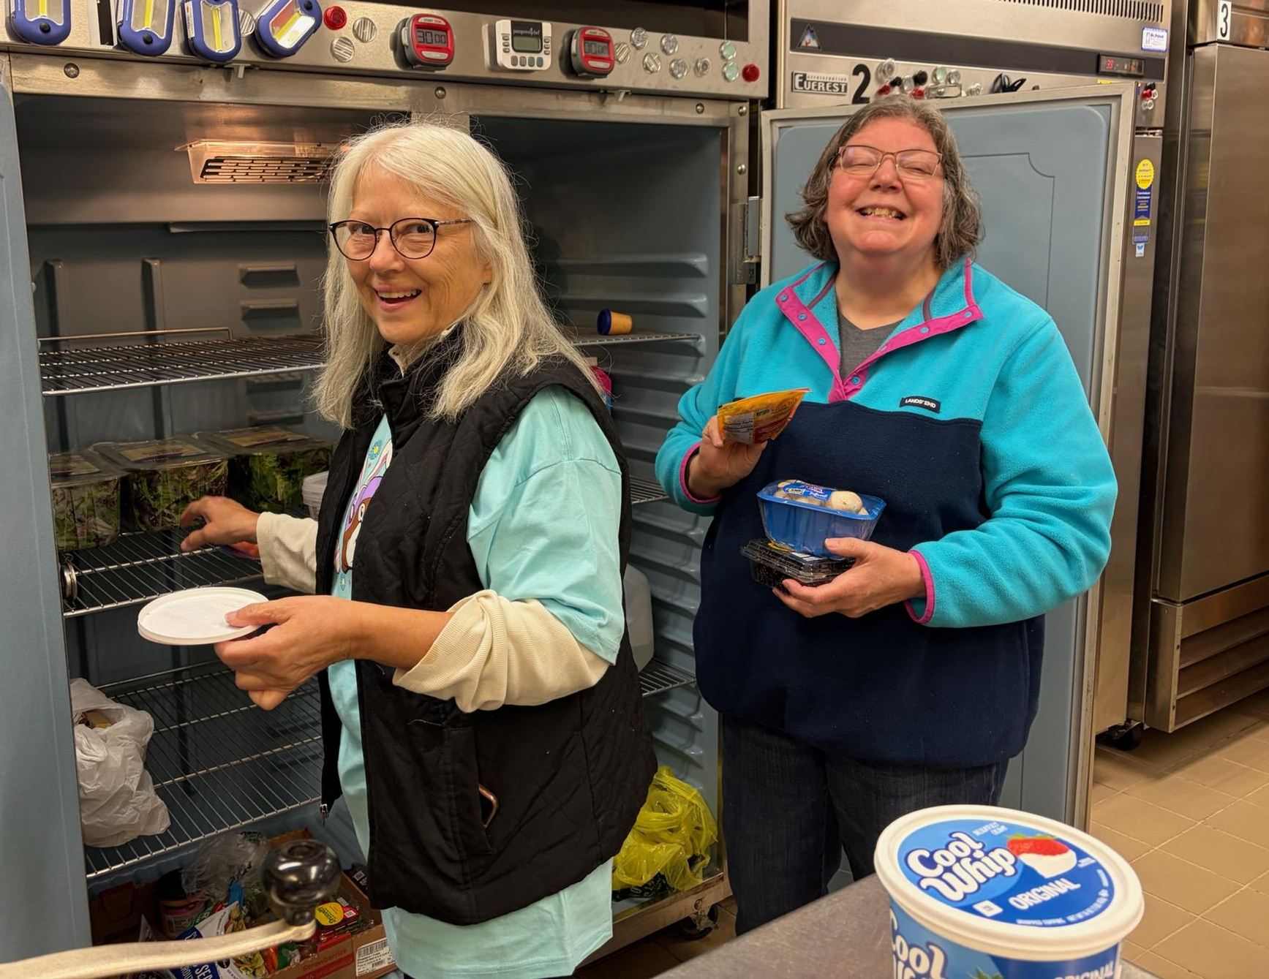

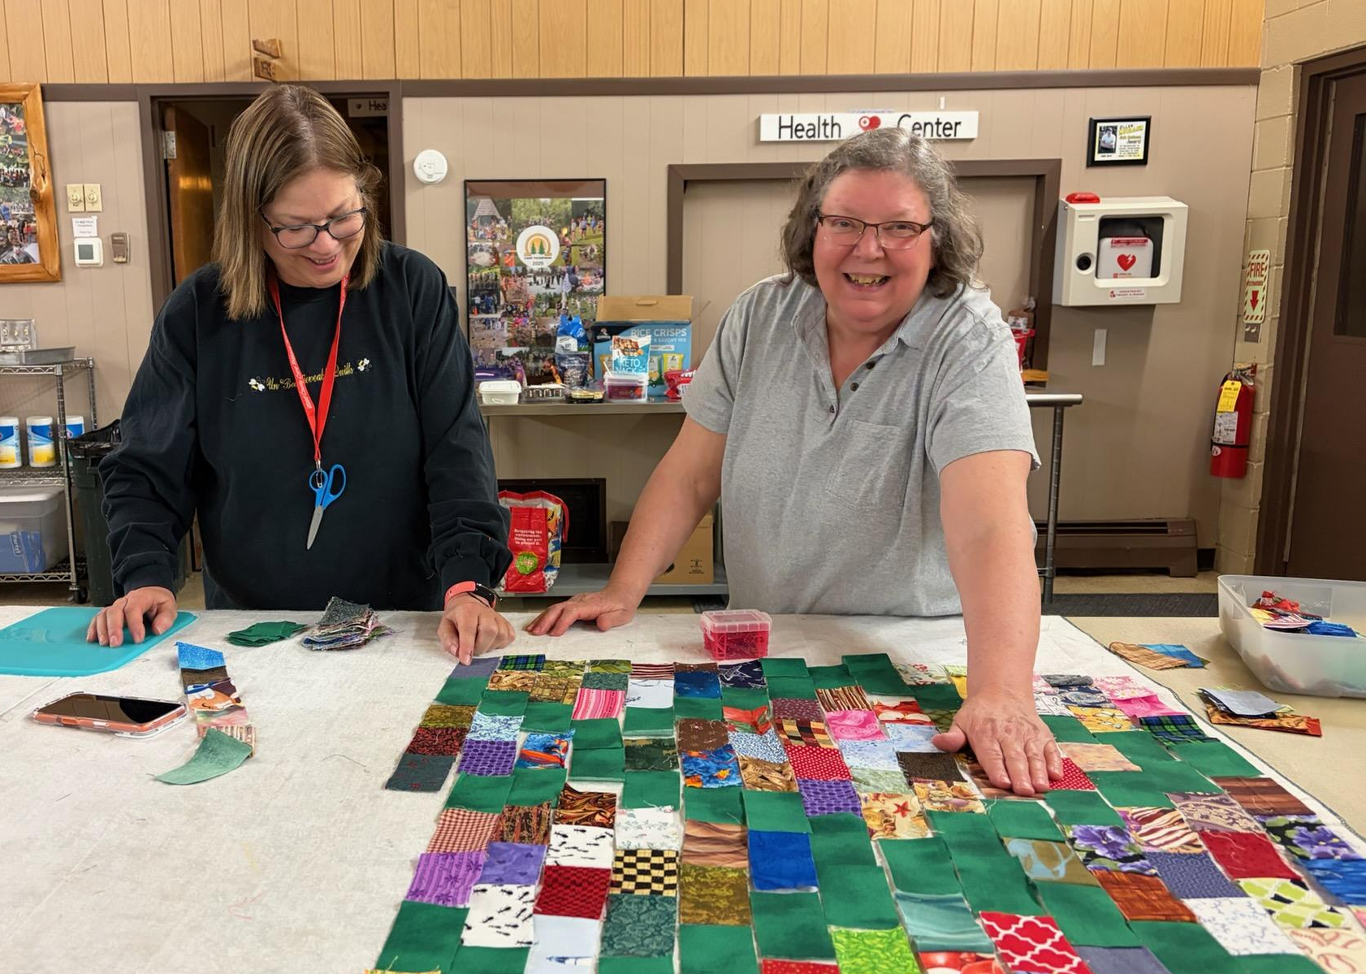
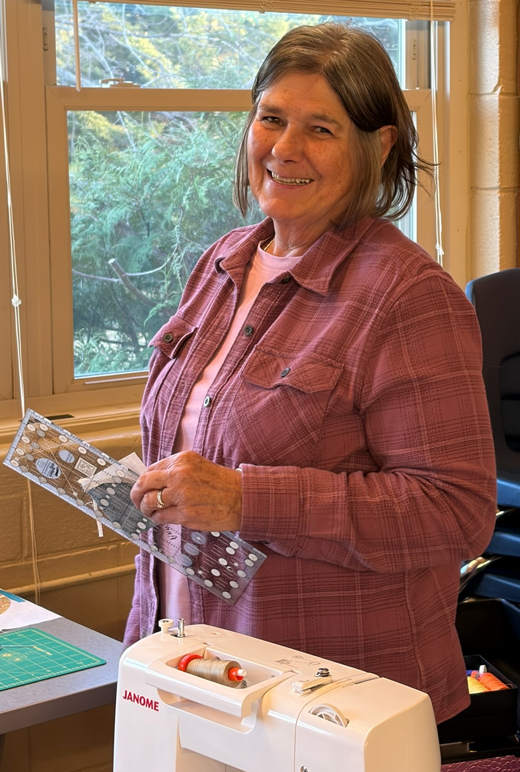
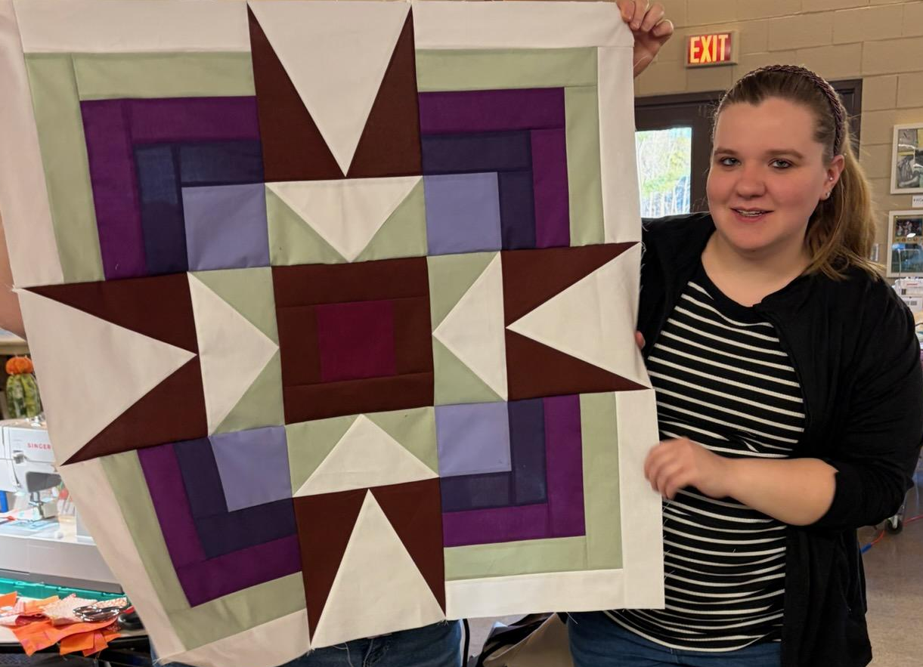

Mark Your
Calendars
Fall Camp: Sept. 18-20

