NEWSLETTER
Volume 20 Issue 01 January 2024

Guild Meeting:  January 11, 6:45pm  Bring 3 ugly Fat Quarters for some games  ~ Ascend Services, Manitowoc  ~Meetings are the 2nd Thursdays of the month | Upcoming events:  Charity Sew Day  Details below  Camp Quilt  April 19-21  Details to come
??? Mystery Quilt Clue #5 - Page 4 ???
Jan Hostesses: Peggy Valitchka, Ann Hall, Lori Hansen-Stein
Feb Hostess: Sue Dupont, Kay Olker, Joni Vandemale
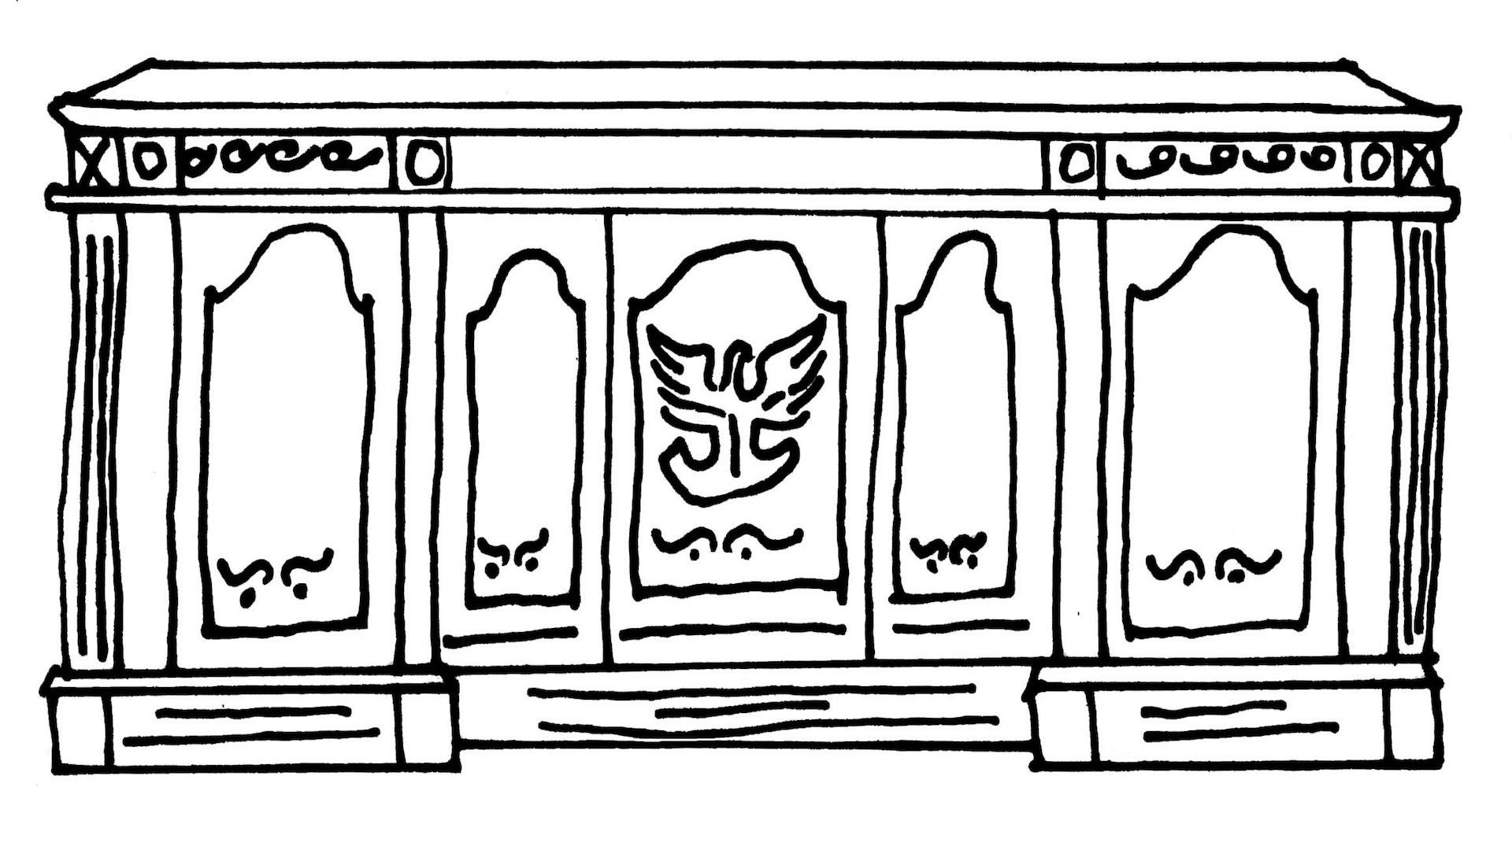
From the President’s Desk
Happy New Year to all! May your resolutions for 2024 include a quilt or two! Following a request from a member, at our last meeting it was voted that we have a collection for ladies and families at Incourage (formerly the Domestic Violence Center). I called there and was told some of the things they can always use are toiletries, hair products (especially ethnic), deodorant and lotions, diapers, and nonperishable foods. Let’s plan to collect these at our February 8th meeting. Please let me know if you need the membership booklet ($2), the binding clips anniversary gift from the picnic, or if you have any questions about anything else. I love being part of a group that is so generous sharing information, fabric, time and talent! See you at the January 11 meeting!
~Ellen Lewellen

Charity Sew Day
January 20, 9am-3pm at Ascend Services.
Cost $10 (to cover rental of the facility.) BYO Lunch. Desserts will be provided.
Bring your machine. Irons and boards will be available.
You can bring your own charity project or some charity fabric will be available.
Item ideas include: placemats for Meals on Wheels, lap quilts for vets, quilts for babies, foster kids, the homeless shelter, etc.
Sign up will be available at the January Meeting. Contact Rosalie Miller
~ Patch of Lakeshore Quilters ~ Dec. 14, 2023 Guild Meeting Minutes ~
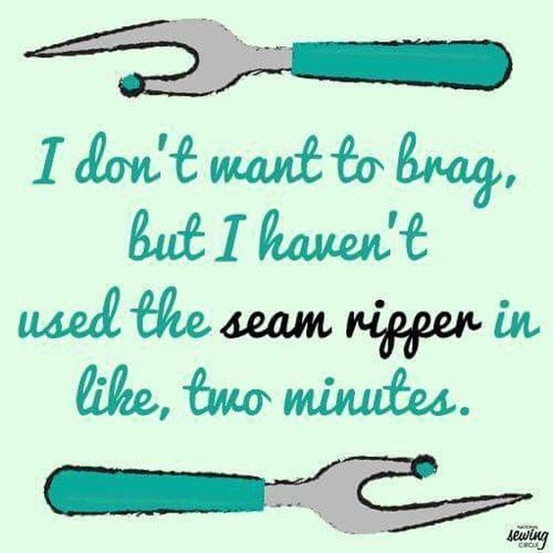
- Call to Order
  - Ellen Lewellen
- Meal
- Business Meeting
  - Secretary & Treasurer Report
    - Motion to accept: Cindy Dillman Second: Chris Bauknecht Carried
  - Mystery Quilt Clue 4 in December Newsletter
    - Correction:
      - The chart for Unit B should read “Background 3 ½ x 3 ½ inch Squares” not “Background 3 ½ x 6 ½ inch rectangles”
        - The diagram shows the correct Unit components/layout.
  - Charity Sewing Day
    - Jan 20, 9am-3pm at Ascend
    - $10, BYO Lunch
    - Can make own project or use provided charity fabric.
    - Items needed include: placemats, lap quilts, baby quilts, etc.
    - Sign up at the January Meeting. Contact Rosalie Miller
  - Days for Girls - charity that makes reusable menstrual products
    - Cotton Flannel donations can be brought to guild meetings.
      - No faces, rainbows, things with eyes.
    - Details about sew days to come.
  - Charity Committee Request
    - Use washable fabrics for your donation quilts. These quilts should be able to run through a regular cycle on a washing machine.
    - (tip from Naomi: consider using flannel as a backing. Many people use quilts as a blanket without sheets; so using flannel guarantees a warm fabric in contact with the skin. Snuggle Flannel from Joanns goes on sale quite frequently.)
  - A Toiletry Collection will be organized. Details to come

  - Booklets
    - Address booklets now available. $2 See Ellen Lewellen
  - Still need your name badge? Please see Gretchen Scheidt
  - Next Meeting: January 11, 2024
    - Because of frequent past cancellations of January meetings due to bad weather, we do not have a scheduled speaker. We shall have an extended show and tell, as well as fun games with prizes and socializing.
  - Quilts for Veterans
    - The success of the presentation of quilts for veterans at our 2023 Quilt Show has led to plans for a future presentation of quilts. If interested in participating (quilt making, or know a veteran), contact Pam Posvic More information to come. A comment was made that lap/throw size quilts were favored.
  - Motion to Adjourn business portion:
    - Motion: Pam Posvic Second Ann Zeiman
- Show and Tell
- Christmas Social
  - Thank you Christmas Social committee for the delicious meal, fun games, and lovely sewn gifts.
Submitted by: Naomi Anderson
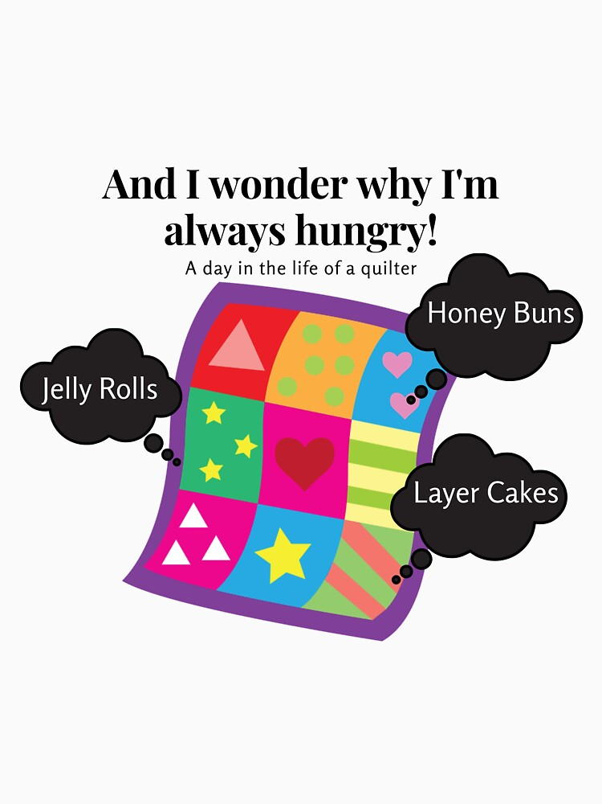

Mystery Quilt Clue #5
Finished block 12′′ x 12′′

Clue #5 - Unit C and assembling Block A
This month we make Unit C and you see the first block.

Pull the following number of background rectangles from your cutting step, and half square triangles from your completed HST step.
Components Needed | Table Topper | Lap Quilt | Twin | Full | Queen | King
Background 3 ½ x 6 ½ inch rectangles | 10 | 20 | 24 | 30 | 42 | 56
Half Square Triangle Units | 20 | 40 | 48 | 60 | 84 | 112
Caution: Do not use more that this step calls for in the charts.

Construct Unit C:

It does not matter which way your pinwheels spin, just make sure they all spin the same way.

With Unit C, and assembled Unit A from Clue 3, construct Block A:

Be sure your scrappy HSTs point outward on the corners.

# of Block A to make | Table Topper | Lap | Twin | Full | Queen | King
 | 5 | 10 | 12 | 15 | 24 | 28

