
NEWSLETTER
Volume 21 Issue 11 December 2025

Guild Christmas Party:  Dec. 11th, 6pm  ~At Ascend Services  2818 Meadow Lane, MTWC | Upcoming:  Cross Stitch Workshop  ~Jan. 31 - info: page 4
Mystery Quilt - Page 7

From the President’s Desk - Ellen Lewellen

I am currently working on a quilt that has bias edged pieces and curved seams because I had told myself that it would be a fun challenge and a change from the half square triangles and straight seams I’d been doing recently. Ha! It wasn’t long before I was asking myself, “What were you thinking?” Shortly after that I realized that it was almost Thanksgiving and there was no way I’d be able to finish all the projects I’d casually promised myself I’d make as Christmas gifts.

Has that happened to you? My mental list of the things I can do and the time it will take to accomplish them doesn’t always coincide with reality. This failing is perhaps most prominent during the holiday season when we are bombarded with advertisements and friends’ stories of beautifully decorated homes, delicious recipes you really should make and, of course, the perfect handmade gifts for everyone on your list. It’s hard to step away from the madness and just enjoy the little things isn’t it? Well, at least we can see friends and enjoy some holiday cheer at the Guild Christmas party. See you there, whether you’re naughty or nice and whether or not you’ve completed your “to do” list!

Christmas Party
Don’t forget to wear a fun scarf to our guild Christmas Party.

~ November Guild Meeting Minutes ~
- Welcome & Pledge
- Speaker: Elaine West, The Sewing Basket, 426 E Mill St, Plymouth, WI
  - Check out their website: sewingbasket.biz
    - Check out The Sewing Basket’s Studio-Y: An Online Gathering Place For Fearless Quilters
  - Quilters Dream Batting Presentation - www.quiltersdreambatting.com

    - Thank you to Quilters Dream for the Lovely Sample Card and Door Prizes
    - Perks of Quilters Dream
      - Flat right out of the package
      - Excellent consistency in fiber thickness
  - General information about batting
    - 80/20 Cotton/Poly Blend is the popular choice for quilts.
      - Wool and Bamboo (lovely for quilts) also have a nice drape for quilted clothing
      - Fusible 80/20 is popular for wall hangings, placemats, runners, etc
    - Know the quilting stitch distance maximum for your batting
      - Have some old mystery batting? Max stitch distance should be about 3 inches
    - Spray basting: PAT your quilting sandwich together, do not smooth
    - Fusible batting: fuse to quilt back
    - Fuse your batting scraps and use for pillows, baby quilts, mug rugs, quilt as you go
- Social Time
- Business Meeting
  - Motion to Accept Minutes as presented in October Newsletter
    - First: Tina Waack Second: Nan Groll motion passed
  - Thank you from Karen Hoffman
  - Membership Booklets available $1
  - Tip Jar - submit a tip or ask a question!
  - Thank you to those who filled out the Roles and Responsibilities
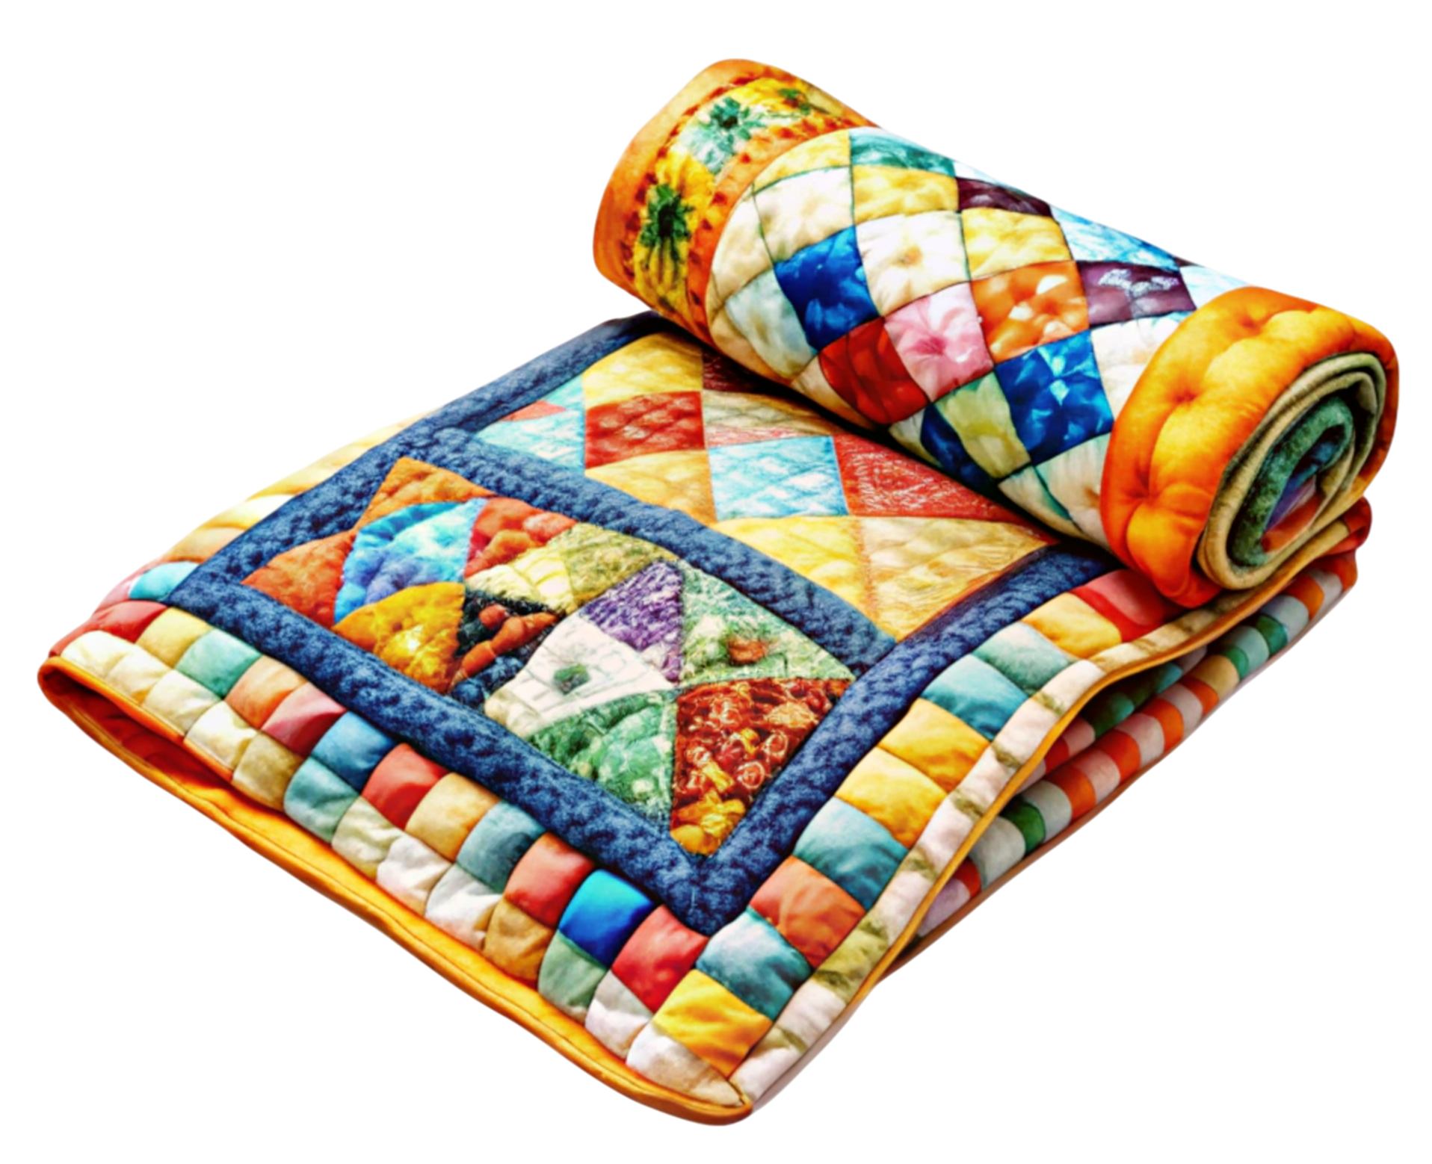
    - Please turn in to Naomi A
  - Board of Director Meeting
    - Nominating Committee needs a few more helpers
      - See Ellen L to help out

~ November Guild Meeting Minutes Continued~
  - 2027 Quilt Show
    - In January 2026 Meeting, we will be looking for:
      - Chair/s for entire event
      - Subcommittee chairs
      - Theme for show
  - Sew for Fun Day - see Julie
    - Nov. 15&16, 8am-3pm
  - Workshop
    - Art Impression Workshop - April 11
      - Start saving scraps: Leaves, flowers, fur, clouds, landscape types
      - Sign up form will be at the December Meeting
  - Mystery Quilt
    - Final block will be revealed in the December NEwsletter
  - Christmas Party
    - Dec. 11th 6pm at Ascend
      - Entertainment, meal, game and prizes
      - Contest: wear your favorite scarf
  - Charity Committee - Thank you everyone for your kindness!
    - Baby Quilts and booties to The Crossing
      - Sweet Thank you note was received from the Crossing
    - Coffee Maker donated to Salvation Army
      - They accept gently used household and clothing
      - Also quilts, blankets, hats, gloves, scarves
    - Craft supplies to Hello Happiness
      - The question was asked: “What’s Hello Happiness?”
        - Basically, it’s a crafting thrift store, located at 1504 New Jersey Ave, Sheboygan
        - From their website: Hello Happiness Creativity Center is a nonprofit community of learning, connection, support, and renewal through creativity. Based on a foundation of kindness, imagination and respect, our mission is to provide affordable access to creative supplies and experiences for everyone.
        - Donate your useable art and craft supplies (currently not taking books or magazines)
          - Check out their website for a complete acceptable donations
          - https://www.hellohappinesscreativitycenter.com/get-involved
- Show and Tell - Running joke, what batting did you use?
- Motion to Adjourn
Submitted: Naomi Anderson
Counted Cross Stitch Workshop - Jan 31, 2026
If you were at the October meeting, you most likely noticed all the counted cross stitch brought by Tina Waak for the sharing table. Were you disappointed you did not know how to cross stitch? Mary Ellen Beebe has been doing cross stitch for many years and will spend a Saturday in January helping you to learn the skill. She will share tips and tricks she has learned over the years as well. Small kits will be provided for you to choose from. All you will need is a small (4-6”) embroidery hoop and embroidery scissors. A few may be available for you to borrow. So join us if you are interested! If you already know how to cross stitch and are working on something, you are welcome to join us.
Date: Saturday, January 31, 9:00-3:00. Ascend Services
Cost: $10 (room fee)
Bring: ~Lunch And Beverage
~Embroidery Hoop
~Scissors

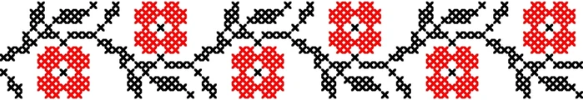


Hand Holding Needle
icon by Icons8

Hand Applique Workshop - June 13, 2026
Vivian Wendorf will be instructing in Hand Applique. The subject is a black cat. Cost is $15 for the class. Time will be shared as we get closer to the date.
You will need to bring:
☐ 18in square fabric (color of your choice) for background for a black cat
☐ Hand sewing needle ☐ Black thread ☐ Scissors

Art Quilt Workshop - April 11, 2026
Barbara from Wyverns Trove located in Columbus, WI will be leading an Impressionist Art Quilt Workshop for our guild. There will be kits with inspiration pictures and fabrics to get you started. Kit themes include: landscapes, pets, window scenes, flower bouquets, wreaths, and the like. All kits are different and Barbara plans to bring extras so there will be plenty of variety.

What you need to do for this workshop:
- Decide your quilt size (larger quilts are easier to create an image)
  - 20”x30” - $15
  - 24”x36” - $20
  - 30”x40” - $30
- If you have novelty fabrics/scraps, please start setting them aside to use in your quilt and to be able to share/swap with others. Leaves, flowers, fur, animals, insects, bricks, rocks, trees, sky, clouds, grass and the like.
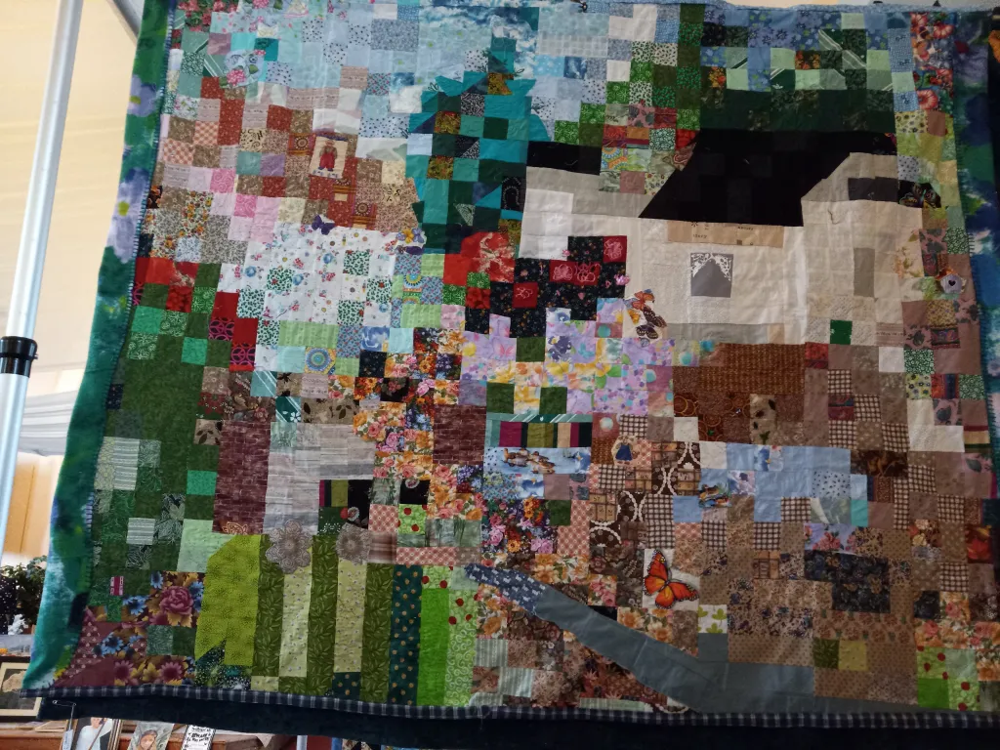
Helpful skills include knowing how to make: 4 patch, 16 patch, snow ball corners, and half square triangles from two pieces of fabric the same size as the finished square. (I plan on including how-to’s in the next few newsletters so everyone knows these techniques.)
Registration will be open at the
Dec & Jan meetings.
Contact Karel Harcus with questions

Barbara’s blog post about her process in making her Impressionist Quilt.
wyvernstrove.wordpress.com/2025/11/07/art-quilt-lessons-learned/

Block Basics = 4 Patch and 16 Patch
(esp. in prep for the Art Quilt Workshop)
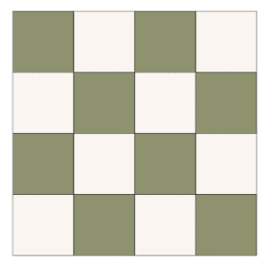

First off, a 4 Patch is a 2x2 grid quilt block
and a 16 Patch is a 4x4 grid quilt block.
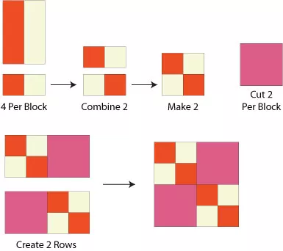
- Strip piecing is a fast assembly method for these types of blocks. Sew strips long sides together, press, then sub cut the strips. Rotate your sub cut pieces, sew together, press, and trim to size.
4 Patch Block Construction
- The math is relatively easy.
  - Figure out your finished block size.
  - Divide that number by 2 (for a 4 patch) or 4 (for a 16 patch)
  - Add ½ an inch for seam allowance. This is your cut size, whether you cut pieces individually or as a strip.
    - For strip piecing, the above measurement is also the size for sub-cutting the assembled strip.
So, for example:
~If I want a 6 inch finished 4-Patch block, I divide 6” by 2, equaling 3”. Add ½ an inch for the seam allowance. So I cut (either pieces or strips) at 3.5 inches.
~For a 6 inch finished 16-Patch block, I divide 6” by 4, equaling 1.5”. Add ½ an inch for the seam allowance. So your cut size is 2”.
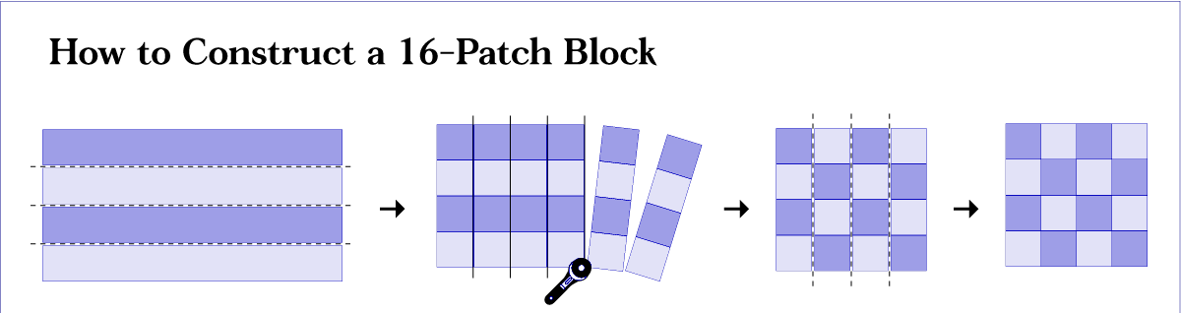

? ? ? 2024-2025 Mystery Quilt ? ? ?
~ Pattern on page 7 ~ quantity: make 1 block ~
It’s our final block!!! January will have the sashing and finishing instructions.
~Chris B
