
NEWSLETTER
Volume 21 Issue 06 June 2025

Guild Meeting:  June 12th, 6pm  ~At Ascend Services  2818 Meadow Lane, MTWC | Upcoming:  Charity Sew Day  June 21 & 22, Details on page 2
Registration Form - Page 6
Mystery Quilt - Page 9

From the President’s Desk
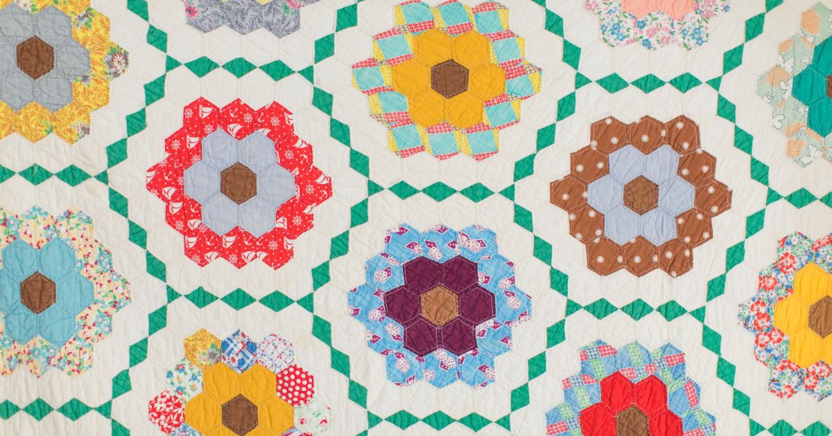
I don’t know about you, but I was really jazzed after the May meeting with so many of you there and five new members or guests. Also, 17 people came to the English Paper Piecing workshop! I had a great time sharing the many different ways this type of quilting can be done and look forward to seeing some finished projects in the future.
I’d like to schedule a board meeting before our regular June meeting and am in the process of coordinating with all the board members. If you have any questions or concerns, please call any of us (p. 5 of the booklet). We will be electing new members at large at the June meeting. Remember that there is no meeting in July. Information about the August picnic will be sent out later.
If you haven’t already done so, please send in or bring to the June meeting your annual registration and $30 dues. (Form is in the May newsletter). This is also a good time to invite a friend who liked the quilt show or the former member you still keep in touch with. Double check that you have updated any email or phone number changes etc. If we don’t hear from you, I will be making phone calls this summer!
Enjoy yourself this summer, spend time with family and friends, and squeeze in a little “me time” to quilt!
~Ellen Lewellen, Guild President

Charity Sew Day - June 21 & 22

We will be having a charity sew day on Saturday, June 21 and Sunday, June 22 from 8a-4p at Ascend Services. InCourage has requested pillowcases. We plan to bring fabric for the pillowcases. The cost per day is $10 per person (helps cover the cost of the facility) and lunch is on your own.

Voting
Guild Members:
We will be voting in June for the following positions.
- President
- Secretary
- 4 members at large
  - 2 for 2 year terms
  - 2 for one year terms (That will get us back in the correct place.)

The following nominations have been submitted.
- President – Ellen Lewellen
- Secretary – Naomi Anderson
Members at Large:
- Chris Bauknecht
- Susie DuPont
- Nan Groll
- Mary Hutchison
- Sue Marquardt
- Kay Olker

Nominations are open and can be submitted to me (Nan Groll) by Phone 920-323-3544, Email nannette1446@sbcglobal.net
Nominations will also be finalized at the June meeting before we begin the vote.
Anyone interested in any of these positions please contact Nan Groll at the above email address and phone number. You can also text.
These positions can be filled by any member of the guild no matter how long you have been a member. Everyone has something to contribute.
Nominating Committee,
Nan Groll
Kay Olker

~ May 8 Guild Meeting Minutes ~
- Call to Order
  - Pledge & Welcome to our many guests!
- Show and Tell
- Snacks and Social Time
  - Thank you ladies for the delicious Pizza Party themed snacks
- Business Meeting (due to number of new members/guests, extra time was taken to explain various aspects of the guild)
  - Brief intro about the guild for the benefit of our guests
    - Website: patchoflakeshore.com
    - Newsletter, available on website, is best way to stay informed
  - Upcoming meetings
    - June 12th: Speaker will be Amber from Painting Pathways
    - July: no meeting due to summer vacations
    - August 14: Picnic. Theme and more info to be announced
    - Sept 11: Speaker from The Sewing Machine Shop. Topic: Project Linus
  - Quilt Show info
    - If you had unsold items in the Charity Booth, Rosalie Miller has your items. You can contact her to pick them up.
    - Linda Londo said we had over 30 baskets at the raffle basket area. Thank you to everyone for their generosity.
    - If your quilt won a ribbon and you had a professional quilter for your quilt, Kay Olker has extra 1st, 2nd, 3rd Place ribbons that you can give to your quilter.
    - Next Quilt Show is set for April 3 & 4, 2027
  - Registration Forms - discussed and select committees explained
    - Charity Committee
      - Consists of Chair person and crew
      - Responsibilities include finding area non-profits that wish to receive quilts and then communicating that to the guild.
        - Especially communicating any specifics, ie size or other items like stockings or placemats
      - Items can be shared to the guild to distribute or you can donate items yourself directly to an organization
    - County Fair Committee
      - Each year the county fair opens up a contest for quilt blocks based off that year’s fair theme. Submitted blocks are voted on and ribbons are given. These blocks are then assembled into a quilt (by members of our guild) that is raffled off at the following County Fair
      - Ellen Buck has been the point person for this committee
      - This year’s theme is Rock & Roll to the County Fair; colors Pink, Royal Blue and Black.
      - Link to Woman’s Day Event website: manitowoccountywi.gov/departments/expo/manitowoc-county-fair/ladies-day-event/***
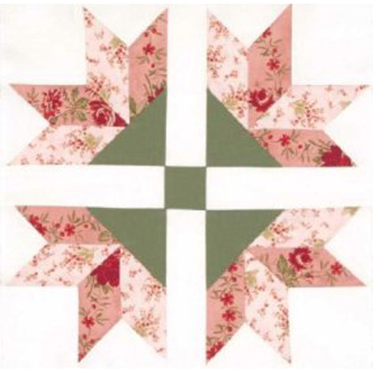
        - ***As of printing, the link on their webpage for the Quilt Block Contest is NOT accurate. I (Naomi) emailed them about this, and it will hopefully get fixed in the coming days.
      - You can help with this committee by:
        - Volunteering at the Quilt Raffle Table
        - Doing a sewing themed demonstration
          - Wed at 1pm OR Thurs at 1pm
      - Contact Ellen Buck with any questions buckconst5@gmail.com
    - Camp Quilt Committee
      - Guild sponsored retreat weekend
      - Twice a year, we spend a Fri-Sun out at Camp Tapawingo sewing and socializing and having a lovely time
      - Overnight stays are available
      - BYO project and needed supplies
        - Guild provides iron, ironing boards, extension cords
  - Mystery Quilt
    - Each step is posted in the monthly newsletter. Newsletters can be found on the website. Join anytime. The current Mystery started Sept 2024.
  - Name Tags
    - See Gretchen if you need a name badge
  - Madison Bus Trip
    - Joan from the Scrap Angels Quilt Club (Brillion) shared an opportunity to go to the Madison Quilt Show on a bus with their guild
    - Details:
      - Thurs. Sept. 4th
        - Pick up in Manitowoc at approx 5:55am
(location to be determined, likely the Park and Ride by Perkins)
        - Pick up in Brillion at 6:30am
        - Arrive Madison at approx. 8:45, doors open at 9am
        - Leave Madison at 2:00pm
        - Drop off in Brillion at approx 4:15
        - Arrive Manitowoc approx 4:45pm
      - Cost is $45 and includes your ticket to the event
      - Deadline to sign up is July
    - Contact: Joan Thor: home 920-772-4104 cell 920-858-8496
    - Approx 25 seats available

    - This is Joan’s first time organizing, so some details may still need some ironing out. Please contact Joan with any questions
  - Nominating Committee: Nan Groll & Kay Olker
    - Vote to be held at the June Meeting
    - Nominations so far:
      - For President: Ellen Lewellen
      - For Secretary: Naomi Anderson
      - For Board of Directors (4 positions available): Sue DuPont, Sue Marquardt, Chris Bauknect, Kay Olker
    - Nominations still open
  - Membership Booklet
    - Info based on your registration form, so please be accurate!
  - “Party Committees”
    - August Picnic, Christmas Social
      - Budgeted committees for planning a party with food, activities and fun
  - Historian
    - Helps track charitable giving
      - If you donate to an organization, try to get a brochure/flier from them to give to the Historian
  - Sew Days
    - National Quilting Day in March
      - Open sew and demonstrations by members
    - Workshop
      - Once a year workshop
      - Upcoming: May 10, English Paper Piecing taught by Ellen Lewellen
  - Sign-in Notebook
    - Each month there is a notebook (usually near the entrance, but sometimes it goes around the tables) for you to sign in.
      - This serves as a both a way to track general attendance and as a door prize drawing.
  - Tip Jar
    - Put your tips and questions into the Tip Jar. They will be shared/answered at a future meeting/in the newsletter.
  - Free Table/Sharing Table
    - Bring your unwanted quilting related items (fabric, notions, tools, magazines) and put them on the Free Table. The only stipulation is that you take whatever of yours was not claimed by others at the end of the meeting. Items are free for the taking! Enjoy a new-to-you treasure!

A Patch of Lakeshore Quilters Guild Membership 2025-2026

CIRCLE ONE: New Member or Returning - Please print or use address label:
Name: __________________________________________________________
Address: ________________________________________________________
City: _______________________ State: ________ Zip Code: ______________
E-mail: __________________________________________________________
Home Phone: _________________ Cell Phone: ________________________
Date of Birth: _________________________ (just for fun)
*Please note that email is the primary way the Guild communicates unless you notify us that you don’t receive email.
ANNUAL DUES
_____ $30.00 Membership if receiving Newsletter via E-Mail
_____ $40.00 Membership if receiving Newsletter via US Postal Service
_____ $10.00 Junior Membership (10 – 18 years) with paid adult member:
Mentor’s name: __________________________________
______ $8.00 Membership name badge ~ circle which: pin or magnet on back
Make Checks payable to: A Patch of Lakeshore Quilters Guild
Return forms and payments to Treasurer or mail to:
A Patch of Lakeshore Quilters Guild
Attn: Treasurer, P. O. Box 1952, Manitowoc, WI 54221-1952

Committees: Place an X by any committee(s) you would like to participate in.
Circle any committee you would be willing to lead.
____Camp Quilt ____County Fair Quilt ____Mystery Quilt ____Picnic
____Charity Projects ____Historian ____Sunshine ____Workshop
____Christmas Social ____Membership Booklet ____Nominating
____New Member Reach Out ____National Quilting Day
____Hostess
Choose a month(s) for Social Hostessing:
___Sept ___Oct ___Nov ___Jan ___Feb ___March ___April ___May ___June
I would like to work with: _______________________________________________________

TREASURER’S USE ONLY:
Dues rec’d: Date__________ Cash_______ Check #_________ Amount_________ Rec’d by _______
Registration Form - Committee Info (most are worked as a team)
- Camp Quilt
  - Set up dates with Camp Tapawingo (currently rolling over the deposit)
  - Reserve table at Two Rivers Family Restaurant for Friday breakfast
  - Contact local quilt shops for camp discounts
  - Committee is responsible for camp menu – That means ordering from the restaurant and picking up if need be and coordinating cooking with members once the menu has been decided
  - Come up with a quick project
  - Get the necessary items out of the storage shed (i.e. irons, ironing boards, plates, napkins, plastic ware, plastic wrap and food storage items, etc)
  - Set up tables/chairs on the Thursday before camp
  - Insure that everything is cleaned up when we leave on Sunday
  - When bill is received from camp, forward to the treasurer for payment.
- Charity Projects
  - Organize/suggest projects which can be made by members. Contact organizations within the community which may be in need of items.
- Christmas Social
  - As a committee (usually 3-4 people) Plan a Christmas Party for the December Guild Meeting. Usually some fun games/activities, delicious food, prizes, and sometimes entertainment. There is a budget.
- County Fair Quilt
- Historian
- Hostess
  - Assist in setting up chairs/tables for the meeting.
  - Bring a light snack for all to share. Help serve. Clean kitchen area.
  - Take out garbage, return the room to its original order.
- Membership Booklet
- Mystery Quilt
- National Quilting Day
  - Mid March event. Reserve Ascend for event. Organize an open sew day/s. Demonstrations are set up, with techniques taught by members.
- New Member Reach Out
- Nominating
- Picnic
  - As a committee (usually 3-4 people) Plan a picnic for the August Guild Meeting. Usually some fun games/activities, delicious food, prizes, and sometimes entertainment. There is a budget available for this.
- Sunshine
- Workshop
  - Organize workshops for members to learn new techniques.
Small Glossary of Quilting Abbreviations

Width of Fabric (WOF) refers to the full width of the fabric, typically from selvage to selvage. Understanding the WOF is crucial for cutting fabric pieces accurately for your quilt.

Right Sides Together (RST) means placing the right sides of two pieces of fabric together before sewing. This is how you create seams that are hidden on the inside of your quilt.

Free-Motion Quilting (FMQ) is a technique where you move the fabric freely under the sewing machine's needle to create intricate and decorative quilt designs.

Half-Square Triangle (HST) is a popular quilting block made by sewing two triangles together, forming a square with a diagonal seam.

Two sewing machines are in a bar.
One says to the other, “Hey, aren’t you a singer?”
It replies, “Why, Ja-no-me?”
The bartender could only say,
“oh brother?”
Unfinished Object (UFO) refers to a quilting project that you've started but haven't completed yet. Many quilters have a few UFOs hiding in their closets.

Work in Progress (WIP) is a project that is currently being worked on but isn't yet finished. WIPs can range from small quilt blocks to full-sized quilts.

? ? ? 2024-2025 Mystery Quilt ? ? ?

~ Pattern on page 9 ~ quantity: make 1 block ~
HST (Half Square Triangles) galore!
Join the Mystery Quilt anytime. Past newsletters, starting with Sept. 2024, contain all the blocks that have previously been revealed.

