
NEWSLETTER
Volume 22 Issue 01 January 2026

Guild Meeting:  Jan 8th, 6pm  ~At Ascend Services  2818 Meadow Lane, MTWC | Upcoming:  Cross Stitch Workshop  ~Jan. 31 - info: page 2
Impressionist Art Quilt Workshop - Page 3 & 4
Mystery Quilt - Page 7

From the President’s Desk - Ellen Lewellen

Happy New Year! For many, the new year is the time to start something new or resolve to do something differently. In the past I’ve mentioned Karen Brown’s (Just Get it Done Quilts on You Tube) declutter your sewing space January challenge. That is happening again this year if that is a desire of yours, but this year I’m promoting an even simpler trick from her which is a timer.
Yep. You could set the timer on your phone just as easily, but the idea is to encourage you to carve out a time to dedicate yourself to one task. It could be sewing, cleaning, or getting exercise. No breaks to change the laundry or send a quick email! If you can set aside 15 or 20 or 30 minutes each day to take a bite out of that UFO, imagine how much you could accomplish!
Other than that, I’m wishing you each good health and something cool or fun in January, and safe travels to those heading to warmer places.
~Ellen Lewellen, Guild President

~From Naomi - you can check out Karen’s Declutter challenge on her blog: www.justgetitdonequilts.com/blog
She posts the declutter “topic/item” each day, or you can sign up to be emailed daily.

~ December 11, Guild Meeting Minutes ~
- Brief Business Meeting
  - Member Directory is available - $1
  - Charlotte Endires (former guild member) has passed away
  - For January 8th Program, please be prepared to discus:
    - Ideas for Quilt Show Theme
    - Chair or Co-Chairs over the show
  - Keep an eye out for future skill building workshops
  - Jan. Hostesses: Ann H, Sue M, Ellie P, Peggy V
  - Show & Tell
- Welcome to the Christmas Party
  - Put on by: Kathy G, Ellen B, Emily B, Gretchen S, Ann H, and Diane S
  - Wonderful entertainment put on by the Roncalli Singers featured a beautiful mix of Christmas songs, such as:
    - Carol of the Bells, The Holly and the Ivy, No Room, and Silent Night
  - Delicious food and a take home mug
  - The night was closed out with a fun “Left - Right” story to distribute door prizes for all

Counted Cross Stitch Workshop - Jan 31, 2026
Mary Ellen Beebe has been doing cross stitch for many years and will spend a Saturday in January helping you to learn the skill. She will share tips and tricks she has learned over the years as well. Small kits will be provided for you to choose from. All you will need is a small (4-6”) embroidery hoop and embroidery scissors. A few may be available for you to borrow. So join us if you are interested! If you already know how to cross stitch and are working on something, you are welcome to join us.
Date: Saturday, January 31, 9:00-3:00. Ascend Services
Cost: $10 (room fee)
Bring: ~Lunch And Beverage
~Embroidery Hoop
~Scissors
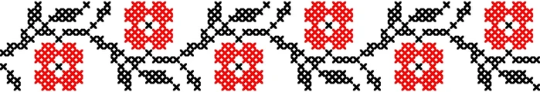

Art Quilt Workshop - April 11, 2026
Barbara from Wyverns Trove located in Columbus, WI will be leading an Impressionist Art Quilt Workshop for our guild. There will be kits with inspiration pictures and fabrics to get you started. Kit themes include: landscapes, pets, window scenes, flower bouquets, wreaths, and the like. All kits are different and Barbara plans to bring extras so there will be plenty of variety.

What you need to do before this workshop:
- Sign up using the form on the next page. Total cost is dependent on the quilt size you choose, listed below. Turn in form at the January meeting. Contact Karel H if you will not be at the Jan meeting.
- Decide your quilt size (larger quilts are easier to create an image)
  - 20”x30” - $15
  - 24”x36” - $20
  - 30”x40” - $30
- Save novelty fabrics to use in your quilt and share/swap with others. Leaves, flowers, fur, animals, insects, bricks, rocks, trees, sky, clouds, grass and the like.

What you need to bring to the workship:
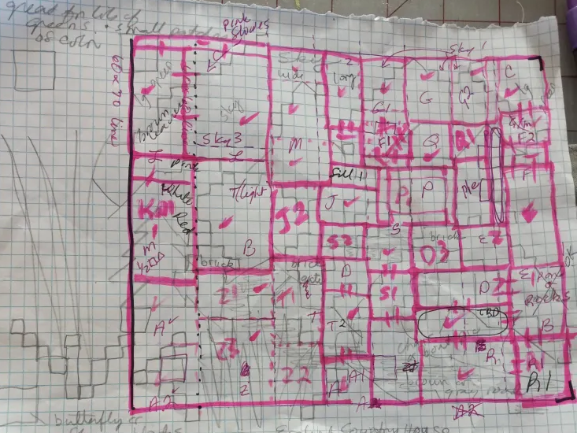
- Sewing Machine
- Neutral Thread - blues, greens, or browns all work as a middle neutral
- Rotary Cutter and cutting mat
- Scissors
- The novelty fabrics you’ve been saving
- Highlighter and pencil
- Straight pins
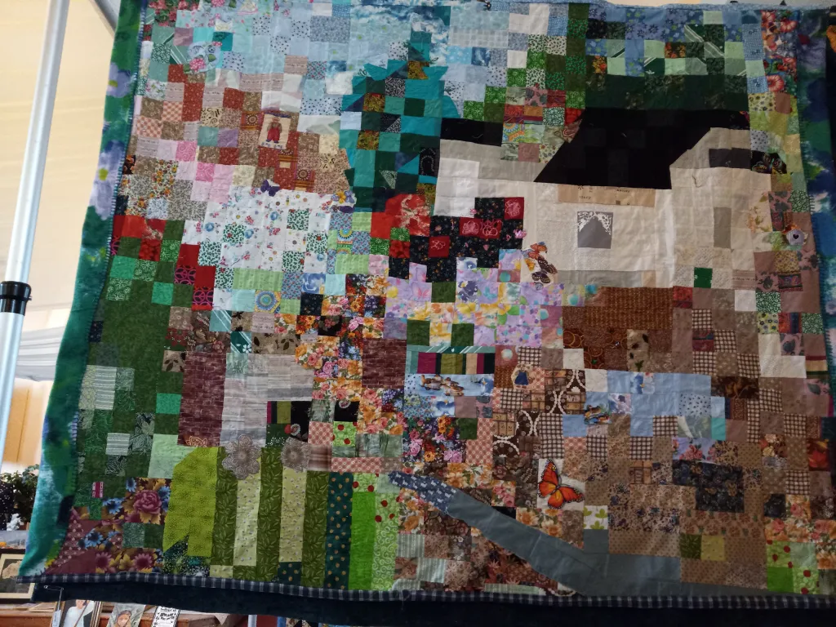
- Lots of scrap paper for labeling

Helpful skills include knowing how to make: 4 patch, 16 patch, snow ball corners, and half square triangles from two pieces of fabric the same size as the finished square. (4 and 16 Patch instructions in Dec. 2025 newsletter. Snowball and half square triangles on )
Contact Karel Harcus with questions
~Barbara’s blog post about her process in making her Impressionist Quilt.
wyvernstrove.wordpress.com/2025/11/07/art-quilt-lessons-learned/
Patch of Lakeshore Quilters
Impressionist Art Quilt Workshop Registration

Saturday, April 11, 2026 9am to 3pm Located at Ascend

Cost: $25 (Room rental and class cost)
PLUS cost of your kit (see below)
Kit sizes:
20”x30” $15
24”x36” $20
30”x40” $30

Return bottom of this form at the January Meeting
Keep the top for your information.
If you are unable to attend the meeting, please phone or text Karel Harcus with your choice of kit size. 920-714-1118

Checks can be made out to Patch of Lakeshore Quilters

— — — — — — — — — — — — — cut here — — — — — — — — — — — —

Impressionist Art Quilt Workshop - April 11, 2026

Name: _________________________ Phone: _________________

Room & Class Fee: $25
My choice of kit size:
20 x 30 - $15 ____________
24 x 26 - $20 ____________
30 x 40 - $30 ____________

Total: ________________

(I [Karel] would like a second kit designed by Barbara to sew on my own. Please mark quantity.)
Snowballs & Specialty Half Square Triangles
(esp. in prep for the Art Quilt Workshop)
Snowball Block

Block featuring triangles sewn onto the corners of a square, creating a rounded or octagonal "snowball" effect.
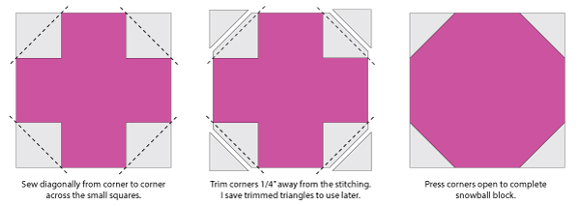
~You need 1 larger square of fabric and 4 contrasting smaller squares.
Construction:
- Start with one square of fabric the size of your desired unfinished block.
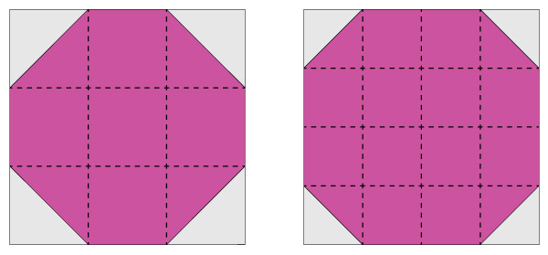
- Mark a diagonal line on the smaller squares and pin them to the corners of the larger square, fabrics right side together.
- Sew all four smaller pieces on the diagonal line
- Trim corners a quarter inch from seam.
- Flip corners and press
Snow ball corners are often based on a 3rds or 4ths of the larger block, but can be wonky or different sizes, especially for an impressionistic art quilt.

Specialty Half Square Triangle (HST)
How to make one 2.5 inch HST from two 2.5 inch squares of fabric
(size can be adjusted to what you need)
- Place fabric pieces right sides together.
- Mark and sew a diagonal seam, corner to corner (solid line=sew line)

- Trim 1/4″ away from the seam and discard the trimmed piece (or save and sew a secondary, smaller HST) (dashed line=cut line)

- Press open

My Wife, The Quilter

She learned to quilt on Monday. Her stitches were very fine.
She forgot to thaw out dinner, so we went out to dine

She quilted miniatures on Tuesday. She says they are a must.
They really are quite lovely, but she forgot to dust.

On Wednesday it was a sampler. She says the stippling’s fun.
What highlights! What shadows! But the laundry wasn’t done.

Her charm quilt was on Thursday, green patches, blue and red.
I guess she was engrossed; she never made the bed.

It was wall hangings on Friday; in colors she adores.
But she never seemed to notice the crumbs on all the floors.

I found a maid on Saturday! My week is now complete.
My wife can quilt the hours away; the house will still be neat.

Well, it’s Sunday. I think I’m about to wilt.
I cursed, I raved, I ranted! The maid has learned to quilt!!

~shared by Marlene

? ? ? 2024-2025 Mystery Quilt ? ? ?

Great Job Gang, Another Mystery {Quilt} is Solved!
Check out the next page for the final clue…sashing and borders!
I (Chris B) did not make the corner squares with a square in a square. That would be 325 small pieces to stitch together and that did not excite me! I just made them using the 2-1/2" squares without the small squares attached.
Review any “clues” by checking out the mystery quilt original site: www.rileyblakedesigns.com/2024-rbd-block-challenge-patterns
